

AR Manual

Table of Contents

Getting Started with ECS – Electronic Chart System’s Accounts Receivable and Billing 13

Notice 13

Proprietary Rights Notice 13

About This Manual 14

Helpful Tools 14

Icons on the Toolbar related to Financial Purposes 14

General Ledger 16

Add Account Numbers to the Chart of Accounts 16

To add an Account Number to the Chart of Accounts 16

Printing the Chart of Accounts 17

To print the entire Chart of Accounts stored in ECS 17

To print selected Account numbers 17

Exporting the Chart of Accounts 17

To export the entire Chart of Accounts stored in ECS 17

Rate Changes Using Charge Master Tasks 17

Facility Specific Rates 18

Entering Rate Changes Using Charge Master Tasks 18

Room and Board Rates 19

PDPM HIPPS Code Rates 19

State RUG Rates 19

Ancillary Rates 20

Therapy Rates 20

Medicare (B) Fee Schedule 20

PE RVU Value 20

GPCI Value 20

Conversion Factor 20

Self Pay Charge 20

Viewing Existing Rates in ECS 20

Print Rates 20

Adding a Name into ECS 21

Names 21

Edit Existing Names 22

Adding a New Name 22

Updating Demographic and Locate Information 23

Inactive vs. Closed Account 23

Name Selection Screen 23

The Filter Button 23

Filtering the Names List 24

The Common Button 24

To common for all Medicare (A) clients ever: 24

To common for Medicare (A) clients for a range of dates: 24

Face Sheet Information 25

Documenting Face Sheet Information 29

Changes to Face Sheet/Status Information 29

Charting Requirements Per Payer Source 30

Requirements for All Payer Sources 30

Self Pay Requirements 30

Medicaid Requirements 30

Hospice Medicaid Requirements 30

Managed Care Requirements 31

Insurance 31

Medicare (A) 31

Medicare Advantage (A) 32

Medicaid MCO 32

VA 32

Optum (A) 33

Medicare (B) Requirements 33

Medicare Advantage (B) Requirements 33

Insurance (B) Requirements 34

Optum (B) Requirements 34

Charting Required When Client Discharges (Any Payer Source) 34

With Payer Source of Medicare (A) or Medicare Advantage (A) 34

Documenting Available Medicare Days 35

Documenting Room Numbers 38

Running a Report to show Status and Rooms Information 38

Documenting Insurance Profile Information 39

Running a Report to show Insurance Information 39

Documenting Contact Information 39

Running a Report to show Contact Information 40

Documenting Physician Information 40

Running a Report to show Physician Information 41

Ancillary Charges 41

Documenting Ancillary Charges 41

Private Room Exception 43

Reports to Run to Show Ancillary Charges Documented 43

Documenting Therapy Charges 43

To Document an Evaluation 43

To Document a Treatment that is a Service HCPCS code 44

To Document a Treatment that is a Timed HCPCS code 44

Documenting Onset, Start of Care, and Plan Reviewed Dates 45

Running Reports to Show Therapy Charges 46

Calendar 46

Daily Census Calendar 46

Troubleshooting Calendar Issues 47

Show Unbalanced Only 47

Printing the Calendar 48

Exporting the Calendar 48

General Accounts Receivable Information 48

Calculate Control Screen 48

Calculate Control Screen Guide 49

View Calculations Button 50

Held Calculation 51

Posted Calculation 51

The Calculating Screen 51

Calculation Screen Buttons 52

Posting Charges 53

Posting Charges 53

Printing/Exporting/Saving a Report 53

Printing a Report 54

Exporting a Report 54

Saving a Report as a PDF 54

Receipts/Adjustments Control Screen 54

Receipt/Adjustment Screen Buttons 54

The Receipts/Adjustment Screen 55

Receipts/Adjustments Screen Buttons 55

Beginning Balances 56

Entering Beginning Balances 57

Print Beginning Balances Report 58

If an Entry is Incorrect 58

Calculating Beginning Balances 58

Self Pay Billing 59

Calendar Reports 60

Self Pay Requirements Calendar 60

Self Pay Ancillary Charges 60

Self Pay Recurring Charges 60

Self Pay Therapy Charges 61

Calculating Self Pay 61

Reviewing Calculations 61

Posting Charges 61

Printing Self Pay Invoices 62

Re-Print a Self Pay Invoice 62

Medicaid Billing 62

Calendar Reports 62

Medicaid Requirements Calendar 63

Medicaid Diagnoses Calendar 63

Medicaid Ancillary Charges 63

Medicaid Recurring Charges 63

Medicaid Therapy Charges 64

Calculating Medicaid 64

Reviewing Calculations 64

Posting Charges 65

Generating UB04s 65

UB04 Electronic Transfer 65

Medicare (A) Billing 65

Calendar Reports 65

Medicare (A) Requirements Calendar 65

Medicare (A) Diagnoses Calendar 66

Medicare (A) Ancillary Charges 66

Calculating Medicare (A) 66

Reviewing Calculations 67

Posting Charges 67

Generating UB04s 67

UB04 Electronic Transfer 67

Medicare (B) Billing 67

Calendar Reports 67

Medicare (B) Requirements Calendar 68

Calculating Medicare (B) 68

Reviewing Calculations 68

Posting Charges 68

Generating UB04s 69

UB04 Electronic Transfer 69

Medicare Advantage (A) Billing 69

Calendar Reports 69

Medicare Advantage (A) Requirements Calendar 69

Medicare Advantage (A) Diagnoses Calendar 69

Medicare Advantage (A) Ancillary Charges 70

Calculating Medicare Advantage (A) 70

Reviewing Calculations 70

Posting Charges 71

Generating UB04s 71

UB04 Electronic Transfer 71

Medicare Advantage (B) Billing 71

Calendar Reports 71

Medicare (B) Requirements Calendar 71

Calculating Medicare Advantage (B) 72

Reviewing Calculations 72

Posting Charges 72

Generating UB04s 73

UB04 Electronic Transfer 73

Managed Care Billing 73

Documenting Status Information for Managed Care 73

Entering the Negotiated Daily Rate 73

Calendar Reports 74

Managed Care Requirements Calendar 74

Calculating Managed Care 74

Reviewing Calculations 75

Posting Charges 75

Generating UB04s 75

UB04 Electronic Transfer 75

Insurance Billing 75

Calendar Reports 75

Insurance Requirements Calendar 75

Calculating Insurance 76

Reviewing Calculations 76

Posting Charges 76

Generating UB04s 77

UB04 Electronic Transfer 77

Benefits Exhaust Billing 77

Charting 77

Calculating Benefits Exhaust 77

Generating UB04s 78

UB04 Electronic Transfer 78

No Pay Billing 78

Charting 78

Calculating No Pay 79

Generating UB04s 79

UB04 Electronic Transfer 79

Reviewing Calculations 79

Deleting a Held Calculation 80

Reversing a Posted Calculation 81

Reversing Multiple Posted Invoices 82

Analyze a Line on the Calculating Screen 83

Errors on the Calculating Screen 84

Interface Errors on Calculating Screen 84

Billing Out of Balance Errors 85

UB04s and Electronic Transfer of UB04s 85

Generating UB04s 85

Viewing Previously Created UB04s 86

Viewing UB04s for a Specific Payer Source 86

Viewing All UB04s – Across All Payers 86

Troubleshooting the UB04/Analysis Tool 87

Printing UB04s 88

To Adjust Printing Options 88

Printing a UB04 88

Printing multiple UB04s 88

Additional UB04 Tools 89

Note 89

Message 89

UB04 Electronic Transfer 90

Posting Cash 91

Selecting the Charges to Post Payments To 92

Paying the Total Due 92

Paying Less than the Total Due 92

Finish Posting Cash 93

Cash Reports 93

Financial Reports 93

Journal Reports 93

Reversing Cash or Adjustments Posted 94

Apply Credits 94

Interface Errors on Receipts/Adjustments Screen 95

Search within Receipts/Adjustments Screen 95

Adjustments 95

Using the Adjustments Documenting and Calculating Screens 95

Reports for the Adjustments Screen 97

Using the Receipts/Adjustments Screen 97

Automatic Adjustments 98

Changing Billing Information 98

Using Automatic Adjustments 98

Self Pay Bills 100

Aging 100

Run an Aging Report 100

Aging Detail 101

Printing an Aging 101

Exporting an Aging 101

Changing the Aging Dates 102

Changing the Number of Months the Aging Looks Back 102

Journals 104

Month End Journal Reports 104

Balance to Aging by Account 104

Last Month Account Totals 104

Temp Liability Account 105

Printing Journal Reports 105

Exporting Journal Reports 105

Miscellaneous Cash 106

Documenting Miscellaneous Cash 106

Calculate and Post Miscellaneous Cash 106

Trust Account 106

Trust Account Beginning Balances 107

Documenting Trust Account Deposits 107

Documenting Trust Account Withdrawals 107

Trust Account Reports 108

Trust Account Activity Documented 108

Trust Account Current Balance 108

Trust Account Interest 109

Entering Account Balance and Interest 109

Calculating and Posting Trust Account Activity 109

Trust Account Activity Posted Report 110

To print the Trust Account Activity Posted after this process 110

Printing Monthly Trust Account Statements 110

Quarterly Trust Account 111

Printing Quarterly Trust Account Statements 111

Security Deposit 111

Security Deposit Beginning Balances 112

Documenting Security Deposit Deposits 112

Security Deposit Reports 112

Security Deposit Activity Documented 112

Security Deposit Current Balance 113

Calculating and Posting Security Deposit Activity 113

Security Deposit Activity Posted Report 114

To print the Security Deposit Activity Posted after this process 114

Lock Periods 114

Locking Periods 114

Adjustments to Locked Periods 115

Billing Screen 115

Receipts/Adjustments Screen 117

Month End Procedures 117

Billing Summary Reports 118

Ancillary Charges Documented vs Posted 118

Miscellaneous Cash 118

Trust Account 118

Aging Reports 118

Journal Tasks 118

Balance to Aging by Account Journal 118

Last Month Account Totals Journal 119

Temp Liability Account Journal 119

Lock Periods 119

# Getting Started with ECS – Electronic Chart System’s Accounts Receivable and Billing

This document is the User’s Guide that accompanies the ECS - Electronic Chart System’s Accounts Receivable & Billing system. It is intended to provide you with the information you need to begin utilizing this program. The document also operates under the assumption that the necessary information has been setup at the time you are ready to begin using the system.

## Notice

American Data provides this manual “as is” without any warranty of any kind, either expressed or implied. American Data may make improvements and/or changes in the product(s) and/or program(s) described in this manual at any time without notice.

## Proprietary Rights Notice

This user guide contains information that is proprietary to and considered to be a trade secret of American Data. This reference manual may not be reproduced in whole or in part, disclosed, divulged, or otherwise made available directly or indirectly to any party other than the original licensee. Reproduction of this document for any purpose is strictly prohibited without prior written permission of American Data. Violators of this policy will be prosecuted to the full extent of the law.

# About This Manual

## Helpful Tools

Throughout this manual, certain tools are used to make it as user-friendly as possible. Below you will find a list of these conventions and how to identify them.

🕭Notes that have this symbol are critical to the function and must NOT be ignored.

* Indicates a special note.
* Indicates a definition.

In addition to the symbols indicated above, other tools will be used throughout the manual to assist you in identifying certain tasks, important words or phrases, and other such information.

When we use the term “double-click”, it means click the LEFT mouse button twice rapidly while pointing at the item you wish to select.

When we use the term “right-click”, it means click the RIGHT mouse button once while pointing at the item you wish to select.

## Icons on the Toolbar related to Financial Purposes

These icons may be accessed by clicking the Toolbar tab at the top of your screen. Icons visible are controlled by user group rights and therefore your user group may not have access to all the icons listed here.

Functions associated with these icons are found within your Access buttons.

|  |  |
| --- | --- |
| **Icon** | **ECS Definition** |
|  | Click this icon to "hide" ECS and present the "ECS Login Password" screen. Using this feature maintains the user's place in the record while locking all users out of the system on that computer This icon is utilized by staff who get "pulled away" from their charting while in the middle of it (e.g. to take a phone call, to tend to an incident, etc.) Utilizing this feature allows the user to lock all users out of the system (on that computer) so that they may come back to where they left off. |
|  | Click this icon to have access to the topic and word setup screens. All the topics (folders) and word grids in ECS may be altered by the system administrator. Changes to the words in the topics/folders may only be done using this icon. Most users are restricted from this area. Setup rights may be restricted to specific Topics within ECS allowing users to make setup changes in only certain locations. |
|  | Click this icon to enter a new client into the system or update an existing account. This icon presents the Demographic screen for a record. The Demographic data includes name, age, birth date, social security number, MRN, Admission Number, Medicare Number, Medicaid Number, etc. |
|  | This icon is the primary documenting icons. The majority of information entered into the system is entered via these screens. The Write screen calls a basic documenting grid. The user defines which record to document in (by selecting a client) and what information to document (by selecting a topic). The Write/View screen is a documenting and viewing screen all in one. The top portion of the screen loads the defined topic for documentation while the bottom portion of the screen calls a viewing screen that pulls data that was previously documented. American Data recommends utilizing the Write/View screen for documenting information. |
|  | This icon in the primary way to view data in a record. The user selects this icon, defines which records to view (by selecting clients) and then what information to view (by selecting topics). The view screen has many options available to further define how/what information to view (e.g. information documenting during a particular time period, by a particular user, or data that was removed from the record). The clinical manual extensively covers the use of this icon for viewing data. |
|  | Click this icon to generate calendar reports. Calendar reports track events documented in the system. Typically the calendar is used to display information in a month to month fashion but it may be used to display information over longer or shorter periods of time. Calendar reports are covered extensively in the manual. |
|  | Click this icon to calculate and post charges. This is the process of producing the charges in ECS. |
|  | Click this icon to post payments or do adjustments to client accounts. |
|  | Click this icon to view aging reports for Accounts Receivable. |
|  | Click this icon to open the General Ledger. Clicking this icon updates all numbers since the last time it was opened. You are also able to print GL reports, view and print account detail, do account comparisons, and print a chart of accounts from this icon. |
|  | Click this icon to access the journal reports. |
|  | Click this icon to create financial forms like UB04s and HCFA 1500s. |
|  | Click this icon to create a batch file containing the financial forms like UB04s and HCFA 1500’s. |
|  | Click the red reports icon to find Financial reports including billing summaries, logs, daily deposit reports, invoices, etc. You will receive a default list of financial reports and these reports will be customized and updated based on the needs of your facility. |

# General Ledger

Although we don’t have a complete General Ledger package, you will be using the General Ledger functions to store your chart of accounts and to control the periods that are locked within your Accounts Receivable system. During the first visit, the financial trainer from American Data will go over the chart of accounts with you, determine what accounts are going to be used, and may guide you in entering the accounts into ECS.

## **Add Account Numbers to the Chart of Accounts**

You may add account numbers to the chart of accounts. If you are adding a new account number because you are going to begin billing for a new service, you should contact American Data’s Financial Support Department to make sure the appropriate setups are also completed.

### To add an Account Number to the Chart of Accounts

1. From the **Main Menu** click **Month End**.
2. Click the **Chart of Accounts** button.
3. Click **Add**.
4. Fill in the **Account Number**. If you have a site pre-fix or site suffix do not include this in the number you enter.
5. Enter a **description** of the account number.
6. Select whether the account is a **Static Account, Calculated Account, or Retained Earnings Account**.
   1. **Static Account** – will be selected for all accounts as we are not using the General Ledger package.
   2. **Calculated Account** – is an account that totals values in other accounts defined in the account set up for General Ledger reporting.
   3. **Retained Earnings Account** – a Retained Earnings account number set up for General Ledger Reporting.
7. Select whether the account is a **Fiscal Year or All Years** accounts.
   1. **Fiscal Year** means the account balance starts over at the start of a new year. A revenue account for example is a Fiscal Year account.
   2. **All Years** means the account balance carries over from year to year. An asset account for example is an All Years account.
8. Select the **Account Type** of Asset, Liability, Revenue, Expense, or Other.
9. In the bottom left select the **Site(s)/Service(s)** that the new account number should be set up for. The site pre-fix or suffix will be displayed here.
10. Click **Set** next to the Site box.
11. If the account is Revenue, Expense, or Other and you would like to be allowed to do adjustments using this account, place a checkmark in the **Adjustments** checkbox.
    1. Revenue and Contractual Adjustment Accounts should have this checked.
    2. ECS will not allow you to select this for Asset or Liability accounts.
12. If the account can be used for Journal Entries, place a checkmark in the Journal Entries checkbox.
13. Click **Save** to save this information and add another account. Click **Save/Close** to save this information and close out of this screen. Click **Close** if you would like to close the screen without saving.
14. Click **Close** again to exit out of the Chart of Accounts.

## Printing the Chart of Accounts

### To print the entire Chart of Accounts stored in ECS

1. From the **Main Menu** click **Month End**.
2. Click the **Chart of Accounts** button.
3. Click the **Print** button.
4. Click **OK** on the printer selection screen.
5. Click **Close** to return to the **General Ledger** screen.

### To print selected Account numbers

1. From the **Main Menu** click **Month End**.
2. Click the **Chart of Accounts** button.
3. Highlight the accounts you would like to print by using the **Shift** and/or **Ctrl** keys on your keyboard.
4. Click the **Print** button.
5. You will be asked if you want to print just the selected items. Click **Yes**.
6. Click **OK** on the printer selection screen.
7. Click **Close** to return to the **General Ledger** screen.

## Exporting the Chart of Accounts

### To export the entire Chart of Accounts stored in ECS

1. From the **Main Menu** click **Month End**.
2. Click the **Chart of Accounts** button.
3. Click the **Export** button.
4. Select a location to save the file and a file format type and click **Save**.
   1. The file will be found in the location where you chose and can be opened with Microsoft Excel.

# Rate Changes Using Charge Master Tasks

When a facility is implementing the Accounts Receivable package, American Data’s trainer will train you on entering the rates for the facility in the Charge Master. When a facility has rate changes, the facility is responsible for updating the values in ECS. Below you will find some instructions on how and where to change your rates.

* If you have existing rates in the system that need to be updated, you will follow the same steps as outlined for entering original values. The main issue is to use the correct **Effective Date** for the rate change and the correct row.

If you have any questions about where to change your rates, please call American Data’s Financial Support.

## Facility Specific Rates

Organizations that have multiple SNFs within one database may need to enter rates that are different per Site. If you share a service between services (like an AL and an IL) but charge different rates for these services, you may also see Service specific rates.

In the Charge Master, you may click the Site/Service box to the right of the field to select or modify the Site/Service.



Rates that are set to “**All/All**” are in **red** text and are applicable for all Sites/Services. This should be used if your database has only 1 SNF and/or has Sites that share the same rates.

Rates that are Site specific (Site 1) are in **black** text and is applicable for the Site(s) selected. You do have the ability to change rates for multiple Sites at the same time by selecting them in the Site/Service picklist.

Rates that Service specific (Site 1/SNF) are in **blue** text and are applicable for the Site(s)/Services(s) selected. You do have the ability to change rates for multiple services at the same time.

## Entering Rate Changes Using Charge Master Tasks

1. From the **Main Menu**, click the **Rate Changes** button.
2. Click the appropriate button related to the rates you are updating. For example, **Room & Board Rates** and then **Self Pay Room and Board Rates.**
3. Check to make sure you have the correct **Site/Service** selected at the top of the Charge Master screen.
4. Use the next available rate column to enter in the new rates.
   1. You may highlight all cells by using your shift and/or control key on your keyboard. Once all are highlighted, right-click and select **Edit All**. This will allow you to edit all rates at one time.
5. If you need to enter a different rate for each room number or level of service, click onto the cell and type in the appropriate rate.
6. Once all rates have been updated, enter the effective date that these changes take effect. This should be done globally for all rates.
   1. **Click** in the top/first associated **Date** column.
   2. Hold the **Shift Key** on your keyboard.
   3. Click in the bottom/last Date column to select the entire column.
   4. Right-click on the selected column and select **Pick Date**.
   5. Select the appropriate **effective date** from the calendar.
   6. Click **OK**.
7. Click **Save** in the lower left-hand corner.

In this example below, I would want to enter my new rates in column AC Value and the effective date in AC Date as those are the next available columns.

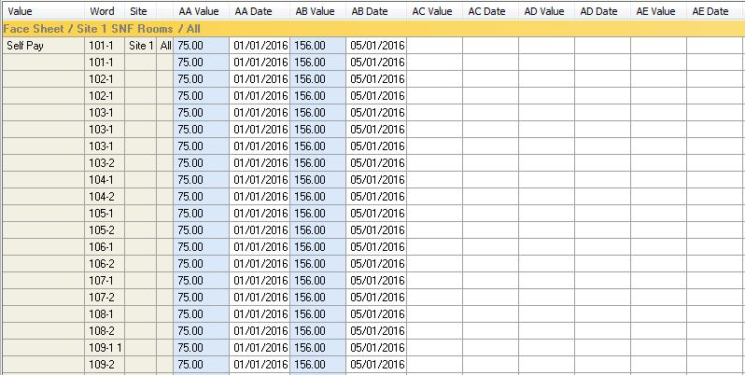

* Once you have reached the end of the columns (AZ) just start over at the beginning with column AA. You may replace what is in column AA with new rates and effective dates.

## Room and Board Rates

You may see several access buttons associated with various room and board rates to include Self Pay, Medicaid, etc. You may have Private Rates, and Semi-Private rates, etc.

## PDPM HIPPS Code Rates

You will find separate Charge Master tasks for each PDPM HIPPS Code component to make rates easier to enter. Please note that although PT and OT share the same components, they do have different rates.

## State RUG Rates

You may see multiple tasks associated with your State RUGs depending on the rates structure of your state.

## Ancillary Rates

Follow the steps above clicking on the appropriate buttons for different ancillary charge types. For example: vaccine rates, beauty shop charges, medical supply charges, etc.

## Therapy Rates

There are several different rates associated with therapy billing. They are each described below. Rates for Medicare (B) billing can be found on the CMS website.

### Medicare (B) Fee Schedule

The Medicare (B) Fee Schedule is the fee schedule from CMS. This is updated for each HCPCS.

### PE RVU Value

The PE RVU values are different for each HCPCS. This value is used to calculate the MPPR for Medicare (B) billing.

### GPCI Value

The GPCI Value is the same value for all HCPCS codes. This value is used to calculate the MPPR for Medicare (B) billing.

### Conversion Factor

The Conversion Factor is the exact same for all HCPCS and all localities. This value is used to calculate the MPPR for Medicare (B) billing.

### Self Pay Charge

The Self Pay value is the charge. This may be the marked-up rate and may be used to generate Medicare (B) Revenue. This is the rate billed out to residents who do not have Part (B) coverages as well as Insurances. Rather than using a Self Pay value, ECS can do the mark up for you.

## Viewing Existing Rates in ECS

You can see the rates exactly as you set them up by clicking the appropriate access button linked to Charge Master task.

## Print Rates

Rates can be printed from any of the Charge Master tasks.

1. Click the access button for the associated Charge Master task (for example Self Pay Room and Board.)
2. You may want to narrow the columns to a specific range to limit the size of the report.
   1. Select the **To** and **From** columns.
   2. Click **Go** to see the other columns disappear. 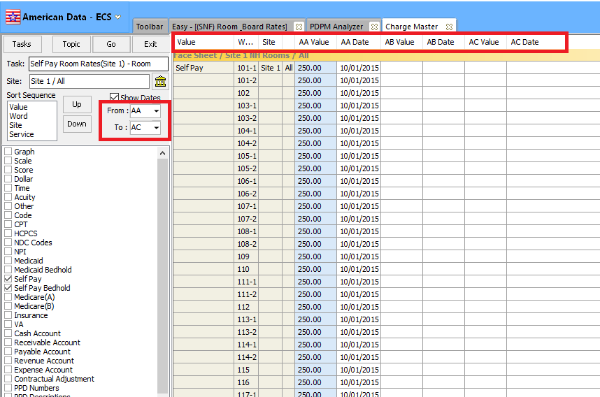
3. You may also want to narrow the results down to a particular Site/Service by clicking the Site box.



1. Go to **American Data – ECS>Print**.
2. Click the **Printer** icon to print.
   1. Make sure you note how many pages the report is. If you did not narrow to particular columns the report may be very longer.
3. Select your **printer**.
4. Click **OK**.

# Adding a Name into ECS

The ID is the location where the client’s basic demographic information is entered. Once this information has been entered, charting may begin on that client. This is also where billing information such as medical record numbers, social security numbers, Medicare and Medicaid numbers are entered. The information entered here pulls directly onto your Face Sheet report and billing forms (UB04s and 1500s).

## Names

The first step in admitting a client is to enter them into the ID portion of ECS. Prior to entering a new name into ECS you must check to see if the client has been admitted to the facility in the past.

1. From the **Financial Main Menu**, click the **ADT/Face sheet button**.
2. Click the **Add/Update/Client** button.
3. On the Names selection screen, click the **Filter** button.
4. Place checkmarks in the **Active**, **Hold**, **Inactive**, **Other**, **Referral**, and **Closed** **Account** checkboxes.
   1. This will allow you to see all client names that have ever been admitted to the facility.
5. If the client’s name ***is*** listed, you must edit and re-activate their account. You should not re-add a new account.
6. If the client’s name ***is not*** listed, you must add the new client’s name to the list.

### Edit Existing Names

If the name already exists in ECS you will re-active that account rather than beginning a new account.

1. From the name selection screen, **double-click the name**.
2. Update any information that may need to be changed on the Demographics screen.
3. Click the **Locate** button.
4. Change the status to **Active** and enter in the **effective date** the resident became Active.
5. Update the Site and Service options, as well as any other required filters.
   * Your Filters may have unique headings any may not match this screen.
   * Filter options with green text are required.
6. Click **OK**.
7. Click **OK**.

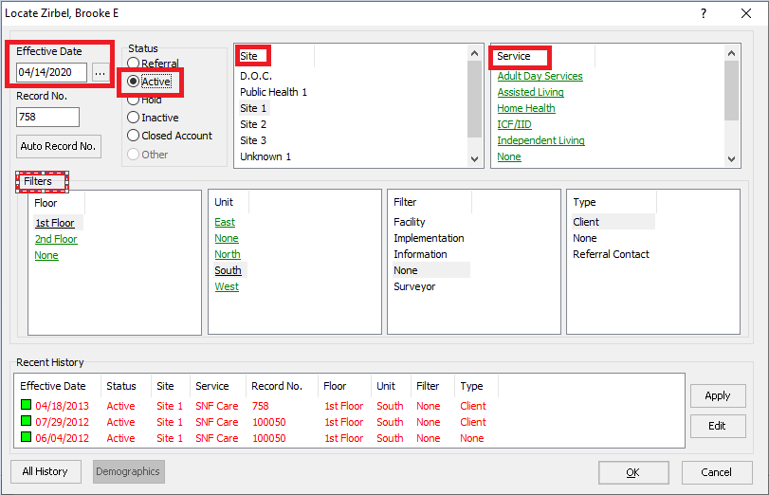

### Adding a New Name

If the name **does not** exist in ECS, you must create a new account.

1. On the bottom right side of the name selection screen, click the **New** button.
2. Select **Client** and click **OK**.
3. Fill in all appropriate Demographic information.
   * You will be required to fill in the client’s Last Name, First Name, and birthday before saving.
4. Click **OK**.
5. Select the effective date the resident becomes active.
6. Click the **Active** radio dial.
7. Select **Site** and **Service** options, as well as any other required filters.
   * Filter options with green text are required.
8. Click **OK**.
9. Click **OK**.

# Updating Demographic and Locate Information

Generally, Admissions staff or Medical Records staff are responsible for adding a new name or re-activating an existing name in ECS. Financial staff have access to this as well so that they may update information. For example, they may need to add a Medicaid number when approval has been received.

Your facility needs to decide who will update existing information in the system. There may be different departments assigned based on the situation.

## Inactive vs. Closed Account

**Inactive** status indicates a name is no longer in your facility and removes this name from the default clinical name selection screen. Inactive status should remain until all billing, payments, and refunds have been completed. Once a name has a zero balance in their Accounts Receivable and Trust Account, the Financial staff should then change the status to **Closed Account**.

# Name Selection Screen

Depending on what function you are performing in ECS you will need to select different groups of names from the List. The ECS Name Selection screen allows you to filter and sort the list to enable you to pick only those names that you need to work with. The Name Selection screen will be presented after clicking any access button to perform a function.

## The Filter Button

The Filter button allows you to select only those name(s) who have a status of Active, Hold, Other, Referral, Inactive, and Closed Account. You can place checkmarks in as many or as few of these options as you need.

The Filter button finds name based on what is in the Status of the Demographics screen. (This button does not filter based on what Occupancy Status has been charted in the Status topic of the Face Sheet tab.)

If you have multiple sites and/or services, the Filter button will also allow you to filter for only names who are in a specific site and/or service.

### Filtering the Names List

The instructions for filtering the Names List are going to be different based on what tasks you will be doing. Following are examples of some of the ways you may filter and sort the Name List.

* + Financial Users should have Active, Hold, and Inactive names selected by default in their User Rights. If you must continuously filter, you need to speak to your ECS System Supervisor to have your rights adjusted.

## The Common Button

The Common button allows you to do a more advanced sort on your clients, based on criteria that you determine. There is a pre-defined list of tasks created for you to allow you to sort, however you can also create your own tasks. For example, the Common button allows you to find only those clients who have ever had a Primary Payment Source of Medicare (A). It also allows you to sort even further by finding only those clients who have a Primary Payment Source of Medicare (A) during a specific time period. The Common button will be used throughout the Accounts Receivable package to do billing and run reports.

### To common for all Medicare (A) clients ever:

To select all clients who **have ever had** a Primary Payer Source of Medicare (A) in your facility.

1. Find any location that prompts you to select names.
2. From the Name Selection screen, click the **Filter** button.
3. Place a checkmark next to **Active**, **Hold,** **Inactive**, and **Closed Account**.
4. Click **OK**. You should now have a list of all those clients who have ever been in your facility.
5. Click the **Common** button.
6. Click the **Tasks** button.
7. Click the **Medicare (A) (enter dates)** task.
8. Click **Load**.
9. Click **OK** on the Common Filter screen.

ECS will sort through the list of selected names to display the name of only those who have ever been Medicare (A).

### To common for Medicare (A) clients for a range of dates:

To select all those clients with a Primary Payer Source of Medicare (A) within a specific time period.

1. Find any location that prompts you to select names.
2. From the Name Selection screen, click the **Filter** button.
3. Place a checkmark next to **Active, Hold**, and **Inactive**.
4. Click **OK**. You should now have a list of all those clients in your facility.
5. Click the **Common** button.
6. Click the **Tasks** button.
7. Click the **Medicare (A) (enter dates)** task.
8. Click **Load**.
9. On the Common Filter screen, enter in the Start Date field the start date of the period you are searching for. (For example, 09/01/2019.)
10. In the End Date field enter the end date of the period you are looking for. (For example, 09/30/2019.)
11. Click **OK** on the Common Filter screen.

This will give you a list of all those clients who have a primary payment source Medicare (A) during the month of September.

# Face Sheet Information

The Face Sheet/Status Topic information is the basis of the Accounts Receivable system. The calculations are based on all this information. It is necessary that all this information be entered correctly for your charges to be calculated and posted correctly.

The following information must be documented with the appropriate effective date. Changes to any of this documentation must be updated as it occurs, for billing to be accurate. The effective date should be the date that the information takes effect or took place. Prior entries should not be discontinued or archived

1. **Admitted From** - Click the Admitted From button and select from where the client was admitted.
2. **Admission Date (original)** – Enter the date that the client was originally admitted to the facility. This is linked to field 12 on the UB04s.
3. **Admission Time** – Enter the time that the client was originally admitted to the facility. This is linked to field 13 on select UB04s.
4. **Re-Admitted From** – Click the Re-Admitted From button if the client is being re-admitted from the hospital or leave of absence. Select where the client is being re-admitted from.
5. **Re-Admission Date** – Enter the date that the client was re-admitted to the facility.
6. **Re-Admission Time** – Enter the time that the client was re-admitted to the facility.
7. **Discharged To** – Is used when a client is being discharged from the facility. Specify here where the client is being discharged to.
8. **Discharged Date** – Enter the date of discharge.
9. **Payer Source on Discharge** – Select the Primary Payer Source the client was covered by on the date of discharge. This allows for reporting opportunities related to what a payer source was on the date of discharge. It also allows us to bill and/or capture revenue on the date of discharge.
10. **Transferred to** – May be used when a client is discharged from the facility with an anticipated return. The use of this term is optional, and your facility should decide whether it is used.
11. **Transfer Date** – Enter the date the client is transferred out of the facility.
12. **Occupancy Status –** Occupancy Status determines the census in your facility. The Occupancy status types are as follows:
    1. **In house** – used when a client is active in the facility. This is a billable day.
    2. **Hospital Bed hold** – used when a client has been sent to a hospital and you are holding a bed for them. Typically, this is a billable day, but setups at your facility will determine this.
    3. **Non-billable Bed hold** – used when a client has gone to the hospital and you are holding a bed, but you may not bill for this day. (Wisconsin Medicaid requires a $0.00 to appear on the UB04)
    4. **Therapeutic Leave** – used when a client is out of the facility, and you are holding a bed. Typically, this is a billable day, but setups at your facility will determine this.
    5. **Non-billable Leave** - used when a client is out of the facility, and you are holding a bed, but you may not bill for this day. (Wisconsin Medicaid requires a $0.00 to appear on the UB04)
    6. **Non-Covered** – typically used when a Medicare (A) resident goes out of the facility but is not gone for more than 3 days. This allows reporting of Non-Covered Days on the Medicare (A) UB04.
    7. **Discharged** – used when a client has been officially discharged from the facility. Discharged status stops all other status information. This day is non-billable.
13. **Primary Payment Source** – Each client must have a Primary Payment Source listed. A client’s Primary Payment Source determines what billing screen their charges will be created. The list below is a default; however, based on customizations, your system may have different options.
    1. **Medicaid**
    2. **Self Pay**
    3. **Medicare (A)**
    4. **Medicare Advantage (A)**
    5. **Medicaid Pending**
    6. **Insurance**
    7. **Managed Care**
    8. **Hospice Medicaid**
    9. **Hospice Self Pay**
    10. **V.A.**
    11. **Medicaid MCO**
    12. **Optum (A*)***
14. **Medicare (B) Coverage, Medicare Advantage (B) Coverage, Insurance (B) Coverage or Optum (B) Coverage** – one of these could be charted when a client is admitted, if the client has coverage.
    1. A Co-Payment Source is also required.
    2. This should be charted if the resident has coverage, even if there are no Part (B) Services being provided at the time of admission.
15. **Co-Payment Source** – The Co-Payment Source is the payer responsible for the co-pay dollars generated by a client’s charges.
    1. **Self Pay Co-Pay –** indicates the resident or resident’s family is responsible for copay.
    2. **Medicaid Co-Pay** – indicates Medicaid is responsible for copay.
    3. **Insurance Co-Pay** – indicates there is an Insurance Company responsible for copay.
    4. **Medicaid MCO Co-Pay** - indicates that a Medicaid MCO payer is responsible for copay.
16. **Level of Service –** Document each client’s Level of Service and the effective date. Some facilities bill room and board based on these levels. Example Levels of Service are as follows:
    1. **SNF**
    2. **ISN**
    3. **ICF1**
    4. **ICF2**
17. **Liability** – The Liability button is where you document the amount of money that the client is responsible for paying when they are on Medicaid, Hospice Medicaid, Medicaid MCO, etc.
18. **Available MC Days 1-20** – Document how many of the fully covered Medicare (A) days that the client has available. This will be a number between 1 and 20. If the resident has used all of their fully covered days, this should not be entered.
19. **Available MC Days 21-100** - Document how many of the co-pay days that the client has available. This will be a number between 1 and 80.
20. **Effective Date (Medicare End)** – The date Medicare (A) coverage ends. (This is the first non-covered day not the last covered day.) It is optional to use this word to project when the client will come off Medicare (A). If a client comes off sooner or goes out of the facility on a bed hold or leave day, this entry will need to be archived and re-entered with the correct date. If it is not used to project, then it should be entered when a resident comes off their Medicare (A) stay.
21. **Start No Pay Bills** – is charted to trigger a No Pay Bill being generated. If a No Pay Bill is no longer needed, chart End No Pay Bills and the date to end.
22. **Start Benefits Exhaust Bills** – is charted to trigger a Full Benefits Exhaust Bill being generated. If a Benefits Exhaust Bill is no longer needed, chart End Benefits Exhaust Bills and the date to end.
23. **Qualifying Hospital Start/End Date** – Clients who are Medicare (A) are required to have a qualifying hospital stay of at least three days and the start and end dates need to be charted. This populates **Occurrence Code 70** with associated dates on the Medicare (A) UB04.
24. **Qualifying SNF Start/End Date –** This can be documented if a resident had a priorqualifying SNF stay. This populates **Occurrence Code 78** and associated dates on the Medicare (A) UB04.
25. **Prior Hospital Start/End Date –** This can be documented to reflect the start date of a hospital stay that ended within 60 days of the current SNF admission. This will populate Occurrence Code 71 and associated dates on the Medicare (A) UB04.
26. **Advantage (A) Level of Service** – Select the level of service that defines how the Advantage company will reimburse for room and board for each resident**.**
27. **Advantage Full days and Co-pay Days**– Enter the number of days covered in Full by the Advantage plan as well as the number of Co-Pay days for the Advantage plan. This allows for flexibility for different client contracts. If the plan omits one of these, do not enter it. For example, if there are no fully covered days, do not enter this.
28. **Advantage Co-pay Rate** – Select which type of Co-Pay plan is effective for the resident. This provides flexibility for different client contracts.
29. **Insurance Levels of Service –** Select the level of service that defines how the Insurance Company will reimburse for Room and Board for each resident.
30. **Insurance Full Days and Co-Pay Days –** – Enter the number of days covered in Full by the Insurance as well as the number of Co-Pay days for the plan. This allows for flexibility for different client contracts. If the plan omits one of these options, do not enter it. For example, if there are no fully covered days, do not enter this.
31. **Insurance Billable** – Documented if an insurance company will compensate for therapy or other ancillary charges on top of the room and board.
32. **Managed Care Levels of Service –** Select the level of service that defines how the Insurance Company will reimburse for Room and Board for each resident.
33. **Managed Care Full Days and Co-Pay Days –** – Enter the number of days covered in Full by the Insurance as well as the number of Co-Pay days for the plan. This allows for flexibility for different client contracts. If the plan omits one of these options, do not enter it. For example, if there are no fully covered days, do not enter this.
34. **Managed Care Billable -** Documented if Managed Care will compensate for therapy or other ancillary charges.
35. **Optum Level of Service -** Select the level of service that defines how the Optum will reimburse for Room and Board for each resident.
36. **Medicaid MCO Level of Service** - Select the level of service that defines how the Medicaid MCO plan will reimburse for Room and Board for each resident.
37. **Medicaid MCO Payer** – Select the actual insurance that is managing the Medicaid MCO contract.
38. **Medicaid MCO Number** – enter the residents Medicaid MCO Number. This will populate on the UB04.
39. **PT/ST Part B Exception (KX) and OT Part B Exception (KX)** – These words are to be charted when a client has exceeded the current year’s Medicare (B) Therapy cap and will place a KX Modifier on all treatments received from this date forward. These words are only stopped by an Occupancy Status of Discharged and by the End KX Exception word, which means it does not need to be re-charted unless a client is Discharged and re-admitted. These words are only needed if your therapy company records therapy treatments in ECS.
40. **End KX Exception (PT/ST KX) and End KX Exception (OT KX)**– These words should be charted to stop billing with the KX Modifier. Typically, at the start of a new year these words are needed to re-start the cap on each client. These words are only needed if your therapy company records therapy treatments in ECS.

## Documenting Face Sheet Information

Below you will find the basic Status information that is to be entered on all clients to include Admission information, Occupancy Status, Primary Payer Source, Part (B) Coverage, Co-Payment Source, and Level of Service. Additional Status information will be entered based on the client’s Primary Payment Source (like Liability, Avail Medicare Days, etc.)

1. From the **Main Menu**, click the **ADT/Face Sheet** button.
2. Click the **Status** button.
3. Select the client(s) that you would like to document Status information for.
4. Click **OK**.
5. Select one of the blue descriptive words below the **ADMITTED FROM** heading to describe from where the client was admitted. The heading ADMITTED FROM will document automatically for you.
6. Select the appropriate **ADMISSION TIME** and click **OK**.
7. Select the appropriate **ADMISSION DATE** and click **OK**.
8. Select the appropriate descriptive word, directly below the **OCCUANCY STATUS** heading. The OCCUPANY STATUS heading will document automatically for you.
9. Select the appropriate effective date for this occupancy and click **OK**.
10. Select the descriptive word under the **PRIMARY PAYMENT SOURCES** heading that describes the client’s Primary Payment Source.
11. Select the appropriate effective date for the Primary Payment Source and click **OK**.
12. If the client has a Part (B) Coverage; click the **corresponding** button word.
13. Enter the **effective date of the Part (B) Coverage** and click **OK**.
    * 1. **Note:** This should be the date this client is admitted to the facility, not the date the coverage started. This should be documented even if the resident is not actively receiving services.
14. Click the appropriate **CO-PAYMENT SOURCE** word under the CO-PAYMENT SOURCE heading if the client has Medicare (A), Medicare (B), Medicare Advantage (A), or Medicare Advantage (B) Coverage.
15. Select the appropriate effective date for the Co-Payment Source and click **OK**.
16. Select the **LEVEL OF SERVICE** word that is applicable for that client.
17. Select the appropriate effective date for this Level of Service and click **OK**.
18. Click **Save**.
19. Click **Exit** to return to the ADT/Face Sheet screen.

Additional Status information may be required based on the Primary Payment Source selected. For example, Liability for Medicaid residents, Avail MC Days 1-20 and 21-100 for Medicare (A) residents, Qualifying Hospital Start and End Dates for Medicare (A) residents, as well as potentially Advantage (A) Levels of Service and Available Days for Medicare Advantage (A) residents.

## Changes to Face Sheet/Status Information

Changes to any of this information must be documented as it occurs, for the census and billing to be accurate. When a client’s status changes, you must enter the new information with the **new effective date**. **Do not** **archive** or **discontinue** any of the prior information unless the documentation was wrong to begin with. This will provide you with a client history.

If an entry was made in error, you should Archive the error and re-enter the correct information.

## Charting Requirements Per Payer Source

Following are guidelines as to what should be charted for each payer source. Charting may vary based on your facility.

### Requirements for All Payer Sources

There are basic pieces of information that must be charted on all names for room and board to bill correctly. Specific payers may have additional requirements as noted.

1. Admitted From or Readmitted From and Date (pulls to the UB04)
2. Occupancy Status and Effective Date (determines which days client can be charged for)
3. Primary Payer Source and Effective Date (determines who will be responsible of paying for the room and board)
4. Level of Service (generates the room and board charges)
5. Room

### Self Pay Requirements

These are items that must be charted for Self Pay residents to be billed correctly.

1. Primary Payer Source of Self Pay
2. Occupancy Status of any of the following:
   1. Inhouse
   2. Hospital bed hold
   3. Therapeutic leave
3. Level of Service
4. Room
5. If applicable: Medicare (B), Medicare Advantage (B), Insurance (B) along with a co-pay source

### Medicaid Requirements

These are items that must be charted for Medicaid residents to be billed correctly.

1. Primary Payer Source of Medicaid
2. Occupancy Status of any of the following:
   1. Inhouse
   2. Hospital Bedhold
   3. Therapeutic Leave
   4. Non-billable Bedhold
   5. Non-billable Therapeutic Leave
3. Level of Service
4. Room
5. Liability
6. If applicable: Medicare (B), Medicare Advantage (B), Insurance ( B) along with a co-pay source.

### Hospice Medicaid Requirements

These are items that must be charted for Hospice Medicaid residents to be billed correctly.

1. Primary Payer Source of Hospice Medicaid
2. Occupancy Status of Inhouse
3. Level of Service
4. Room
5. Liability
6. If applicable: Medicare (B), Medicare Advantage (B), Insurance ( B) along with a co-pay source

### Managed Care Requirements

These are items that must be charted for Managed Care residents to be billed correctly.

1. Primary Payer Source of Managed Care
2. Occupancy Status of Inhouse
3. Level of Service
4. Room
5. Managed Care Level of Service
6. Billable Ancillaries if applicable
7. Full Days and/or CoPay Days Available in the plan
8. Co-Pay Rates if applicable

### Insurance Requirements

These are items that must be charted for Insurance residents to be billed correctly.

1. Primary Payer Source of Insurance
2. Occupancy Status of Inhouse
3. Level of Service
4. Room
5. Insurance Level of Service
6. Billable Ancillaries if applicable
7. Full Days and/or CoPay Days Available in the plan
8. Co-Pay Rates if applicable
9. Insurance Levels of service (if applicable)

### Medicare (A) Requirements

These are items that must be charted for Medicare (A) residents to be billed correctly.

1. Primary Payer Source of Medicare (A)
2. Occupancy Status of Inhouse
3. Available Medicare Days 1-20 and/or 21-100
4. Qualifying Hospital Start and End Dates
5. Co-Pay Source of any of the following:
   1. Self Pay Co-Pay
   2. Medicaid Co-Pay (chart liability if needed as well)
   3. Medicaid MCO Co-Pay (chart liability if needed as well)
   4. Insurance Co-Pay
6. Room
7. PDPM HIPPS Codes will be generated by the MDS and will populate automatically after the MDS is submitted.
8. Optional Items:
   1. Medicare End Date/Alarm
   2. Prior SNF Start Date (Occurrence Code 78)
   3. Prior Hospital Start Date (Occurrence Code 71)

### Medicare Advantage (A) Requirements

These are items that must be charted for Medicare Advantage (A) residents to be billed correctly.

1. Primary Payer Source of Medicare Advantage (A)
2. Occupancy Status of Inhouse
3. Available Medicare Advantage (A) Full and Co-Pay Days
4. Co-Pay Source of any of the following:
   1. Self Pay Co-Pay
   2. Medicaid Co-Pay (chart liability if needed as well)
   3. Medicaid MCO Co-Pay (chart liability if needed as well)
   4. Insurance Co-Pay
5. Daily Co-Pay Rate
6. Room
7. PDPM HIPPS Codes will be generated by the MDS and will populate automatically after the MDS is submitted.
8. Optional:
   1. Advantage (A) Levels of Service
   2. Qualifying Hospital Start and End Dates
   3. Medicare Advantage (A) End Date/Alarm
   4. Prior SNF Start Date (Occurrence Code 78)
   5. Prior Hospital Start Date (Occurrence Code 71)

### Medicaid MCO Requirements

These are items that must be charted for Medicaid MCO residents to be billed correctly.

1. Primary Payer Source of Medicaid MCO
2. Occupancy Status of any of the following:
   1. Inhouse
   2. Hospital Bedhold
   3. Therapeutic Leave
3. Level of Service
4. Room
5. Liability
6. State RUG (optional – per contract guidelines)
7. Medicaid MCO Payer to include the company managing the Medicaid MCO plan.
8. Medicaid MCO Number.
9. If applicable: Medicare (B), Medicare Advantage (B), Insurance (B) along with a co-pay source of Medicaid MCO

### VA Requirements

These are items that must be charted for VA residents to be billed correctly.

1. Primary Payer Source of VA
2. Occupancy Status of any of the following:
   1. Inhouse
   2. Hospital bed hold
   3. Therapeutic leave

### Optum (A) Requirements

These are items that must be charted for Optum (A) residents to be billed correctly.

1. Primary Payer Source of Optum (A)
2. Occupancy Status of Inhouse
3. Co-Pay Source of any of the following:
   1. Self Pay Co-Pay
   2. Medicaid Co-Pay (chart liability if needed as well)
   3. Medicaid MCO Co-Pay (chart liability if needed as well)
   4. Insurance Co-Pay
4. Room
5. PDPM HIPPS Codes will be generated by the MDS and will populate automatically after the MDS is submitted.
6. Optional Items:
   1. Qualifying Hospital Start and End Dates
   2. Medicare End Date/Alarm
   3. Prior SNF Start Date (Occurrence Code 78)
   4. Prior Hospital Start Date (Occurrence Code 71)

### Medicare (B) Requirements

These are items that must be charted for Medicare (B) services to be billed correctly.

1. A Primary Payer Source
2. Medicare (B) Coverage with Effective Date
3. Occupancy Status of Inhouse
4. Medicare (B) Co-Pay source of any of the following:
   1. Self Pay Co-Pay
   2. Medicaid Co-Pay
   3. Medicaid MCO Co-Pay
   4. Insurance Co-Pay
5. Any necessary KX Modifiers

### Medicare Advantage (B) Requirements

These are items that must be charted for Medicare Advantage (B) services to be billed correctly.

1. A Primary Payer Source
2. Medicare Advantage (B) Coverage with Effective Date
3. An Advantage (B) Rate Type
4. Occupancy Status of Inhouse
5. A Co-Pay Type
6. If anything other than ‘No Co-Pay’ is charted, you must also enter a (B) Co-Pay source of any of the following:
   1. Self Pay
   2. Medicaid
   3. Medicaid MCO
   4. Insurance

### Insurance (B) Requirements

These are items that must be charted for Insurance (B) services to be billed correctly.

1. A Primary Payer Source
2. Insurance (B) Coverage with Effective Date
3. Occupancy Status of Inhouse
4. Insurance (B) Co-Pay source of any of the following:
   1. Self Pay Co-Pay
   2. Medicaid Co-Pay
   3. Medicaid MCO Co-Pay
   4. Insurance Co-Pay
5. Any necessary KX Modifiers

### Optum (B) Requirements

These are items that must be charted for Optum (B) services to be billed correctly.

1. A Primary Payer Source
2. Optum (B) Coverage with Effective Date
3. Occupancy Status of Inhouse
4. Optum (B) Co-Pay source of any of the following:
   1. Self Pay Co-Pay
   2. Medicaid Co-Pay
   3. Medicaid MCO Co-Pay
   4. Insurance Co-Pay
5. Any necessary KX Modifiers

## Charting Required When Client Discharges (Any Payer Source)

1. Discharged/Transferred To (Pulls to field 17 on UB04)
2. Occupancy Status of Discharged (Stops charges)
3. Payer Source on Discharge

### With Payer Source of Medicare (A) or Medicare Advantage (A)

1. Check to see if there are any co-pay days with effective start dates after the client was discharged or went off Medicare (A)/Medicare Advantage (A). If there are, you will need to archive those days.
2. Archive the Medicare End Date and Alarm.

## Documenting Available Medicare Days

In billing Medicare (A), there are days that Medicare (A) will pay in full and days that are paid by Medicare (A) less a co-payment amount. For ECS to know what receivable amount to calculate, you need to document how many days they have available in the Medicare stay.

You must enter in the Full Days (a number between 1 and 20) and Co-Pay Days (a number between 1 and 80) that a resident has upon admission to the facility. If a resident is admitted and they have no fully covered days available, do not enter Avail MC Days 1-20. You would only need to enter Avail MC Days 21-100.

#### Example 1: The client is admitted with the full 100 days available

1. Click **Avail MC Days 1-20**.
2. Enter in the # of days available that are **fully covered** by Medicare (A).
3. In this example, that would be 20.
4. Click **OK**.
5. Enter the effective date that the client was admitted Medicare (A).
6. Click **OK**.
7. Click **Avail MC Days 21-100**.
8. Enter in the # of days available in their co-pay period.
9. In this example, that would be 80.
10. Click **OK**.
11. Enter the effective date that the client’s co-pay days become effective.
    1. When the calendar pops up, today’s date will be highlighted (which is accurate if they were admitted today). If they were admitted prior to today, select the appropriate effective date of Medicare (A).
    2. Below the calendar grid, place a checkmark in the box that says **Count**.
    3. In this example enter 20 in the box next to it. This will tell ECS to count 20 days from the effective date of Medicare (A) which is when their 21-100 days will start.
12. Click **OK**. The effective date will appear to be 20 days out.
13. Click **Save**.
14. Click **Exit.**

#### Example 2: The client is admitted with 90 days available

1. Click **Avail MC Days 1-20**.
2. Enter in the # of days available that are **fully covered** by Medicare (A).
3. In this example, that would be 10.
4. Click **OK**.
5. Enter the effective date that the client was admitted Medicare (A).
6. Click **OK**.
7. Click **Avail MC Days 21-100**.
8. Enter in the # of days available in their co-pay period.
9. In this example, that would be 80.
10. Click **OK**.
11. Enter the effective date that the client’s co-pay days become effective.
    1. When the calendar pops up, today’s date will be highlighted (which is accurate if they were admitted today). If they were admitted prior to today, select the appropriate effective date of Medicare (A).
    2. Below the calendar grid, place a checkmark in the box that says **Count**.
    3. In this example enter 10 in the box next to it. This will tell ECS to count 20 days from the effective date of Medicare (A) which is when their 21-100 days will start.
12. Click **OK**. The effective date will appear to be 10 days out.
13. Click **Save**.
14. Click **Exit.**

#### Example 3: The client is admitted with 70 days available

1. Do **not** click on Avail MC Days 1-20 as the client does not have any of these days available.
2. Click **Avail MC Days 21-100**.
3. Enter in the # of days available in their co-pay period.
4. In this example, that would be 70.
5. Click **OK**.
6. Enter the effective date that the client’s co-pay days become effective.
   1. When the calendar pops up, today’s date will be highlighted (which is accurate if they were admitted today). If they were admitted prior to today, select the appropriate effective date of Medicare (A).
7. Click **OK**.
8. Click **Save**.
9. Click **Exit.**

#### Example 4: A client is admitted on 01/01/2016 with 100 days available. They are then discharged on 01/05/2016 and re-admitted on 01/07/2016.

##### Original Admit Entries

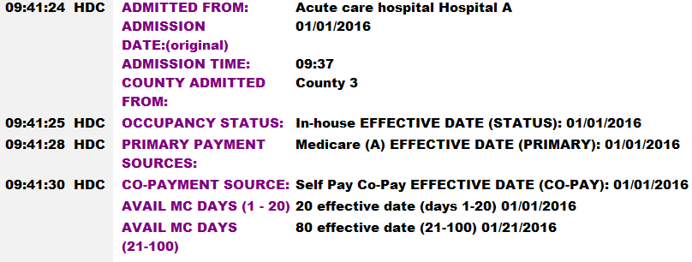

##### Upon discharge the entries would look like this

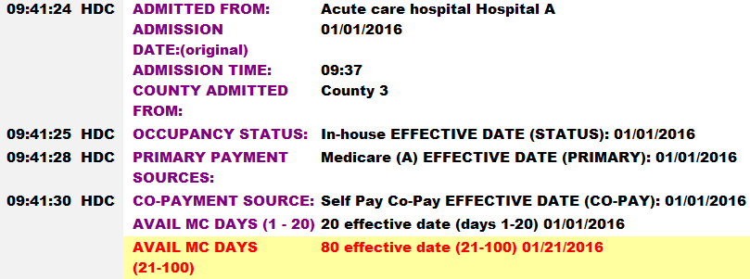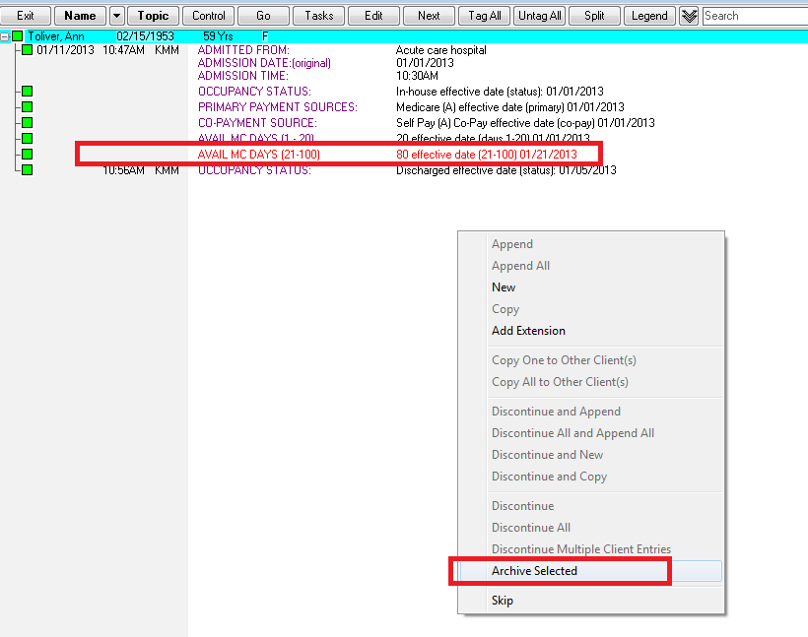

We archive the Avail MC Days 21-100 because they have an effective date in the future which is no longer accurate.

##### Upon Re-Admit their entries would look like this

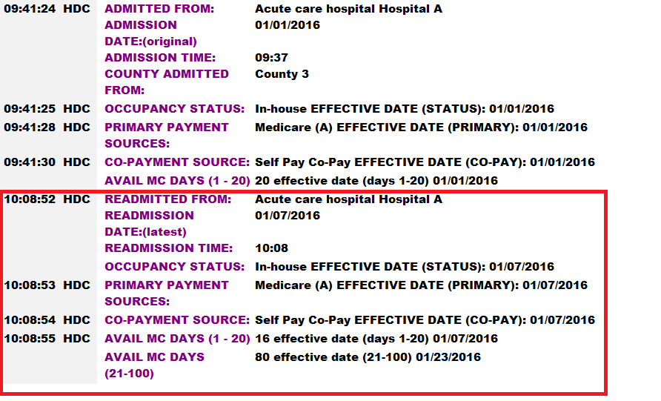Note that the original entry for Avail MC Days 21-100 is no longer visible as it has been archived.

## Documenting Room Numbers

Each client in your facility must have a room number documented along with the date they moved into the room.

1. From the **Main Menu**, click the **ADT/Face Sheet** button.
2. Under the face sheet column heading, click the **Rooms** button (if you have several different services at your facility, click the rooms button underneath the appropriate service).
3. Select the client.
4. Click **OK**.
5. Select the appropriate room number.
6. Select the effective date the client moved into this room.
7. Click **OK**.
8. Click **Save**.
9. Click **Exit** to return to the ADT/Face Sheet screen.

### Running a Report to show Status and Rooms Information

There is a report in ECS called the Daily Census. The Daily Census Report will show you the resident’s Occupancy Status, Primary Payment Source, Level of Service and Room. These are the items that must be balanced for all clients. The Daily Census report has group totals at the bottom for Billable Days, Primary Payer Sources, Levels of Service, and Rooms. Each client must have these items charted, therefore the Group Totals on the bottom of this report should always equal.

1. From the **Main Menu**, click the **ADT/Face Sheet** button.
2. Under the Reports column heading, click the **Calendar Reports** button.
3. Click the **Daily Census Report** from either the **Current Month** or **Last Month** column.
4. Click the **Select All** button to select all clients or select individual client names.
5. Click **OK**.
6. Click **Exit** when finished viewing the calendar.

## Documenting Insurance Profile Information

The Insurance Profile folder is used to document insurance information including Insurance company name and policy numbers. This information is used when creating UB04s and any other financial form.

1. From the **Main Menu**, click the **ADT/Face Sheet** button.
2. Under the face sheet column heading (or shared column heading), click the **Insurance Profile** button.
3. Select the client.
4. Click **OK**.
5. Select the appropriate insurance company and enter the effective date and policy number when prompted to do so.
6. Click onto any of the other words that are necessary such as group name or scanning in of the insurance card.
7. Click **Save**.
8. Click **Exit** to return to the ADT/Face Sheet screen.

### Running a Report to show Insurance Information

There is a report that will allow you to show all clients and the insurance information that has been entered into ECS.

1. From the **Main Menu**, click the **ADT/Face Sheet** button.
2. Under the Reports column heading, click the **Insurance Profile** button.
3. Click the **Select All** button to select all clients or select individual client names.
4. Click **OK**.
5. Click **Exit** when finished viewing the report.

## Documenting Contact Information

The Financial Responsible Party is the name who will receive the client’s Self Pay invoice and trust account statements.

1. From the **Main Menu**, click the **ADT/Face Sheet** button.
2. Under the face sheet column heading (or shared column heading), click the **Contacts** button.
3. Select the client.
4. Click **OK**.
5. Click the word called **CONTACT NAME**. Follow through all the prompts documenting the contact’s address, city, state, zip, and phone number.
6. Specify any responsibility that the contact may have, such as durable POA or legal guardian.
7. Tag the contact with all necessary contact types, selecting all that apply from the list (Primary Contact, Financial Contact, Health Care Contact, etc.).
8. Specify the relationship and method of contact.
9. Start over with **CONTACT NAME** to enter in the next contact.
10. Click **Save**.
11. Click **Exit** to return to the ADT/Face Sheet screen.

##### Example of a Correctly Documented Contact

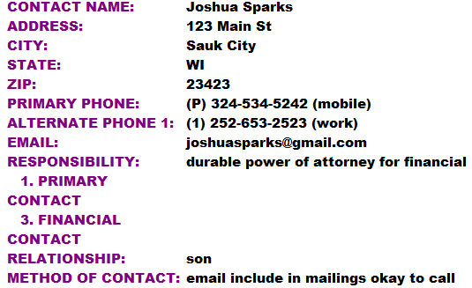

🕭This screen is meant to be documented from left to right for **each** different contact name. For the contacts to populate all the reports correctly, each contact type tag can only be used one time on each client. For example, this means that each client can only have one financial responsible party and one health care responsible party.

### Running a Report to show Contact Information

There is a report that will allow you to show all clients and financial responsible party.

1. From the **Main Menu**, click the **ADT/Face Sheet** button.
2. Under the Reports column heading, click the **Contacts** button.
3. Click the **Select All** button to select all clients or select individual client names.
4. Click **OK**.
5. Click **Exit** when finished viewing the report.

## Documenting Physician Information

Physician information is entered as it is needed to produce billing forms such as the UB04 and HCFA 1500.

1. From the **Main Menu**, click the **ADT/Face Sheet** button.
2. Under the face sheet column heading (or shared column heading), click the **Physician** button.
3. Select the client.
4. Click **OK**.
5. Click onto the Physician’s name.
6. Click **Save**.
7. Click **Exit** to return to the ADT/Face Sheet screen.

### Running a Report to show Physician Information

There is a report that will allow you to show all clients and the insurance information that has been entered into ECS.

1. From the **Main Menu**, click the **ADT/Face Sheet** button.
2. Under the Reports column heading, click the **Physician** button.
3. Click the **Select All** button to select all clients or select individual client names.
4. Click **OK**.
5. Click **Exit** when finished viewing the report.

# Ancillary Charges

For ECS to calculate and post charges, you must document what each client will be billed for. Typically, charges are documented in the Ancillary Charges and Therapy Administered folders, however charges can be recorded in any location within ECS and linked to billing.

## Documenting Ancillary Charges

In the Ancillary Charges folder, you can document a client’s additional charges. These may be charges that appear on any type of billing. Charges that are generally found here include Pharmacy, Laboratory, Radiology, Oxygen, Medical Supplies, and any additional charges you may bill for.

There are various ways you can enter charges into ECS. During your initial setup we will determine how items are billed and how you would like to enter them into ECS. You will have the same options to choose form for each type of ancillary to be billed. The options you have are as follows:

* An ***Enter Dollar Amount*** charge is a charge that you will be prompted to enter the amount of the charge. This is because the amount and date may vary per person and per month.
* A ***Set Value*** charge is one where you will chart that they had the service and on what date and the system has been pre-set to know the rate that should be charged.
* An ***Enter Quantity*** charge is one where you will be prompted to enter in the number of units to be billed and the system will have been pre-set with the per unit rate to be charged.
* A ***Recurring Service*** is a charge that will be billed each month until you tell the system to stop billing the client, or until the resident discharges. You do not have to document the charge each month; you must tell the system when to start billing the charge and when to stop billing the charge. Services can be recurring daily or monthly.

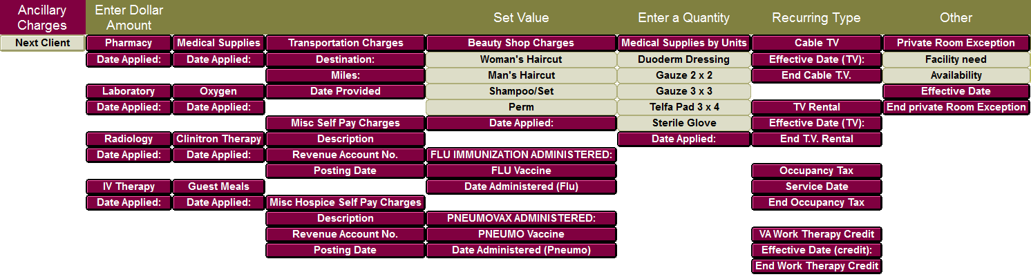

1. From the **Main Menu**, click the **Ancillary Charges** button.
2. Click into the **Ancillary Charges** button underneath the appropriate service heading.
3. Select which name(s) to enter ancillary charges on.
4. Click **OK.**
5. If the heading says **Enter Dollar Amount**.
   1. Click the word of the charge you would like to create.
   2. Type in the dollar amount of the charge.
   3. Click **OK**.
   4. Choose the date the charge is to be applied. This date must one that the client was documented as Inhouse.
   5. Click **OK**.
6. If the heading says **Set Value**.
   1. Click the word of the charge you would like to create.
   2. Choose the date the charge is to be applied. This date must one that the client was documented as Inhouse.
   3. Click **OK**.
7. If the heading says **Enter a Quantity.**
   1. Click the word of the charge you would like to create.
   2. Enter the number of units to be billed.
   3. Click **OK.**
   4. Choose the date the charge is to be applied. This date must one that the client was documented as Inhouse.
   5. Click **OK.**
8. If the heading says **Recurring**.
   1. Click the word of the charge you would like to create.
   2. Choose the date to start billing that service.
   3. Click **OK**.
9. Click **Save** or click the client arrow button to go to the next client.
10. Click **Exit** to return to the Ancillary Charges screen.

### Private Room Exception

If your facility charges additional rates for a client staying in a private room, you will have the **Private Room Exception** listed in your Ancillary Charges folder. If a client is in a private room, but should not be charged the additional private surcharge, for any reason, you need to document the word Private Room Exception. This will tell ECS that although the client is in a private room, that it should not bill the additional charge. The Private Room Exception must also have an effective date documented.

### Reports to Run to Show Ancillary Charges Documented

The reports that you may run to show the Ancillary Charges that have been entered may vary depending on your facility specific setups. Reports may be displayed as financial reports and/or as calendar reports.

#### Running Ancillary Charges Documented Report

The financial report allows you to see charges that are entered as a dollar amount, set value, or quantity. They will not display recurring charges.

1. From the **Ancillary Charges** screen, click the **Ancillary Reports** button.
2. Click onto the **Ancillary Charges Documented** from either the **Last Month** or **Current Month** column.
3. Select the client(s) you would like to run the report on.
4. Click **OK**.
5. Click **Exit** to return to the Ancillary Reports screen.

#### Running Recurring Ancillary Charges Calendar

The calendar allows you to show how many days a client had an ancillary or it may show you the dollar amount of the ancillary. If you have any recurring charges, you will want to run a calendar report to show what days the client will be charged.

1. From the **Ancillary Charges** screen, click the **Ancillary Reports** button.
2. Click onto the **Recurring Services Calendar** from either the **Last Month** or **Current Month** column.
3. Select the client(s) you would like to run the report on.
4. Click **OK**.
5. Click **Exit** to return to the Ancillary Reports screen.

## Documenting Therapy Charges

Therapy charges are generally documented by your therapy department. The business office may have access to the therapy charting, but most likely your therapists are documenting, or you are importing from the therapy company’s program. In the case that the business office does have to document therapy treatments, instructions may be followed starting below.

### To Document an Evaluation

1. From the **Main Menu**, click the **Ancillary Charges** button.
2. Click the **Therapy** button.
3. Under the charting column click the button called **OT**, **PT**, or **SLP**.
4. Select the client(s).
5. Click **OK**.
6. Click the **EVAL** word.
7. Enter the number of minutes the service was performed.
8. Click **OK**.
9. Enter the **Date of Service**.
10. Click **OK**.
11. Click **Save**.
12. Click **Exit** to return to the Therapy screen.

### To Document a Treatment that is a Service HCPCS code

1. From the **Main Menu**, click the **Ancillary Charges** button.
2. Click the **Therapy** button.
3. Under the charting column click the button called **OT**, **PT**, or **SLP**.
4. Select the client(s).
5. Click **OK**.
6. Click the **SERVICE CODES** word.
7. Select the **HCPCS code** defining the treatment given.
8. Click the button to identify whether these **were Individual Minutes, Concurrent Minutes**, or **Group Minutes**.
9. Enter the number of minutes the service was performed.
10. Click **OK**.
11. Enter the **Date of Service**.
12. Click **OK**.
13. Click **Save**.
14. Click **Exit** to return to the Therapy screen.

### To Document a Treatment that is a Timed HCPCS code

1. From the **Main Menu**, click the **Ancillary Charges** button.
2. Click the **Therapy** button.
3. Under the charting column click the button called **OT**, **PT**, or **SLP**.
4. Select the client(s).
5. Click **OK**.
6. Click the **TIMED CODES** word.
7. Select the **HCPCS code** defining the treatment given.
8. Enter the number of minutes the service was performed.
9. Click the button that coincides with the number of minutes you entered to appropriately calculate the number of units.
10. Enter the **Date of Service**.
11. Click **OK**.
12. Click **Save**.
13. Click **Exit** to return to the Therapy screen.

### Documenting Onset, Start of Care, and Plan Reviewed Dates

Typically, your therapists will enter this information into ECS and it will pull directly from the therapy charting onto your financial billing forms. The Onset and Start of Care Dates are entered in the Therapy tab in the PT Eval, OT Eval, and ST Eval folders.

These dates are set to pull the following codes to your Medicare (B) UB04s in field 31-34:

* Onset Date produces an 11 code
* Start of Care Date produces
  + 29 code for PT
  + 17 code for OT
  + 30 code for SLP
* Planned Review Date updates
  + 29 code for PT
  + 17 code for OT
  + 30 code for SLP

#### To Document and/or View Plan Onset/Start of Care Dates

1. From the **Main Menu**, click the **Ancillary Charges** button.
2. Click the **Therapy** button.
3. Under the charting column click the button called **OT/PT/SLP Onset SOC Diagnosis**.
4. Select the client(s).
5. Click **OK**.
6. If the date(s) are not found in the view section of the screen below, click the necessary gray button in the top portion of the screen (either for ONSET DATE or SOC DATE).
7. Select the date.
8. Click **OK**.
9. Click **Save**.
10. Click **Exit** to return to the Therapy screen.

#### To Document and/or View Plan Review Date Charting

1. From the **Main Menu**, click the **Ancillary Charges** button.
2. Click the **Therapy** button.
3. Under the charting column click the button called **OT/PT/SLP Plan Review Date**.
4. Select the client(s).
5. Click **OK**.
6. If the date is not found in the view section of the screen below, click the **Plan Reviewed Date** button.
7. Select the date.
8. Click **OK**.
9. Click **Save**.
10. Click **Exit** to return to the Therapy screen.

### Running Reports to Show Therapy Charges

There are therapy reports that can be run to show what treatments were documented, the number of units, and minutes.

#### Running the Therapy Log Report

1. From the **Main Menu**, click the **Ancillary Charges** button.
2. Click the **Therapy** button.
3. From the **Reports** column, click the **Therapy Log** button for the discipline you would like to view.
4. Select the client(s) you would like to run the report for.
5. Select the date range.
6. Click **OK**.
7. Click **Exit** when done viewing the report to return to the Therapy screen.

#### Running the Therapy Log Calendar

1. From the **Main Menu**, click the **Ancillary Charges** button.
2. Click the **Therapy** button.
3. From the **Reports** column, click the **Therapy Log - Calendar** button.
4. Select the client(s) you would like to run the report for.
5. Click **OK**.
6. Click **Exit** when done viewing the calendar to return to the Therapy screen.
   * This report will default to *Last Month* dates. Should you need to run it for different dates, click the **Control** button. Select a new **Date Range** and click **OK**.

# Calendar

The Calendar is a record of events that have been documented within the ECS System. Words must be set up as “Calendar words” to appear on the calendar. These calendar words must be documented, for the appropriate dates, and these words must appear on the calendar, for the billing to be accurate. Each Payment Source has specific words that are required to appear on the calendar for charges to be produced. If an invoice does not calculate correctly, there is a good chance that the calendar requirements have not been met for this client.

The very first step to ensure accurate billing in ECS is to run a Daily Census calendar report on all clients in your facility. Running the calendar reports will allow you to check the accuracy of your documenting, before you begin calculating charges each period.

## Daily Census Calendar

The Daily Census calendar report contains all the Status information that must be charted and kept up to date on all clients. Typically, this task includes Occupancy Status, Primary Payment Source, Level of Service, and Room number. The totals at the bottom of this report should always equal. The specific items in this task may be modified to meet the needs of your facility.

1. From the **Main Menu**, click the **Calendar** button.
2. Select the **Daily Census button** (either from the Last Month or Current Month column).
3. Select all clients.
4. Click **OK**.

Along the left-hand side of your screen, you will see the Name, the Topic, the name of the Event, and the total number of days that the event took place. The items listed in the Event column are determined by the items in the task setup. Going across the screen, you will see a column for each day of the month.

If an **x** is indicated in a column, the event took place on that day for that client. If you have questions about an **x**, double-click the **x** to see what was documented.

There are group totals at the bottom of the Daily Census Calendar as well as each “Requirements” calendar. These group totals must equal for your billing to be accurate.

## Troubleshooting Calendar Issues

When the group totals are not in balance the billing will not be accurate. The Group Totals will not balance if charting in the Status Topic was done incorrectly or was missed completely. You must determine which resident has inaccurate or missing charting.

### Show Unbalanced Only

Show Unbalanced Only is a checkbox at the top of the Calendar report screen that may be checked to assist with determining which resident is off and why. If your Group Totals do not match, you may place a checkmark in the Show Unbalanced Only checkbox and the Calendar will change to show you only the name of those residents who’s Group Totals do not balance. You may also click the Analyze button at the top of the screen to help determine what is off on each resident listed. To get back to the list of all names, un-check the Show Unbalanced Only checkbox.

For Show Unbalanced Only to work, there are a few conditions that need to be met on your calendar report.

* On the Control screen, you must have “Warn if Group Totals Not Equal” checked.
* Your Calendar Report must have Group Totals on it.
* The recommended setting is to have Show Names Without Data unchecked or anyone with no data at all will appear as unbalanced.

## Printing the Calendar

You can generate a printed copy of the calendar report that is displayed in the screen. The report will print exactly as it is displayed on the screen.

1. 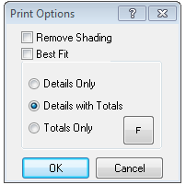While you have the calendar report displayed, click the **Print** button on the toolbar. The print options screen will then appear.
2. You will have the following printing options:
   1. **Remove Column Shading** – this removes the shading from the printout.
   2. **Details** – prints just the details section of the report without any totals.
   3. **Details with Totals** – prints everything you see on the screen, details, and totals.
   4. **Totals Only** – prints just the totals section and any group totals that are set.
   5. **F** – changes the font of the printout (changing the font may mean the report prints on multiple pages.
3. Click **OK**.

## Exporting the Calendar

You also can export a copy of the calendar report that you see on the screen.

1. While you have the calendar report displayed, click the **Export** button on the toolbar.
2. A Save File As dialog box will appear which allows you to name the file and save it to the location that you would like.
3. Click **OK** when finished.

# General Accounts Receivable Information

Once your system has been completely set up, you will be able to generate bills. In ECS you must document what charges needs to be billed. Then you will calculate and post the charges. Once the charges have been calculated and posted, you are able to print any financial forms necessary.

## Calculate Control Screen

From the Billing Access screens you will be taken directly to the calculating screen of the associated payer. If you click the Control button on the toolbar of the calculating screen you will be brought back to the Calculate Control screen.

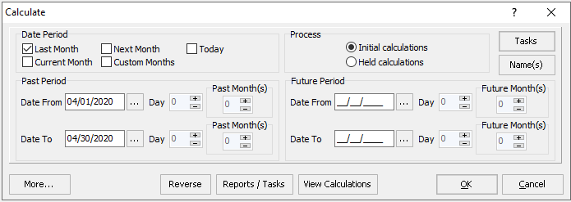

The information on the calculate control screen will automatically populate based on the button that you click on and the task that is then loaded.

### Calculate Control Screen Guide

|  |  |
| --- | --- |
| Section | Definition |
| **Tasks Button** | Allows you to select a pre-defined task, which will be used to calculate charges |
| **Name(s) Button** | Allows you to select which clients you will be calculating charges for. |
| **Date Period**  **Past Period** | These checkboxes are used to determine the default dates of the Past and Future Periods.  The past period deals with post billing of services. |
| **Future Period** | The future period deals with pre-billing of services. |
| **Process** | You have two choices in the process section. If you select **Initial Calculations**, you are indicating to the system that you wish to process any new information for the selected clients. If you select **Held Calculations**, you are indicating that you want to review or process invoice information that has been held but not yet posted. |
| **More…**  **Reverse**  **Reports/Tasks**  **View Calculations Button** | The More button expands the screen to display additional setups for the task.  The Reverse button will allow you to see all Posted Calculations. You may select multiple calculations here and Reverse them all at the same time.  The Reports/Tasks button displays any reports or other tasks linked to the calculation task. These reports/tasks run automatically.  The View Calculations button will show you any invoices currently in the system and what their status is. You can print this screen, delete Held invoices, or view Posted invoices. |

### View Calculations Button

The View Calculations button will show you all calculations in the system and what their status is. You can print this screen, delete Held calculations from this screen, or view Posted calculations from this screen. When you have finished viewing the information, click **Cancel** to return to the Calculate control screen.

#### To View All Calculations for a Resident or if you are unsure of which Payer Source they were generated under

1. From the **Main Menu**, click the **Billing** button.
2. Click the **View Calculations** button from the column labeled All.
3. Click the **Name(s)** button.
4. Select the name(s) and click **OK**.
5. Click the **View Calculations** button.

#### To View Calculations for a Resident for a specific Payer Source

1. From the **Main Menu**, click the **Billing** button.
2. Click the button associated with the Payer Source you want to view (Self Pay for example.)
3. Click the **View** **Calculations** button.

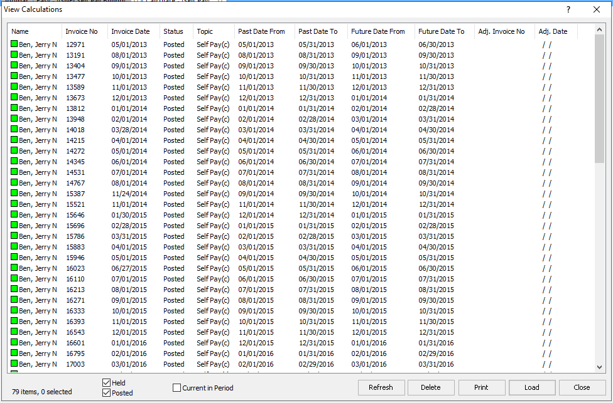

The screen will show you what invoices have been calculated and placed on hold or posted. If an invoice is not listed here, it has not been calculated within ECS.

### Held Calculation

A held calculation is the status of an invoice when charges have been calculated and placed on hold but have not yet been posted. Charges on a held calculation do not appear on the View Entries, Receipts/Adjustments, or Aging screen, and are not written to the Interface files. They are on hold for you to determine if they are correct prior to posting. If they are correct you may post them. If they are incorrect, you may delete the held calculation, make changes, and recalculate.

Click this link to find instructions on Deleting a Held Calculation. (Deleting a Held Calculation)

### Posted Calculation

A posted calculation is one where charges have been calculated and posted. When a calculation is posted, the charges are written to the View Entries screen, the Receipts/Adjustments screen, the Aging screen, and the Interface files. Once the charges have been posted, you must Reverse the calculation in order to make any changes to the charges.

Click this link to find instructions for Reversing a Posted Calculation. (Reversing a Posted Calculation)

## The Calculating Screen

The calculating screens are used to process your charges. The screen will change based on the type of charges you are processing. You will see the client’s name in the second blue title bar on the screen. The name will change as the system continues processing the client invoices. There will be a dialog box in the middle of the screen with an hourglass turning until the calculations are done.

The buttons that on the calculating screen will be active based on the function you are performing. Only those buttons that are highlighted are active. If they are grayed out they are not active during the function you are performing.

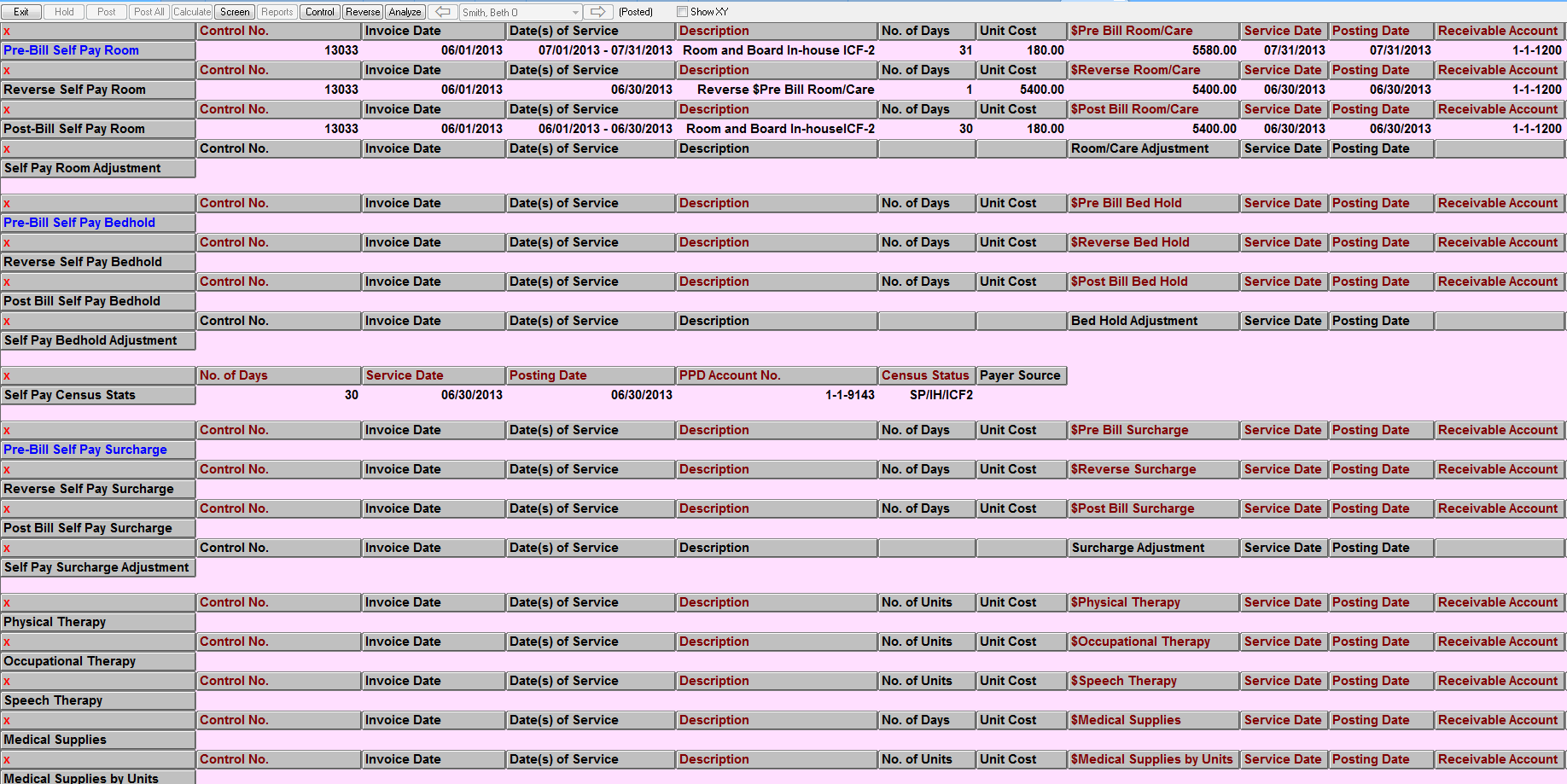

### Calculation Screen Buttons

|  |  |
| --- | --- |
| **Button** | **Description** |
| **Exit** | Allows you to exit the calculation screen and return to the primary ECS screen. |
| **Hold** | Places the current invoice on hold prior to posting. This means that the invoice is saved in the system for you to review but has not yet been posted. If changes need to be made to a held invoice, you must delete the invoice and recalculate it. |
| **Post** | Posts the data on the current invoice to the appropriate files. |
| **Post All** | Posts all invoices in this group to the appropriate files. |
| **Calculate** | If you selected “No” when asked if you wish to process all selected clients and place the results on hold, you will have to click Calculate to calculate each client’s invoice individually. This is also true if you are calculating only one client. |
| **Screen** | Re-calculates all screen calculations and refreshes the screen. |
| **Reports** | Allows you to preview held reports that will display a summary of all charges that were calculated and placed on hold. These reports will preview automatically for you if you have multiple names selected that have gone on hold. This button can be used if you accidentally close the report and need to look at it again or if you are working on one name at a time. |
| **Control** | Takes you back to the calculate control screen without having to exit the billing area. |
| **<<** | Changes the screen to display the name immediately preceding the one you are currently viewing. |
| **>>** | Changes the screen to display the name immediately following the one that you are currently viewing. |
| **Reverse** | Will reverse the selected invoice. |
| **Analyze** | Allows you to analyze why a charge has not calculated correctly. |

## Posting Charges

You have two options on the calculating screen, you can click Post, which will post only the charges for the client currently on the screen, or you can click Post All, which will post the charges for all selected clients.

### Posting Charges

1. If you have reviewed the calculations, click the **Post All** button. The system will ask if you are sure.
2. If you are sure you want to proceed, click **Yes**.
3. The system will post all of the applicable charges to the client’s account.
4. When the posting is complete, a log will appear on your screen.
   1. If the log states “No Problems,” all charges posted correctly. You may click **Close**.
   2. If your log lists names and says that there are errors, those charges will remain on hold until the errors are fixed. If you have errors click the following link to help determine what is causing the error. (Interface Errors on the Calculating Screen)
5. If you completed the billing that is needed, click the **Exit** button in the upper left hand corner of your screen.
6. A posted billing summary will appear. This is a summary of everything that was posted during this process only. This report may be printed, saved as a PDF, or exported.

## Printing/Exporting/Saving a Report

Financial reports generate may preview automatically from your calculating screens. These reports can be re-printed and/or additional reports can be previewed from several locations throughout ECS.

ECS currently uses Adobe Acrobat Reader to manage printing. If you have Adobe installed on your computer, you will get an Adobe toolbar. You may manage the icons on this toolbar by right-clicking and choosing More Tools.

If you do not have Adobe Acrobat Reader installed on your computer you will get a toolbar created by ECS.

### Printing a Report

1. Once you have the financial report previewed, click the **printer** icon to print the report. A print properties screen will appear for you to determine what pages to print, what printer to print on, how many copies you want to print, etc.
2. Click **OK** to print.

### Exporting a Report

1. Once you have the financial report previewed, click the **Export** button to export the report.
2. Select the location of where you would like to save the file and enter a file name.
3. Click **Save**. This file may now be opened with Excel.

### Saving a Report as a PDF

1. Once you have the financial report previewed, click the **Save** **a copy** icon to print the report.
2. Select the location of where you would like to save the file and enter a file name.
3. Click **Save**.

## Receipts/Adjustments Control Screen

The Receipts/Adjustments screen is used for posting cash and in some cases doing adjustments. You will have buttons on your Access screens for loading the appropriate charges. From the Receipts/Adjustments screen if you click the Control button on the toolbar you will see the Receipts/Adjustments Control Screen.

### Receipt/Adjustment Screen Buttons

|  |  |
| --- | --- |
| **Button** | **Description** |
| **Purpose** | **Reverse:** used to reverse an incorrect payment or adjustment.  **Cash Receipts:** shows charges that have not been paid in full.  **Adjustments:** used to adjust an account.  **Apply Credits:** used to apply credit from a charge that has been overpaid to a charge that has not been paid yet.  **Display All:** place a checkmark here if you want to display all account activity. This will display unpaid and fully paid charges. |
| **Date** | Allows you to select what period you would like to see charges for. You may narrow the charges/payments by Posting Date, Transaction Date, or Service Date if you like. |
| **Date Period** | Enter a date range to see charges for a period. If there is no date range entered, you will see all outstanding charges regardless of dates. |

## The Receipts/Adjustment Screen

This is the actual screen where you will see the outstanding charges owed by each client. This is where you will post the cash payments.

### Receipts/Adjustments Screen Buttons

|  |  |
| --- | --- |
| **Button** | **Description** |
| **Exit** | Allows you to exit the calculation screen and return to the primary ECS screen. |
| **Control** | Takes you the Receipts/Adjustments control screen where you can change the processing options of the screen. |
| **Name(s)** | Allows the user to select different names. |
| **Post All** | Posts all cash or adjustments that are highlighted in red. |
| **Refresh** | Refreshes the screen back to its original state without posting. |
| **Apply Credits** | This button is used once you have highlighted the lines that have credits and then the lines that you would like to apply the credits to. |
| **Reverse** | Allows you to reverse a cash payment or adjustment from the account. You may only reverse an item if the period the date paid is in is not locked. |
| **Print** | Allows you to print the Receipts/Adjustments screen. |
| **View** | Allows you to view the selected information. This button must have information set up on the control screen to work. |
| **Write** | Allows you to write entries in the selected topics (such as collection notes). This button must have information set up on the control screen to work. |
| **Export** | The export button allows you to export the data on this screen. |
| **Search** | The Search box allows you to search the Receipts/Adjustments screen. This could be used to search for an amount, or reference, or date paid, or control no. or any data on this screen. Enter the data into the Search box and click the magnifying glass button to search. To continue searching, click the arrow to the right. The cursor will move to each item that matches the search criteria. |
| **Reference** | This is where you enter a reference to the payment or adjustment being received. This field holds 40 characters and can be numbers and/or letters. |
| **Fixed Reference** | Placing a checkmark in this field will keep the reference you typed in. You will not have to re-enter the reference. For example, when doing a Medicaid Remit, you may enter the same Remit number for all names. |
| **Auto Account** | The Auto Account checkbox allows you to do adjustments to multiple lines on the Receipts/Adjustments screen and utilize the same account number for all lines. Once you select the account number the first time, it will continue to utilize this account number for all adjustments done until you Post All, Refresh, or un-check Auto Account. |
| **Date Paid** | The date that you would like the cash or adjustments posted to. |
| **Target Amount** | This field can be filled in with the total of the deposit. If this field is used, you will not be able to post until the amount field equals the field. |
| **Amount** | This filed will increment each time you click on a line to keep a running total. |
| **Remainder** | The remainder field is the difference between the target amount field and the amount field. |
| **Equal Amount** | By default, this button is selected. This means that when you click on a line it will apply a payment or adjustment equal to the remaining outstanding balance on that line. |
| **Unequal Amount** | This button is used if you need to post a payment or adjustment that does not equal the remaining outstanding balance on that line. |

# Beginning Balances

Beginning Balances are done one time at the beginning of your ECS implementation. They will start your Accounts Receivable in ECS with an aging that matches the aging from your current billing system.

Once you have all the setups in place, you are ready to enter Beginning Balances. You will start by determining what date you will enter beginning balances for and what payer type the beginning balance should be entered for.

* Your beginning balances will be up to the month end prior to your go live in ECS. For example, if your go live is January 1, 2020, your beginning balances will end as of 12/31/2020.
* Balances should not include any pre-bill charges for your go live month. In the example above, you would not include any January 2020 pre-bills in your beginning balances.
* A client may have beginning balance amounts in multiple pay sources. For example, a resident may have a Medicaid beginning balance as well as a Self Pay beginning balance. These are considered two separate beginning balances.
* If you would like to age your beginning balances, you may also have multiple balances for the same payer source with different dates. For example, you may have outstanding balances with dates of October 31, November 30, and December 31.

You may have clients that have outstanding balances that are no longer in your facility. These clients should have some minimum charting in their Face Sheet to assist with collecting their balances:

1. An occupancy status of discharged,
2. Financial responsible party charted,
3. Medicare and/or Medicaid number entered in their ID,
4. Insurance company charted if appropriate.

🕭**Please talk with a Financial Training Consultant at American Data prior to entering any balances.**

## Entering Beginning Balances

1. From the **Main Menu**, click the **Beginning Balances** button.
2. Click the Enter **Beginning Balances** button.
   1. Depending on the access screen you are using, you may then need to click the Enter Beginning Balances button under the appropriate service heading.
3. Click **Filter** on the name selection screen.
4. Filter for **Active**, **Hold**, and **Inactive** names for just the **Site/Service** that you are entering balances for.
5. Click **Select All** to select all names.
6. Click **OK.**
7. Click the button word that would describe the payer source of the client’s beginning balance.
8. Type in the dollar amount of the balance.
9. Click **OK**.

* If the beginning balance is a credit, enter a “-“ (minus sign) in front of the dollar amount to show a credit.

1. The date applied will automatically pop up for you. Select the date that the beginning balances should be applied.
2. Click **OK**.
3. Click the **Client>>** button to move to the next client or the Save button to save the entry. If a client has multiple beginning balances, enter the additional beginning balances, and click the **Client>>** button when you are ready to move to the next client.
4. Repeat these steps until all the clients beginning balances have been entered.
5. When you have finished, click the **Save** button and click the **Exit** button.

## Print Beginning Balances Report

Once you have entered all the beginning balances, print, or save a copy for your records. This will allow you to check the accuracy of the entries, to make sure you have entered the correct dollar amounts and have entered them in the correct payer types.

1. From the **Beginning Balances** screen, click the **Beginning Balances Entered** button.
   1. Depending on the access screen you are using, you may need to go back to the previous access screen and click the **Reports** button first.
2. Select all names.
3. Click **OK**.

You should now see a list of all beginning balances that you entered. You must verify that all balances that you entered are on this report, and that they are all in the correct payer source. If they are all correct, you are ready to begin calculating and posting beginning balances. You will want to keep this report as part of your beginning balance history in ECS.

### If an Entry is Incorrect

1. Return to the **Beginning Balances** screen.
2. Click the **Enter Beginning Balances** button.
3. Select the appropriate name.
4. Click **OK**.
5. At the bottom of the screen, highlight the incorrect beginning balance entry. It will turn red when it has been selected.
6. Click the **Edit** button and choose **Archive Selected**.
7. Click **Yes** to the prompt to continue. The entry will be archived from the system; however, it will continue to show on the screen until you click Go which refreshes it.

This has archived the incorrect entry. You may now enter the correct beginning balance. You must then go back to the Beginning Balances Entered report and re-run it.

## Calculating Beginning Balances

The process of calculating beginning balances attaches the Receivable Account and Cash Account numbers to the dollar amounts that have been entered. This calculating process is what creates the aging in ECS. You will only perform this calculation once.

1. From the **Main Menu**, click the **Beginning Balances** button.
2. Click on the **Calculate/Post** button.
3. When the Calculate control screen appears, you will need to adjust the date ranges.
4. In the **Past Period Date From**, click the button to the right of the field and select the date that you entered as the Date Applied for the earliest beginning balance.
5. Click **OK**.
6. In the **Past Period Date To**, click the button to the right of the field and select the last day of the month with latest beginning balances.
7. Click **OK**.
8. Click **OK** on the bottom of the Calculate control screen.
9. Click **Yes** to process and hold on all clients.

The system is going to calculate the beginning balances and attach the receivable account number, revenue account number, and cash account number to the dollar values.

You should review the data that has put on hold to verify everything has calculated correctly. Held Billing Summary report(s) will display automatically once you are done calculating. These reports should tie back to the Beginning Balances Entered report(s) you printed to start.

1. If the reports match (Beginning Balances (Held) and Beginning Balances Entered), close the report preview screen by clicking the **Exit** button.
2. On the calculating screen, click the **Post All** button.
3. Click **Yes** when you are prompted if you want to post all.

* If the balances are not correct, you must delete the held calculations, correct the documenting, and recalculate the charges. Refer to the section in the manual on deleting held invoices for instructions. (Deleting a Held Calculation)

When the system is finished posting, you will get a log. If there are any errors, you will see the errors listed in the log. If everything posted successfully, you would get a blank log that says ‘No Problems.’ If your log has client names with errors, you will need to contact the American Data Financial Support to help you.

1. If the reports are correct, you should print/save the report as part of your beginning balance history in ECS. Then click **Exit** to close out of the report.

# Self Pay Billing

The Self Pay billing processes calculates charges for two months. It allows you to pre-bill an estimate of charges for the upcoming month as well as post-bill any room and board adjustments and ancillary charges incurred in the previous month. As the system pre-bills an estimated charge, the following month the system will reverse the estimated charge, and post-bill what has occurred.

The Self Pay calculations must be run on all clients. This ensures that all clients regardless of payer source have all possible Self Pay charges generated.

Payments that you would like to be reflected on a Self Pay statement (and be factored into the client’s New Balance) must be posted prior to billing Self Pay. Any cash or adjustments that are posted after Self Pay billing has been done will be factored into the next month’s billing.

## Calendar Reports

Prior to billing Self Pay you must make sure all calendar information is accurate. For Self Pay billing to be accurate you should run the calendar report called Self Pay Requirements. This report is generally exactly like the AR Daily Census, unless specific changes have been made at your facility. You must make sure all totals at the bottom of this report equal. Because you likely pre-bill your room and board, you should run the Self Pay Requirements calendar once for the post-bill period and once for the pre-bill period so that you can verify days billed for both periods.

### Self Pay Requirements Calendar

1. From the **Main Menu**, click the **Billing** button.
2. Click the **Self Pay** button.
3. Click the **Self Pay Requirements button** from the **Last Month** column.
4. This will show you the number of room and board days you will be post billing.
5. Select all clients.
6. Click **OK**.
7. Make sure that the **Group Totals** at the bottom of the report are all tied out.
8. Click **Exit** on the calendar.
9. Click the **Self Pay Requirements** from the **Current Month** column.
10. This will show the number of room and board days you will be pre-billing.
11. Select all clients.
12. Click **OK**.
13. Make sure that the **Group Totals** at the bottom of the report are all tied out.
14. Click **Exit**.

## Self Pay Ancillary Charges

You may also want to ensure that all ancillary charges that are to be billed on Self Pay have been entered into ECS.

1. From the Self Pay Billing access screen, click the **Ancillary Charges Documented** buttonfrom the **Last Month** column.
2. Select all names.
3. Click **OK**.

This report will show you just the ancillary charges that will be billed to the Self Pay account.

## Self Pay Recurring Charges

If you have any ancillary charges that are recurring, they will appear on a different report (Calendar Report). You should confirm that all recurring charges have been entered that should be billed.

1. From the Self Pay Billing access screen, click the **Recurring Ancillary Calendar** from the **Last Month** column.
2. Select all names.
3. Click **OK**.

This report will show you just the ancillary charges that will be billed to the Self Pay account.

## Self Pay Therapy Charges

If you bill Therapy to Self Pay residents who do not have any Part (B) Coverage, you will want to ensure that all therapy charges have been entered/imported.

1. From the Self Pay Billing access screen, click the **Therapy Units** buttonfrom the **Last Month** column.
2. Select all names.
3. Click **OK**.

This report will show you just the therapy charges that will be billed to the Self Pay account.

## Calculating Self Pay

1. From the **Self Pay Billing** screen, click the **Self Pay** button underneath the Calculate column.
2. Select all name(s) that are Active, Hold, or Inactive. Every client in your facility has the potential of having Self Pay charges; therefore, you will want to calculate on all names.
3. Click **OK**.
4. The system will provide with a message and ask if you would like to process all clients and place on hold.
5. Click **Yes** if you are ready to process charges for all selected clients. Click **No** if you have corrections that need to be made prior to continuing with this process.

* If you are billing multiple names, the system will automatically calculate and place on hold all selected charged. If you are only billing on name, you will not see the above-mentioned message. You will see the calculation screen and you must manually click the Calculate button.

The system will now calculate charges on all selected name(s).

## Reviewing Calculations

Once the billing process has been completed a Held Billing Summary report will appear. This report will summarize all charges produced and placed on hold during this process only.

Click the following link for steps that should be taken for reviewing the calculations while they are on hold. (Reviewing Calculations)

## Posting Charges

Once you have reviewed the calculation information and determined it to be correct, you are ready to post. Posting the charges sends data to the Journals, to the Receipts/Adjustments screen, and to the View Entries screen. You must post the calculations before you can print statements, financial forms, or aging reports.

Click the following link for steps on Posting Charges. (Posting Charges)

## Printing Self Pay Invoices

The Self Pay Invoice will print a Balance Forward, which is the ending balance from the last statement, any Payments or Adjustments that have been applied since the last Self Pay Invoice was generated, Current Charges that have been applied since the last Self Pay Invoice was generated, and a Total Due at the bottom.

The Responsible Party information that pulls to the Self Pay Invoices should be documented in the Face Sheet tab in the Contacts folder using the tag Financial Responsible Party.

Self Pay Invoices should only be run after running the posted Self Pay Billing Summary report verifying that the charges calculated and posted are correct.

1. From the **Self Pay Billing** screen, click the **Self Pay Bills** button.
2. Select all clients.
3. Click **OK**.
4. The invoices or those clients who have charges, payments, and/or a total balance due will be previewed.
5. Click the print or save icon on the toolbar to print/save the bills.
6. Click **Exit** when finished.

### Re-Print a Self Pay Invoice

There may be times when you may need to reproduce an invoice from a prior period for a client.

1. From the **Self Pay Billing** Access Screen, click the **Self Pay Invoices** button.
2. Select the resident name and click **OK**.
   1. This will generate the most recent Self Pay bill. This can be printed or saved to PDF if needed.
3. If you need a prior invoice, click the **Control** button on the Report Preview screen.
4. Click the **More** button on the right side of the screen.
5. Click the **Special** button.
   1. This will give you a list of every Self Pay invoice generated for this resident.
6. Select the invoice(s) that you would like to re-print.
7. Click **OK**.
8. Click **OK** again.

# Medicaid Billing

The Medicaid calculating screen allows you to calculate charges for Medicaid clients. Medicaid charges are processed for the previous month.

## Calendar Reports

Prior to billing Medicaid, you must make sure all calendar information is accurate. For Medicaid billing to be accurate you should run the calendar report called Medicaid Requirements. This report is exactly like the AR Daily Census, but also includes the client’s liability amounts. If your facility reimburses on State RUGs, it will also include these. You must make sure all Group Totals at the bottom of this report equal.

## Medicaid Requirements Calendar

1. From the **Main Menu**, click the **Billing** button.
2. Click the **Medicaid** button.
3. Select the **Medicaid Requirements** button from the Reports column.
4. Select all clients.
5. Click **OK**.
6. Make sure that the **Group Totals** at the bottom of the report are all tied out. Make sure that you print or keep track of the number of days to tie this back to the days that are billed.
7. Click **Exit**.

## Medicaid Diagnoses Calendar

The Medicaid UB04 requires diagnosis codes to be documented. There is a button on your Medicaid Billing screen called Diagnoses Codes. This button allows you to run a calendar report for your Medicaid clients, prior to generating UB04s to ensure that each client has a diagnosis code charted.

1. From the **Main Menu**, click the **Billing** button.
2. Click the **Medicaid** button.
3. Select the **Diagnoses Codes** button from the Reports column.
4. Select all clients.
5. Click **OK**.
6. In your **Group Totals** area, your **Total Medicaid Days** should tie to the **Total Admission DX** and **Total Primary DX**. This is since the Medicaid UB04 requires these two diagnoses.
7. Click **Exit**.

## Medicaid Ancillary Charges

You may also want to ensure that all ancillary charges that are to be billed on Medicaid have been entered into ECS. This may be ancillary services paid by Medicaid or revenue captured and adjusted off to a contractual adjustment account.

1. From the Medicaid Billing access screen, click the **Ancillary Charges Documented** button.
2. Select all names.
3. Click **OK**.

This report will show you just the ancillary charges that will be billed to the Medicaid account.

## Medicaid Recurring Charges

If you have any ancillary charges that are recurring, they will appear on a different report (Calendar Report). You should confirm that all recurring charges have been entered that should be billed.

1. From the Self Pay Billing access screen, click the **Recurring Ancillary Calendar** from the **Last Month** column.
2. Select all names.
3. Click **OK**.

This report will show you just the ancillary charges that will be billed to the Medicaid account.

## Medicaid Therapy Charges

If you bill Therapy to Medicaid for residents who do not have any Part (B) Coverage, you will want to ensure that all therapy charges have been entered/imported.

1. From the Medicaid Billing access screen, click the **Therapy Units button**.
2. Select all names.
3. Click **OK**.

This report will show you just the therapy charges that will be billed to the Medicaid account.

## Calculating Medicaid

1. From the **Medicaid Billing** screen, click the **Medicaid** button underneath the Calculate column.
2. Click the **Refresh** button on the **Name Selection** screen to return to your default name list (filter down to only SNF if needed).
3. Click **Select All**.
4. Click **OK**.
5. Another **Name Selection** screen will appear with just the names of those listed with Medicaid as their primary payer source for the month that you are billing. Click the **Select All** button.
6. Click **OK**.
7. The system will provide with a message and ask if you would like to process all clients and place on hold.
8. Click **Yes** if you are ready to process charges for all selected clients. Click **No** if you think you may corrections that need to make prior to continuing with this process.

* If you are billing multiple names, the system will automatically calculate and place on hold all selected charged. If you are only billing on name, you will not see the above mentioned message. You will see the calculation screen and you must manually click the Calculate button.

The system will now calculate charges on all selected name(s).

## Reviewing Calculations

Once the billing process has been completed a Held Billing Summary report will appear. This report will summarize all charges produced and placed on hold during this process only.

Click the following link for steps that should be taken for reviewing the calculations while they are on hold. (Reviewing Calculations)

## Posting Charges

Once you have reviewed the calculation information and determined it to be correct, you are ready to post. Posting the charges sends data to the Journals, to the Receipts/Adjustments screen, and to the View Entries screen. You must post the calculations before you can print statements, financial forms, or aging reports.

Click the following link for steps on Posting Charges. (Posting Charges)

## Generating UB04s

Once you have posted your charges you are then able to generate your UB04s. You do not have to generate UB04s before you have locked the month. You may proceed with posting charges for all payer sources if you like prior to generating the UB04s.

Click the following link for steps on Generating UB04s. (Generating UB04s)

## UB04 Electronic Transfer

The ECS system allows you to create individual UB04s that will then be batched together in order to submit them electronically to your intermediary or directly to the appropriate website.

Click the following link for steps on Generating UB04s. (UB04 Electronic Transfer )

# Medicare (A) Billing

The Medicare (A) calculating screen allows you to calculate charges for Medicare (A) clients. Medicare (A) charges are processed for the previous month.

## Calendar Reports

Prior to billing Medicare (A) you must make sure all calendar information is accurate. For Medicare (A) billing to be accurate you should run the calendar report called Medicare (A) Requirements. You must make sure all totals at the bottom of this report equal.

### Medicare (A) Requirements Calendar

1. From the **Main Menu**, click the **Billing** button.
2. Click the **Medicare (A)** button.
3. Select the **Medicare (A) Requirements** button from the Reports column.
4. Select all clients.
5. Click **OK**.
6. Make sure that the **Group Totals** at the bottom of the report are all tied out. Make sure that you print or keep track of the number of days to tie this back to the days that are actually billed.
7. Click **Exit**.

### Medicare (A) Diagnoses Calendar

The Medicare (A) UB04 requires diagnosis codes to be documented. There is a button on your Medicare (A) Billing screen called Diagnoses Codes. This button allows you to run a calendar report for your Medicare (A) clients, prior to generating UB04s to ensure that each client has a diagnosis code charted.

1. From the **Main Menu**, click the **Billing** button.
2. Click the **Medicare (A)** button.
3. Select the **Diagnoses Codes** button from the Reports column.
4. Select all clients.
5. Click **OK**.
6. In your **Group Totals** area, your **Total Medicare (A) Days** should tie to the **Total Admission DX** and **Total Primary DX**. This is due to the fact that the Medicaid UB04 requires these two diagnoses.
7. Click **Exit**.

### Medicare (A) Ancillary Charges

There are also buttons on this screen that allow you to view ancillary charges documented. These can be run following the same steps as above and is just used to make sure charges have been entered.

## Calculating Medicare (A)

1. From the **Medicare (A) Billing** screen, click the **Medicare (A)** button underneath the Calculate column.
2. Click the **Refresh** button on the **Name Selection** screen to return to your default name list (filter down to only SNF if needed).
3. Click **Select All**.
4. Click **OK**.
5. Another **Name Selection** screen will appear with just the names of those listed with Medicare (A) as their primary payer source for the month that you are billing. Click the **Select All** button.
6. Click **OK**.
7. The system will provide with a message and ask if you would like to process all clients and place on hold.
8. Click **Yes** if you are ready to process charges for all selected clients. Click **No** if you think you may corrections that need to make prior to continuing with this process.

* If you are billing multiple names, the system will automatically calculate and place on hold all selected charged. If you are only billing on name, you will not see the above mentioned message. You will see the calculation screen and you must manually click the Calculate button.

The system will now calculate charges on all selected name(s).

## Reviewing Calculations

Once the billing process has been completed a Held Billing Summary report will appear. This report will summarize all charges produced and placed on hold during this process only.

Click the following link for steps that should be taken for reviewing the calculations while they are on hold. (Reviewing Calculations)

## Posting Charges

Once you have reviewed the calculation information and determined it to be correct, you are ready to post. Posting the charges sends data to the Journals, to the Receipts/Adjustments screen, and to the View Entries screen. You must post the calculations before you can print statements, financial forms, or aging reports.

Click the following link for steps on Posting Charges. (Posting Charges)

## Generating UB04s

Once you have posted your charges you are then able to generate your UB04s. You do not have to generate UB04s before you have locked the month. You may proceed with posting charges for all payer sources if you like prior to generating the UB04s.

Click the following link for steps on Generating UB04s. (Generating UB04s)

## UB04 Electronic Transfer

The ECS system allows you to create individual UB04s that will then be batched together in order to submit them electronically to your intermediary or directly to the appropriate website.

Click the following link for steps on Generating UB04s. (UB04 Electronic Transfer )

# Medicare (B) Billing

The Medicare (B) calculating screen allows you create charges for those clients who are eligible for Medicare (B) coverage and have had Medicare (B) eligible services during the month. Typically these include Therapy and Vaccines but there are additional items you may be billing for as well. Medicare (B) charges are processed for the prior month.

## Calendar Reports

Prior to billing Medicare (B) you must make sure all calendar information is accurate. For Medicare (B) billing to be accurate you should run the calendar report called Medicare (B) Requirements. You must make sure all totals at the bottom of this report equal. This report is not used to balance days to be billed; it is simply to verify that anyone who has Medicare (B) also has an Occupancy Status of In house as well as a Co-payment Source.

### Medicare (B) Requirements Calendar

1. From the **Main Menu**, click the **Billing** button.
2. Click the **Medicare (B)** button.
3. Select the **Medicare (B) Requirements** button from the Reports column.
4. Select all clients.
5. Click **OK**.
6. Make sure that the **Group Totals** at the bottom of the report are all tied out. We will be billing for units of service rather than days so there is no need to remember this number for tying back to your Medicare (B) calculation.

## Calculating Medicare (B)

1. From the **Medicare (B) Billing** screen, click the **Medicare (B)** button underneath the Calculate column.
2. Click the **Refresh** button on the **Name Selection** screen to return to your default name list (filter down to only SNF if needed).
3. Click **Select All**.
4. Click **OK**.
5. Another **Name Selection** screen will appear with just the names of those listed with Medicare (B) as their payer source for the month that you are billing. It will also include anyone who is Medicare (B) and had a vaccine charge if you bill vaccines in ECS. Click the **Select All** button.
6. Click **OK**.
7. The system will provide with a message and ask if you would like to process all clients and place on hold.
8. Click **Yes** if you are ready to process charges for all selected clients. Click **No** if you think you may corrections that need to make prior to continuing with this process.

* If you are billing multiple names, the system will automatically calculate and place on hold all selected charged. If you are only billing on name, you will not see the above mentioned message. You will see the calculation screen and you must manually click the Calculate button.

The system will now calculate charges on all selected name(s).

## Reviewing Calculations

Once the billing process has been completed a Held Billing Summary report will appear. This report will summarize all charges produced and placed on hold during this process only.

Click the following link for steps that should be taken for reviewing the calculations while they are on hold. (Reviewing Calculations)

## Posting Charges

Once you have reviewed the calculation information and determined it to be correct, you are ready to post. Posting the charges sends data to the Journals, to the Receipts/Adjustments screen, and to the View Entries screen. You must post the calculations before you can print statements, financial forms, or aging reports.

Click the following link for steps on Posting Charges. (Posting Charges)

## Generating UB04s

Once you have posted your charges you are then able to generate your UB04s. You do not have to generate UB04s before you have locked the month. You may proceed with posting charges for all payer sources if you like prior to generating the UB04s.

Click the following link for steps on Generating UB04s. (Generating UB04s)

## UB04 Electronic Transfer

The ECS system allows you to create individual UB04s that will then be batched together in order to submit them electronically to your intermediary or directly to the appropriate website.

Click the following link for steps on Generating UB04s. (UB04 Electronic Transfer )

# Medicare Advantage (A) Billing

The Medicare Advantage (A) calculating screen allows you to calculate charges for Medicare Advantage (A) clients. Medicare Advantage (A) charges are processed for the previous month. Your billing screen is typically designed similar to a Medicare (A) billing screen with some additional flexibility built in for copays.

## Calendar Reports

Prior to billing Medicare Advantage (A) you must make sure all calendar information is accurate. For Medicare Advantage (A) billing to be accurate you should run the calendar report called Medicare Advantage (A) Requirements. You must make sure all totals at the bottom of this report equal.

### Medicare Advantage (A) Requirements Calendar

1. From the **Main Menu**, click the **Billing** button.
2. Click the **Medicare Advantage (A)** button.
3. Select the **Medicare Advantage (A) Requirements** button from the Reports column.
4. Select all clients.
5. Click **OK**.
6. Make sure that the **Group Totals** at the bottom of the report are all tied out. Make sure that you print or keep track of the number of days to tie this back to the days that are actually billed.
7. Click **Exit**.

### Medicare Advantage (A) Diagnoses Calendar

The Medicare Advantage (A) UB04 requires diagnosis codes to be documented. There is a button on your Medicare Advantage (A) Billing screen called Diagnoses Codes. This button allows you to run a calendar report for your Medicare (A) clients, prior to generating UB04s to ensure that each client has a diagnosis code charted.

1. From the **Main Menu**, click the **Billing** button.
2. Click the **Medicare Advantage (A)** button.
3. Select the **Diagnoses Codes** button from the Reports column.
4. Select all clients.
5. Click **OK**.
6. In your **Group Totals** area, your **Total Medicare Advantage (A) Days** should tie to the **Total Admission DX** and **Total Primary DX**. This is due to the fact that the Medicaid UB04 requires these two diagnoses.
7. Click **Exit**.

### Medicare Advantage (A) Ancillary Charges

There are also buttons on this screen that allow you to view ancillary charges documented. These can be run following the same steps as above and is just used to make sure charges have been entered.

## Calculating Medicare Advantage (A)

1. From the **Medicare Advantage (A) Billing** screen, click the **Medicare Advantage (A)** button underneath the Calculate column.
2. Click the **Refresh** button on the **Name Selection** screen to return to your default name list (filter down to only SNF if needed).
3. Click **Select All**.
4. Click **OK**.
5. Another **Name Selection** screen will appear with just the names of those listed with Medicare (A) as their primary payer source for the month that you are billing. Click the **Select All** button.
6. Click **OK**.
7. The system will provide with a message and ask if you would like to process all clients and place on hold.
8. Click **Yes** if you are ready to process charges for all selected clients. Click **No** if you think you may corrections that need to make prior to continuing with this process.

* If you are billing multiple names, the system will automatically calculate and place on hold all selected charged. If you are only billing on name, you will not see the above mentioned message. You will see the calculation screen and you must manually click the Calculate button.

The system will now calculate charges on all selected name(s).

## Reviewing Calculations

Once the billing process has been completed a Held Billing Summary report will appear. This report will summarize all charges produced and placed on hold during this process only.

Click the following link for steps that should be taken for reviewing the calculations while they are on hold. (Reviewing Calculations)

## Posting Charges

Once you have reviewed the calculation information and determined it to be correct, you are ready to post. Posting the charges sends data to the Journals, to the Receipts/Adjustments screen, and to the View Entries screen. You must post the calculations before you can print statements, financial forms, or aging reports.

Click the following link for steps on Posting Charges. (Posting Charges)

## Generating UB04s

Once you have posted your charges you are then able to generate your UB04s. You do not have to generate UB04s before you have locked the month. You may proceed with posting charges for all payer sources if you like prior to generating the UB04s.

Click the following link for steps on Generating UB04s. (Generating UB04s)

## UB04 Electronic Transfer

The ECS system allows you to create individual UB04s that will then be batched together in order to submit them electronically to your intermediary or directly to the appropriate website.

Click the following link for steps on Generating UB04s. (UB04 Electronic Transfer )

# Medicare Advantage (B) Billing

The Medicare Advantage (B) calculating screen allows you create charges for those clients who are eligible for Medicare Advantage (B) coverage and have had Medicare Advantage (B) eligible services during the month. Typically these include Therapy and Vaccines but there are additional items you may be billing for as well. Medicare Advantage (B) charges are processed for the prior month. This screen is typically set up like your Medicare (B) billing screen with some flexibility built in for copays.

## Calendar Reports

Prior to billing Medicare Advantage (B) you must make sure all calendar information is accurate. For Medicare Advantage (B) billing to be accurate you should run the calendar report called Medicare Advantage (B) Requirements. You must make sure all totals at the bottom of this report equal. This report is not used to balance days to be billed; it is simply to verify that anyone who has Medicare Advantage (B) also has an Occupancy Status of In house as well as a Co-payment Source.

### Medicare (B) Requirements Calendar

1. From the **Main Menu**, click the **Billing** button.
2. Click the **Medicare Advantage (B)** button.
3. Select the **Medicare Advantage (B) Requirements** button from the Reports column.
4. Select all clients.
5. Click **OK**.
6. Make sure that the **Group Totals** at the bottom of the report are all tied out. We will be billing for units of service rather than days so there is no need to remember this number for tying back to your Medicare (B) calculation.

## Calculating Medicare Advantage (B)

1. From the **Medicare Advantage (B) Billing** screen, click the **Medicare Advantage (B)** button underneath the Calculate column.
2. Click the **Refresh** button on the **Name Selection** screen to return to your default name list (filter down to only SNF if needed).
3. Click **Select All**.
4. Click **OK**.
5. Another **Name Selection** screen will appear with just the names of those listed with Medicare Advantage (B) as their payer source for the month that you are billing. It will also include anyone who is Medicare Advantage (B) and had a vaccine charge if you bill vaccines in ECS. Click the **Select All** button.
6. Click **OK**.
7. The system will provide with a message and ask if you would like to process all clients and place on hold.
8. Click **Yes** if you are ready to process charges for all selected clients. Click **No** if you think you may corrections that need to make prior to continuing with this process.

* If you are billing multiple names, the system will automatically calculate and place on hold all selected charged. If you are only billing on name, you will not see the above mentioned message. You will see the calculation screen and you must manually click the Calculate button.

The system will now calculate charges on all selected name(s).

## Reviewing Calculations

Once the billing process has been completed a Held Billing Summary report will appear. This report will summarize all charges produced and placed on hold during this process only.

Click the following link for steps that should be taken for reviewing the calculations while they are on hold. (Reviewing Calculations)

## Posting Charges

Once you have reviewed the calculation information and determined it to be correct, you are ready to post. Posting the charges sends data to the Journals, to the Receipts/Adjustments screen, and to the View Entries screen. You must post the calculations before you can print statements, financial forms, or aging reports.

Click the following link for steps on Posting Charges. (Posting Charges)

## Generating UB04s

Once you have posted your charges you are then able to generate your UB04s. You do not have to generate UB04s before you have locked the month. You may proceed with posting charges for all payer sources if you like prior to generating the UB04s.

Click the following link for steps on Generating UB04s. (Generating UB04s)

## UB04 Electronic Transfer

The ECS system allows you to create individual UB04s that will then be batched together in order to submit them electronically to your intermediary or directly to the appropriate website.

Click the following link for steps on Generating UB04s. (UB04 Electronic Transfer )

# Managed Care Billing

The Managed Care calculating screen allows you create charges for those names that have Insurance policies. Because facilities may negotiate contracts with Insurance companies, we have made these screens flexible so you can tell the system what rate to bill, what charges will be paid and/or what charges will be contractualized. Depending on the specific information you have provided us regarding your Managed Care contracts your screens may be set up differently than what we describe in this manual.

## Documenting Status Information for Managed Care

Additional documentation may be needed for the Managed Care names to tell the system exactly how to bill. The way ECS is set up by default is that all ancillary charges are contractualized off and you are able to enter in a negotiated daily rate that you are to be paid. Ancillary charges will appear on the UB04, similar to Medicare (A). If you negotiate contracts where charges are always paid or always contractualized this additional documentation will be unnecessary for you.

### Entering the Negotiated Daily Rate

1. From the **Main Menu**, click the **ADT/Face Sheet** button.
2. Click the **Status** button.
3. Select the name.
4. Click **OK**.
5. Under the **Managed Care Level of Service**, click onto **Managed Care Daily Rate**.
6. Enter in the negotiated rate amount.
7. Click **OK**.
8. Select the effective date of the rate.
9. Click **OK**.

If you negotiate contracts where the insurance company sometimes pays for ancillary charges there are buttons in the status topic to accommodate this. These are the words that say Managed Care Billable in the status topic. If these words are not charted, all ancillary charges will go to a contractual account. If these words are charted, a receivable will be generated. You simply need to chart the word and an effective date and a receivable will be produced.

## Calendar Reports

Prior to billing Managed Care you must make sure all calendar information is accurate. For Managed Care billing to be accurate you should run the calendar report called Managed Care Requirements. You must make sure all totals at the bottom of this report equal. This report verifies the Daily Census information as well as the Negotiated Daily Rate is all in balance.

### Managed Care Requirements Calendar

1. From the **Main Menu**, click the **Billing** button.
2. Click the **Managed Care** button.
3. Select the **Managed Care Requirements** button from the Reports column.
4. Select all clients.
5. Click **OK**.
6. Make sure that the **Group Totals** at the bottom of the report are all tied out. Make sure that you print or keep track of the number of days to tie this back to the days that are actually billed.

## Calculating Managed Care

1. From the **Managed Care Billing** screen, click the **Managed Care** button underneath the Calculate column.
2. Click the **Refresh** button on the **Name Selection** screen to return to your default name list (filter down to only SNF if needed).
3. Click **Select All**.
4. Click **OK**.
5. Another **Name Selection** screen will appear with just the names of those listed with Managed Care as their payer source for the month that you are billing. Click the **Select All** button.
6. Click **OK**.
7. The system will provide with a message and ask if you would like to process all clients and place on hold.
8. Click **Yes** if you are ready to process charges for all selected clients. Click **No** if you think you may corrections that need to make prior to continuing with this process.

* If you are billing multiple names, the system will automatically calculate and place on hold all selected charged. If you are only billing on name, you will not see the above mentioned message. You will see the calculation screen and you must manually click the Calculate button.

The system will now calculate charges on all selected name(s).

## Reviewing Calculations

Once the billing process has been completed a Held Billing Summary report will appear. This report will summarize all charges produced and placed on hold during this process only.

Click the following link for steps that should be taken for reviewing the calculations while they are on hold. (Reviewing Calculations)

## Posting Charges

Once you have reviewed the calculation information and determined it to be correct, you are ready to post. Posting the charges sends data to the Journals, to the Receipts/Adjustments screen, and to the View Entries screen. You must post the calculations before you can print statements, financial forms, or aging reports.

Click the following link for steps on Posting Charges. (Posting Charges)

## Generating UB04s

Once you have posted your charges you are then able to generate your UB04s. You do not have to generate UB04s before you have locked the month. You may proceed with posting charges for all payer sources if you like prior to generating the UB04s.

Click the following link for steps on Generating UB04s. (Generating UB04s)

## UB04 Electronic Transfer

The ECS system allows you to create individual UB04s that will then be batched together in order to submit them electronically to your intermediary or directly to the appropriate website.

Click the following link for steps on Generating UB04s. (UB04 Electronic Transfer )

# Insurance Billing

The Insurance calculating screen allows you to calculate charges for Insurance clients. Insurance charges are processed for the previous month.

## Calendar Reports

Prior to billing Insurance you must make sure all calendar information is accurate. For Insurance billing to be accurate you should run the calendar report called Insurance Requirements. You must make sure all totals at the bottom of this report equal.

### Insurance Requirements Calendar

1. From the **Main Menu**, click the **Billing** button.
2. Click the **Insurance** button.
3. Select the **Insurance Requirements** button from the Reports column.
4. Select all clients.
5. Click **OK**.
6. Make sure that the **Group Totals** at the bottom of the report are all tied out. Make sure that you print or keep track of the number of days to tie this back to the days that are actually billed.

## Calculating Insurance

1. From the **Insurance Billing** screen, click the **Insurance** button underneath the Calculate column.
2. Click the **Refresh** button on the **Name Selection** screen to return to your default name list (filter down to only SNF if needed).
3. Click **Select All**.
4. Click **OK**.
5. Another **Name Selection** screen will appear with just the names of those listed with Insurance as their payer source for the month that you are billing. Click the **Select All** button.
6. Click **OK**.
7. The system will provide with a message and ask if you would like to process all clients and place on hold.
8. Click **Yes** if you are ready to process charges for all selected clients. Click **No** if you think you may corrections that need to make prior to continuing with this process.

* If you are billing multiple names, the system will automatically calculate and place on hold all selected charged. If you are only billing on name, you will not see the above mentioned message. You will see the calculation screen and you must manually click the Calculate button.

The system will now calculate charges on all selected name(s).

## Reviewing Calculations

Once the billing process has been completed a Held Billing Summary report will appear. This report will summarize all charges produced and placed on hold during this process only.

Click the following link for steps that should be taken for reviewing the calculations while they are on hold. (Reviewing Calculations)

## Posting Charges

Once you have reviewed the calculation information and determined it to be correct, you are ready to post. Posting the charges sends data to the Journals, to the Receipts/Adjustments screen, and to the View Entries screen. You must post the calculations before you can print statements, financial forms, or aging reports.

Click the following link for steps on Posting Charges. (Posting Charges)

## Generating UB04s

Once you have posted your charges you are then able to generate your UB04s. You do not have to generate UB04s before you have locked the month. You may proceed with posting charges for all payer sources if you like prior to generating the UB04s.

Click the following link for steps on Generating UB04s. (Generating UB04s)

## UB04 Electronic Transfer

The ECS system allows you to create individual UB04s that will then be batched together in order to submit them electronically to your intermediary or directly to the appropriate website.

Click the following link for steps on Generating UB04s. (UB04 Electronic Transfer )

# Benefits Exhaust Billing

In order to produce Full Benefits Exhaust UB04s, you will use ECS to go through a “billing” process. This process is simply used to create the charges needed on the UB04. No actual charges are posted to the general ledger however.

## Charting

Prior to doing this Full Benefits Exhaust process, additional information is needed in the Status topic. You will have a word saying “Start Benefits Exhaust Billing” that will pop up an effective date. This must be effective on the client’s chart before the billing can take place.

1. From the **Main Menu**, click the **ADT/Face Sheet** button.
2. Click the **Status** button.
3. Select the name of the client you would like to document on.
4. Scroll to the right and click the button for **Start Benefits Exhaust**.
5. Enter the effective date that the Benefits Exhaust should start.
6. Click **OK**.
7. Click **Save**.
8. Click **Exit**.

## Calculating Benefits Exhaust

1. From the **Main Menu** screen, click the **Billing** button.
2. From the **Billing** screen, click the **Benefits Exhaust Bills** button.
3. From the column labeled Calculate Charges click Benefits Exhaust.
4. Click the **Refresh** button on the **Name Selection** screen to return to your default name list (filter down to only SNF if needed).
5. Click **Select All**.
6. Click **OK**.
7. Another **Name Selection** screen will appear with just the names of those listed with Benefits Exhaust for the month that you are billing. Click the **Select All** button.
8. Click **OK**.
9. The system will provide with a message and ask if you would like to process all clients and place on hold.
10. Click **Yes** if you are ready to process charges for all selected clients. Click **No** if you think you may corrections that need to make prior to continuing with this process.

* If you are billing multiple names, the system will automatically calculate and place on hold all selected charged. If you are only billing on name, you will not see the above mentioned message. You will see the calculation screen and you must manually click the Calculate button.

The system will now calculate and post on all selected name(s).

## Generating UB04s

Once you have posted your charges you are then able to generate your UB04s. You do not have to generate UB04s before you have locked the month. You may proceed with posting charges for all payer sources if you like prior to generating the UB04s.

Click the following link for steps on Generating UB04s. (Generating UB04s)

## UB04 Electronic Transfer

The ECS system allows you to create individual UB04s that will then be batched together in order to submit them electronically to your intermediary or directly to the appropriate website.

Click the following link for steps on Generating UB04s. (UB04 Electronic Transfer )

# No Pay Billing

In order to produce No Pay Bill UB04s, you will use ECS to go through a “billing” process. This process is simply used to create the AAA RUG rate and charges needed on the UB04. No actual charges are posted to the general ledger however.

## Charting

Prior to doing this No Pay Billing process, additional information is needed in the Status topic. You will have a word saying “Start No Pay Billing” that will pop up an effective date. This must be effective on the client’s chart before the billing can take place.

1. From the **Main Menu**, click the **ADT/Face Sheet** button.
2. Click the **Status** button.
3. Select the name of the client you would like to document on.
4. Scroll to the right and click the button for **Start No Pay Billing**.
5. Enter the effective date that the Benefits Exhaust should start.
6. Click **OK**.
7. Click **Save**.
8. Click **Exit**.

## Calculating No Pay

1. From the **Main Menu** screen, click the **Billing** button.
2. From the **Billing** screen, click the **No Pay Bills** button.
3. From the column labeled Calculate Charges click Benefits Exhaust.
4. Click the **Refresh** button on the **Name Selection** screen to return to your default name list (filter down to only SNF if needed).
5. Click **Select All**.
6. Click **OK**.
7. Another **Name Selection** screen will appear with just the names of those listed with No Pay for the month that you are billing. Click the **Select All** button.
8. Click **OK**.
9. The system will provide with a message and ask if you would like to process all clients and place on hold.
10. Click **Yes** if you are ready to process charges for all selected clients. Click **No** if you think you may corrections that need to make prior to continuing with this process.

* If you are billing multiple names, the system will automatically calculate and place on hold all selected charged. If you are only billing on name, you will not see the above mentioned message. You will see the calculation screen and you must manually click the Calculate button.

The system will now calculate and post on all selected name(s).

## Generating UB04s

Once you have posted your charges you are then able to generate your UB04s. You do not have to generate UB04s before you have locked the month. You may proceed with posting charges for all payer sources if you like prior to generating the UB04s.

Click the following link for steps on Generating UB04s. (Generating UB04s)

## UB04 Electronic Transfer

The ECS system allows you to create individual UB04s that will then be batched together in order to submit them electronically to your intermediary or directly to the appropriate website.

Click the following link for steps on Generating UB04s. (UB04 Electronic Transfer )

# Reviewing Calculations

You should review the held calculations for each name before posting. This will allow you to correct mistakes before the charges are posted.

1. **The Billing Summary (Held)** will appear for the specific pay. If it does not appear automatically, follow the steps listed here:
   1. Click the **Reports** button on the calculating screen toolbar.
   2. Select the report listed.
   3. Click **OK**.

This report will show you what has been calculated on the screen. You should verify the following information on this report to make sure the calculations are correct:

* Look at the Days column. The total pre-bill days and post-bill days must match the totals on the requirements calendars for that payer (unless it is Medicare (B) or Medicare Advantage (B) in which case days will not tie back).
* Verify the unit cost is coming out correctly for each item.
* Verify that the correct revenue account, receivable account, and contractual adjustment account numbers are the correct ones.
* Make sure the report is in balance by looking at the totals of the revenue, receivable, and contractual columns (**Revenue** less **Receivable** should equal **Contractual**).

It is not necessary to print this report unless the items above are not accurate. Click the **Printe**r icon on the toolbar to print this report if you need to. Otherwise close the report by clicking the **Exit** button.

If the charges are correct, you may begin posting.

If they are not correct, you must delete the held calculation, correct the documentation, and recalculate the charges. Following instructions on the next page for deleting held calculations.

If something does not seem to have calculated correctly, you may also analyze the line that produces the charges to see what the calculation is looking for. Follow instructions for analyzing a line on the calculation screen. (Analyze a Line on the Calculating Screen)

# Deleting a Held Calculation

Deleting a Held calculation allows you to make changes to the calculation prior to posting. Once you have a Held calculation that is not correct, you must delete the Held calculation, and recalculate the charges. You cannot delete a Posted calculation.

1. From the **Main Menu**, click the **Billing** button.
2. Click the button for the appropriate payer source.
3. From the **Billing** screenof that payer, click the **View Calculations** button.
4. Select the name(s) and click **OK**.
5. You get a log showing that there are calculations on hold. Click **Close**.
6. Select the calculation(s) that you would like to delete. Hold **Shift** and/or **Ctrl** on your keyboard to select multiple calculations.
   1. You are only able to delete calculations that are held (shown under the Status column). You may click on the **Status** column heading to bring all of the held calculations to the top so it is easier to delete all of them at one time.
7. Click the **Delete** button.
8. Click **Yes** at the prompt if you are sure you want to delete the invoice. The system will delete the calculation(s) and you will return to the screen that lists all the calculations.
9. If you finished deleting the calculations, click **Close** to return to the original Calculate Control screen.
10. Click **Cancel.**

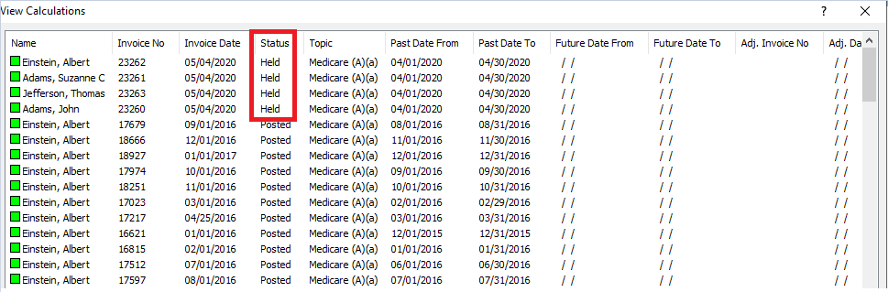

# Reversing a Posted Calculation

Once an invoice is posted to make changes to it, you must Reverse the calculation. Calculations may only be reversed if they have no payments and/or adjustments applied to any line.

1. From the **Main Menu**, click the **Billing** button.
2. Click the button for the appropriate payer source.
3. From the **Billing Screen** of that payer, click the **View Calculations** button.
4. Select the name and click **OK**.
5. Select the Invoice that you would like to reverse.
6. Click the **Load** button.
7. Click the **Reverse** button.
   1. If an invoice has cash or adjustments posted to it, you must first reverse the receipts and then reverse the invoice. If the receipts or adjustments have a date paid that is within a locked period, you will not be allowed to reverse them. If you do reverse cash or adjustments, remember to go back and post the charges again. If you try to reverse the calculation without first reversing the cash or adjustments, you will see the error message shown here.

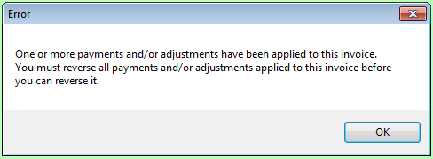

1. Click **Yes** on the message asking if you are sure you want to reverse this invoice.
   1. If the invoice you are reversing has posting dates in a locked period, you will receive a message stating that you cannot reverse out of the locked period, but you may continue and post the reversal in the current period. You can proceed by clicking Yes and select a date in an open period to post the reversal to.
2. Click **OK** on the message that says **Done** when it is finished.
   1. You may click the **Calculate** button on the screen to re-calculate the charges if you had to make corrections to the charting and re-calculate. The posting process will give you the same errors if the posting dates were within locked periods.
3. Click **Exit** to return to the billing screen.
4. Click the **Main Menu** button to return to the financial **Main Menu**.

## Reversing Multiple Posted Invoices

1. From the **Main Menu**, click the **Billing** button.
2. Click the button for the appropriate payer source.
3. From the **Billing Screen** of that payer, click the **View Calculations** button.
4. Select the names and click **OK**.
5. Click **Close** on the View Calculations screen where all invoices are displayed.
6. Make sure that the **Past Period** and/or **Future Period** dates are set to the dates that you are looking to reverse.
7. Click the **Reverse** button.
8. Enter in a date in the **Posting Date for Locked Periods** box.
9. Click **Select All** or use the **Ctrl key** on your keyboard to highlight invoices you are looking to reverse.
10. Click **Reverse**.
11. Click **Yes** on the message asking if you are sure you want to reverse all selected invoices.
12. Click **Close** on the message that says **Done** or **No Problems** when it is finished.
13. Click **Exit** to return to the billing screen.
14. Click the **Main Menu** button to return to the financial **Main Menu**.

# Analyze a Line on the Calculating Screen

If a charge does not calculate like you think it should have, you can click the Analyze button, on the Calculation screen toolbar, to see why the row produced the results that it did. The Analyze button allows you to see exactly what criteria the algorithm is looking for in order to process charges. It also allows you to see whether the calendar shows that the documentation matches these criteria.

1. Click the row heading for the calculation that did not process correctly.

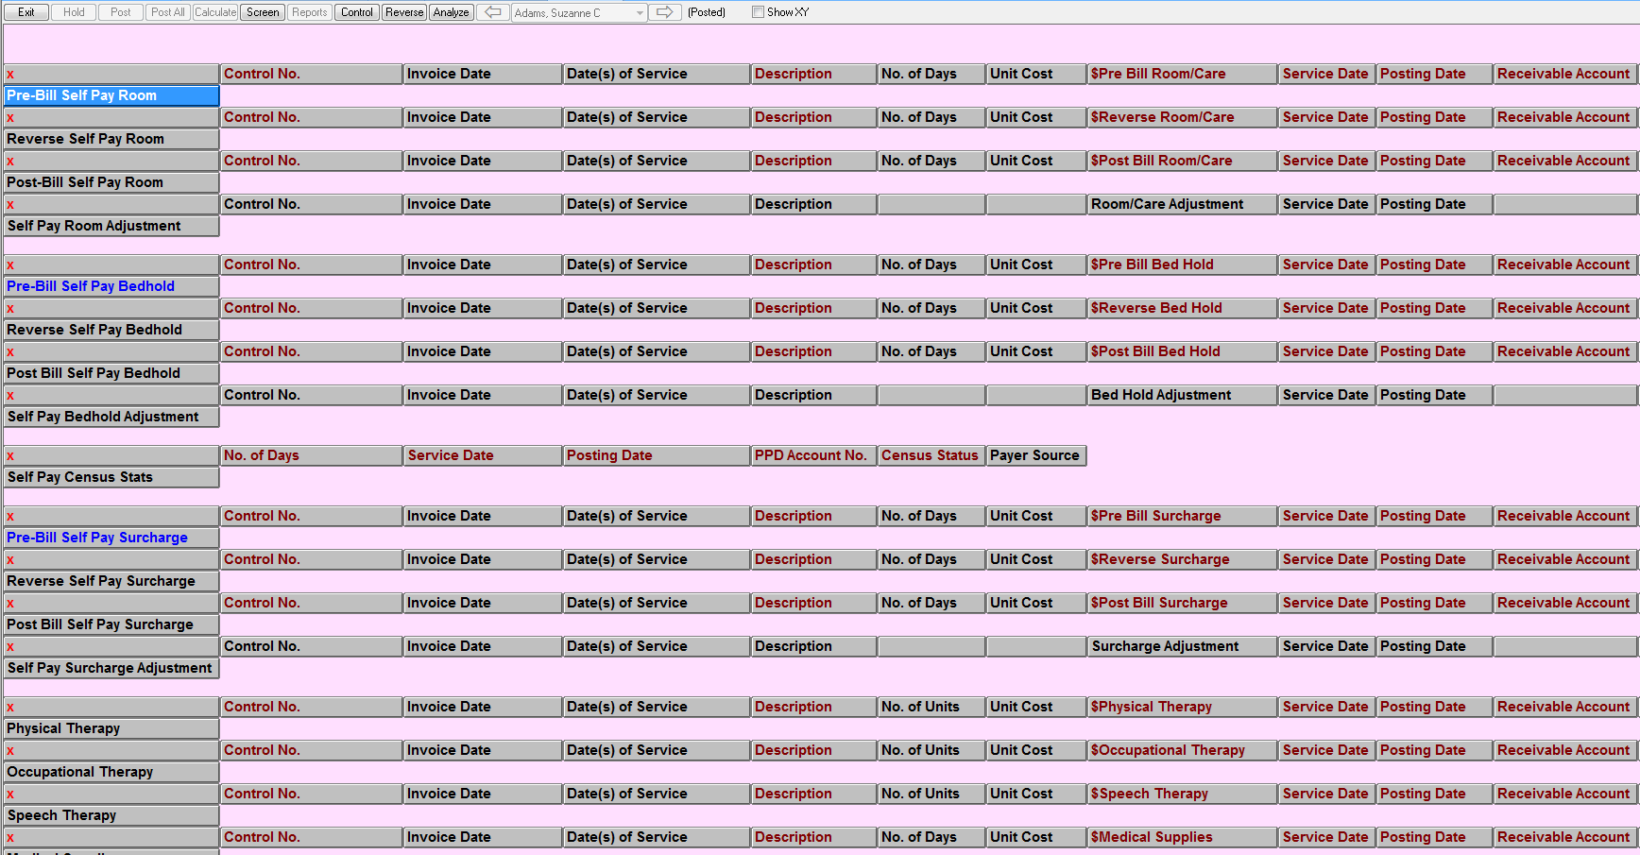

1. Click the **Analyze** button.
2. The first screen that appears will show the algorithm that is used to create the charges.

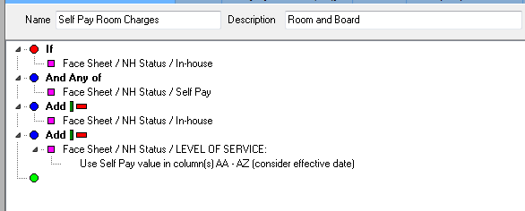

1. You will see in the algorithm what documentation is necessary for the charges to be processed. In the example above, the client must have In house and Self Pay documented. They must also have a Level of Service documented.
2. Once you have looked at the algorithm to see what needs to be documented, close the algorithm screen.
3. You will now see the calendar screen. The criteria documented in the algorithm will appear on the calendar, along with what has been documented for the selected name. In the example below, you can see the client has In house and Level of Service charted, but is missing Self Pay. What displays in the calendar will determine whether or not the calculation can process correctly.

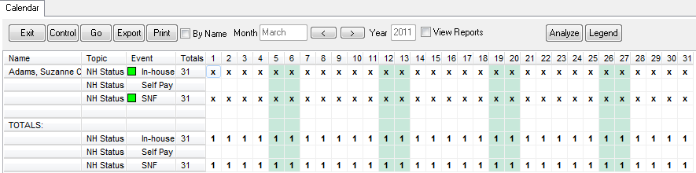

1. If the data on the calendar does not appear to be correct, you can go to the ADT/Face Sheet screen and view the documentation to see exactly what has been documented.
2. If you may any changes to the documentation, you will then have to re-calculate in order for any changes to appear. Remember that if the calculation is already on hold, you will first have to delete the held calculation before you can recalculate. (Deleting a Held Invoice)

If after using the Analyze button, you are still not able to get the calculation to process correctly, you can call American Data’s Financial Support.

# Errors on the Calculating Screen

When the posting is complete, a log will appear on the screen. If the log is blank, all of the invoices have posted successfully. If the log says that a client’s invoice has errors, you must correct the invoice before it will post successfully. There are generally two types of errors you may receive.

## Interface Errors on Calculating Screen

You will receive interface errors when one of the following occurs in a row that charges are calculated:

* A red **Revenue** word does not have a dollar value
* A red **Revenue Account** word foes not have an account number
* A red **Receivable Account** word does not have an account number
* A red **Control No.** word does not have a control number
* Any red word on the line that does not have a value listed, for example: Description, Posting Date, Item Amount, etc.

To find what is missing, scroll to the client’s held invoice. Look to see that all of the red words listed above are filled in on rows that have charges generated. If you can find what is missing, you can fix the problem. You must then delete the held invoice and recalculate.

If you cannot find what is causing the interface error, please call American Data’s Financial Support.

## Billing Out of Balance Errors

A billing out of balance error will occur when the system determines the revenue, receivable, and contractual adjustments are not in balance. Typically these errors are found on the Medicare (B) billing screen when a co-pay is not documented.

To identify if this is the problem, scroll to the lines that calculate co-pay. They are labeled:

* Med (B) Self Pay Co-Pay
* Med (B) Insurance Co-Pay
* Med (B) Medicaid Co-Pay

The entire co-pay line needs to be filled in. If one of these lines is not filled in, go back and run your Medicare (B) Requirements calendar task to see if the co-pay source is appearing on there.

# UB04s and Electronic Transfer of UB04s

UB04 setups and Electronic Claim Files must be done for the first time with an American Data staff person before you will be able to print or submit UB04s. Once the setup is complete, it will remain as the default and you will not have to change the setups each month. In order to print or submit UB04s, you must have calculated and posted your charges for the month.

## Generating UB04s

Once you have posted your charges, you are then able to generate your UB04s. You do not have to generate UB04s before you have locked the month. You may proceed with posting charges for all payer sources if you like prior to generating the UB04s.

1. From the **Main Financial Access** screen click the **Billing** button.
2. From the **Billing** screen, UB04s can be generated one of two ways:
   1. Click the payer source that you would like generate UB04s for.
   2. Click the **Forms** button and then click **UB04s** to access UB04s for all payers.
3. Click the button correlating to the UB04 you would like to generate.
4. Click **Select All** or select specific names.
5. Click **OK**.
6. The system will prompt with a message asking if you would like to process all and save.
7. Click **Yes** if you’d like to create UB04s for the selected name(s) and default dates. Click **No** and use Control to adjust the date range if needed.
8. If you selected Yes, the system will process all UB04s for you. When finished, a message will appear displaying how many claims were processed, how many were completed, and how many were held.
9. Click **OK** on this message.
10. If you have no errors, you may click Close on the log and proceed to creating the batch of UB04s to submit electronically.
11. If you have errors, a log will display showing you all of them.
12. Click **Print** or **Close** to continue to fixing the errors.

## Viewing Previously Created UB04s

All of the UB04s that you create will be saved in ECS and are accessible at any time. There are a couple of different ways you may view previously created UB04s.

### Viewing UB04s for a Specific Payer Source

1. From the **Main Financial Access** screen click the **Billing** button.
2. From the **Billing** screen, click the payer source button that you would like view UB04s for.
3. Click the **View UB04s** button.
4. Select the name(s) you are interested in.
5. Click **OK**.
6. Select the **UB04** that you would like to view and click **OK**. Note that you are only able to select one (1) UB04 at a time from this screen.

If you are already on a UB04 from, you may click the **Open** button on the toolbar to access to list of previously created forms. Select the one you want to view and click OK.

### Viewing All UB04s – Across All Payers

If you are looking for a UB04 but don’t necessarily know which Task/Payer Source/Setup Type the form was created for you are able to view all UB04s regardless of Task/Payer Source/Setup Type used in creating the form.

1. From the **Main Financial Access** screen click the **Forms** button.
2. Click the **UB04** button.
3. Click the **All UB04s** button.
4. Click the **Names** button and select either the name of the resident you are interested in or multiple names.
5. Click **OK**.
6. Click the **View UB04s** button.
7. Select the **UB04** that you would like to view and click **OK**. Note that you are only able to select one (1) UB04 at a time from this screen.

If you are on a UB04 from, you may click the **Open** button on the toolbar to access that list of previously created forms.

## Troubleshooting the UB04/Analysis Tool

If there are errors on the UB04, they will be identified on the log produced at the end of processing. If a field is highlighted in yellow it means that the field is required and you will not be able to complete the UB04 without it filled in. Fields can be customized per payer source to determine what data is required and if the field is required at all.

The fields on the UB04 pull from a variety of sources throughout ECS. You may click on a field on the form and look at the Analysis area on the right side to see what setups are in place for this field (which will tell you where the data is populating from). If the data is pulling from Entries, you may view the source of that information by clicking the **Show Source** button. The Show Source button will take you to the location of where the data is charted.

For example, in the picture below the **Show Source** button would take us to the View Entries screen of the Face Sheet/NH Status topic to view the Admission Date information.

If a field like Admission Date is blank and you’d like to enter the appropriate Admission Date into the charting you can click the **Write** button where you can add the Admission Date to the record. When you are finished entering the Admission Date, click Save and Exit and you would be returned to the UB04 screen. In order to pull this new Admission Date to the UB04 form you would need to click the Go button to update the form. When it asks you to click Yes to create a new form or No to update the existing form, click No to update the existing form you were on.

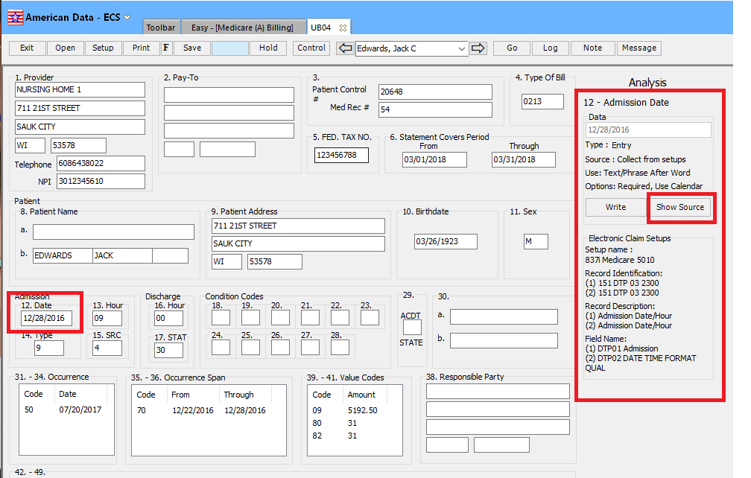

You also have the ability to type in the UB04 fields to add/edit information. You may right-click on data that is already there and choose add/edit/remove from various places to manually adjust the data.

If you do not want users to have access to manually adjust data on the UB04, user group settings can be set to control this access for each field. You should talk to your ECS System Supervisor about changing these settings.

#### Field Setups

The Analysis Tool on the right will show you were data is setup to pull from. Generally American Data’s Financial Staff will assist you in making setup changes. To view or change the setups:

1. Click the **Setup** button on the UB04 toolbar.
2. Select the field number from the dropdown list.
3. Click the box to the right of the word **Type** to see exactly what the field is pulling.
   1. If the Type field says “Entry” it is pulling from entries.
   2. If it says “Invoice” it is pulling from a calculating screen.
   3. If it says “Demographic” it is pulling from the client’s Demographic screen.
   4. If it says “System” it is pulling dates from the System Settings. System Settings can be found by going to File/Setup/Settings/System Settings.
   5. If it says “Text Label” it is just text typed in this field.

## Printing UB04s

The UB04 will print the data that you see on the screen. There are setup options per UB04 form that will allow you to control if ECS will print form lines for you.

### To Adjust Printing Options

1. Click the Setup button on the UB04 toolbar.
2. Click the Setups Options tab.
3. In the bottom right you will see the Print Form Lines options.
   1. **Yes** – indicates ECS will print the data and the form lines for you.
   2. **No** – indicates that ECS will print the data but NOT form lines. This is to be used if you need to print on official red forms.
   3. **Prompt** – indicates that each time you choose to Print a UB04 you will be prompted to choose whether or not you want the form lines to print.

### Printing a UB04

1. From the UB04 screen, click **Print** on the toolbar.
2. Select the appropriate printer and click **OK** on the print dialog box.
3. If you have **Prompt** selected, click **Yes** or **No** to print form lines. Clicking Cancel will cancel the print job.

### Printing multiple UB04s

You may print multiple UB04s at a time.

1. Click the **Open** button on the UB04 toolbar.
2. Select multiple forms and click **Print**.
3. Select the appropriate printer and click **OK** on the print dialog box.
4. If you have **Prompt** selected, click **Yes** or **No** to print form lines. Clicking Cancel will cancel the print job.

## Additional UB04 Tools

On the UB04 toolbar there are two additional buttons that are useful when processing forms. The Note button and the Message button are new in ECS10.

### Note

The note button can be used to add a note related to the selected form. This note will be saved and attached to the form for historical context. This can be used if you received a rejected claim and made a change before re-submitting. This note may indicate what you added/removed/changed from the rejected claims. This note could also be used to record information about payment status.

To use the Note button:

1. Click the **Note** button on the toolbar.
2. Enter a note.
3. Click **Close**. The note is saved automatically upon clicking Close.

### Message

The Message button allows users to enter and send an internal message to themselves or other staff. For example, you may want to enter a message and send it to yourself to remind yourself to check payment status in a couple of days. You may also want to send a message to another staff member if perhaps charting was missing or needs to be updated.

To use the Message button:

1. Click the **Message** button on the toolbar.
2. In the Text box, enter your message.
3. To the right of the Send To box;
   1. Select **Add User** if you’d like to send this message to one or more users. Select the user name(s) and click **OK**.
   2. Select Add User Group if you’d like to send this message to one or more user groups. Select the user group(s) and click **OK**.
      1. Note: You may select a combination of Users and User Groups.
4. Click **Send** to send the message.

The users will see this as a message in their Internal Messages screen. They will get a red notification in the bottom left of their screen. The Internal Messages screen will indicate a subject of “Financial Forms – UB04”, the user who sent the message and the date/time it was sent. Users may double-click the message to open it.

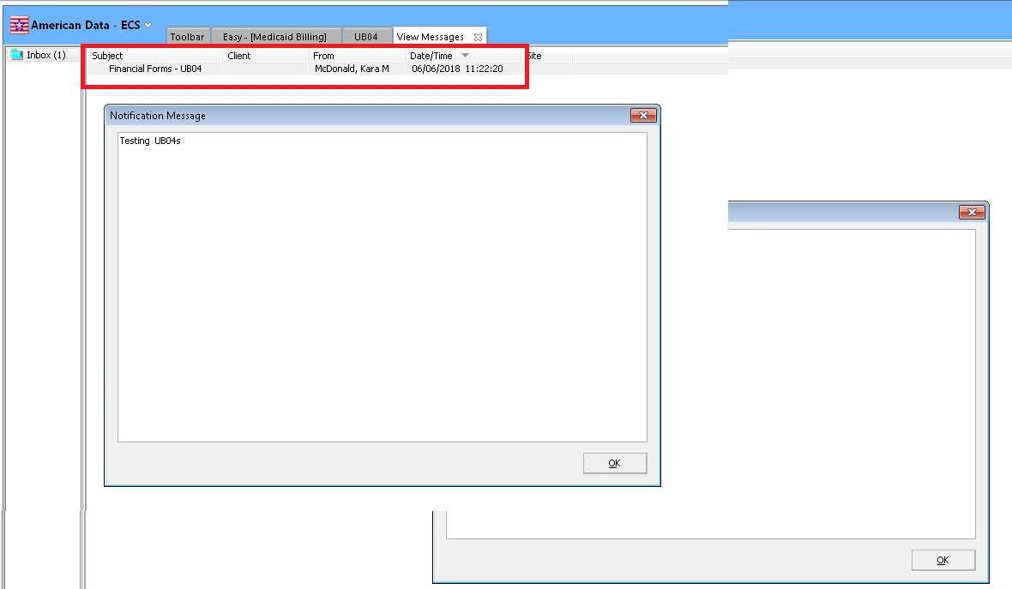

Users may keep the message in their Internal Messages or Delete it when finished reading it. There is no ability to respond to this message from this screen.

## UB04 Electronic Transfer

ECS allows you to create individual UB04s that will then be batched together in order to submit them electronically to your intermediary.

1. From the **Billing** screen, click into the payer source that you would like to batch UB04s for.
2. Click onto the **Batch** button under the Electronic Files column.
3. Select the name(s).
4. Click **OK**.
5. The UB04s generated from the previous month will display. Click onto each of the UB04s that you would like to be included within the batch or click **Select All**.
6. Click **OK**.
7. Click **Proceed**.
8. Verify that the correct **File Path** is displayed. If not, click the picklist box to the right and navigate to the location where they should be saved.
9. Click **Create File**. The system will create the electronic file for you and display the electronic file creation results screen that will show you information related to the file. Print this log as a reference of what was included in the batch.
   1. The log will display the date/time the batch was created, total charges, total non-covered charges, a list of the UB04s displayed in the file, and the location where the file was saved.
10. Click **Close**.

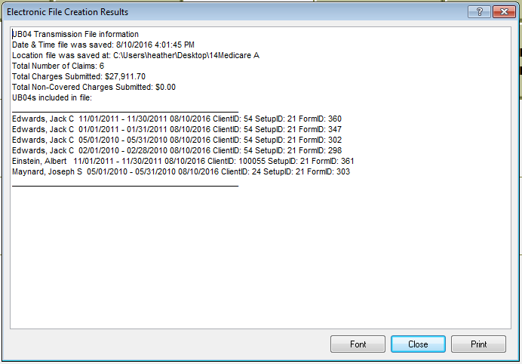

# Posting Cash

Ideally cash should be posted in ECS daily. You can generate daily and month cash reports to verify what has been posted. Any cash payments that you would like to be displayed on your Self Pay bills must be posted prior to calculating and posting Self Pay. All cash must be posted and balanced before locking the period.

1. From the **Main Menu**, click the **Post Cash** button.
2. From the **Post Cash** screen click the button for the appropriate payer source.

* You may select the **All Payer Source** button instead; however, if you do just double check you are applying cash to the correct payer source. The All Payer Source is more so to be used for viewing purposes only so that nothing is posted to the incorrect payer by mistake.

1. Select the name(s) for which you are posting cash receipts.
2. Click **OK**.
3. You will see the **Receipts/Adjustments** screen appear displaying those names with outstanding charges.
4. If you want to have ECS verify before posting that you are posting the same cash that is listed on the deposit slip (or whatever document you are keying off of), enter the total amount in the **Target Amount** field. This field is optional as you will be unable to post until you have entered in payments that exactly equal this amount.
5. In the **Reference** field, enter a number or word(s) to use as a reference. You may want to enter the check or credit card number that used to pay the invoice.

* The Reference field will accept any combination of letters and numbers and has a limit of 40 characters.
* If you are posting cash using the Self Pay task, the Reference that you enter will appear on the resident’s next Self Pay bill.

1. If you want the same reference to be applied to more than one payment, place a checkmark in the box called **Fixed Reference**.
2. Change the date in the **Date Paid** section to reflect the date you want the payment posted to.

## Selecting the Charges to Post Payments To

Next to each name, you will see the total amount due. This amount will be next to the name in white text with a black background. At the end of each line you will see the total amount outstanding for that line. These figures will be in black text with white backgrounds.



### Paying the Total Due

If the payment amount you received equals the total amount due, click on the total amount due. All lines will highlight in red and the total due will change to 0.00.

### Paying Less than the Total Due

If the payment amount you received is less than the total amount due you have two options. Option #1 will pay off the oldest charges first. Option #2 will allow you to select what you want to pay off.

#### Option #1 – Pay off Oldest Charges First

1. Click **Unequal Amount**.
2. Click the **Total Amount Due**.
3. Enter in the amount of the payment.
4. Click **OK**.

#### Option #2 – Select What you Want to Pay Off

1. Leave **Equal Amount** highlighted.
2. Click onto any lines that are less than the total amount due.
3. You may need to also click on **Unequal Amount** and highlight additional lines to enter in the remaining amount due.

## Finish Posting Cash

When all lines using any of the methods described above have been selected, make sure that the total in the **Amount Field** matches the total amount of the payments received.

* If you have used the Target Amount, then the **Target Amount** and **Amount** field must match.

Click the **Post All** button. The system will now post the cash to the charges you have selected.

Click **Exit** to return to the **Post Cash** screen.

## Cash Reports

ECS has reports to verify the cash posting. Cash should be verified after each posting. There are options to verify daily and monthly. If you use Financial Reports, you may see Cash broken down by Payer Source. If you use the Journal reports cash can be totaled by name, but you will not get totals by Payer Source.

### Financial Reports

1. From the Post Cash screen, click the **Reports** button.
2. Select one of the Cash Posted reports.
3. Select name(s).
4. Click **OK**.
5. **Print**, **Save**, or **Export** this report if needed.
6. Click **Exit** when finished viewing.

### Journal Reports

1. From the Post Cash screen, click the **Reports** button.
2. Click the **Cash Journal Reports**.
3. Select one of the **Cash Posted Reports**.
4. Click **Print** if you would like to print this report. If wanting to export, follow the steps below.
5. Click **Close** when done viewing the journal.

#### Export the Journal Report

1. From within the journal report screen, click the Export button.
2. Click **Yes**.
3. Choose a location to save the file.
4. Click **OK**.
5. Click **Close** when done exporting the journal.

## Reversing Cash or Adjustments Posted

If a mistake is found after posting cash, you can reverse the cash entry. You are not allowed to reverse cash once the period the date paid is within is locked. Reversals will not be displayed on Financial Reports but may be seen in the Journal Reports (if asked for).

1. From the **Main Menu**, click the **Post Cash** button.
2. Click the **Reverse** button.
3. Click the button that is the appropriate payer source.
4. Select the name(s) that you will reverse payments for.
5. Click **OK**.
6. Enter a **Reference**. You may want to check **Fixed Reference** if there are multiple payments/adjustments to be reversed.
7. Highlight the green entry that needs to be reversed.
8. Click the **Reverse** button. The payments/adjustments will be removed from your screen.
9. Click **Exit**.

* A user may also access the **Reverse** option when already in a cash receipts screen (if for example a user had just posted cash and realized it needs to be reversed), by clicking onto the **Control** button and changing the **Purpose** to **Reverse**.
* You do not need to change the Date Paid to the original date the payment was applied that you are reversing. ECS will reverse the payment based on the original date paid, regardless of what Date Paid is entered when reversing.

## Apply Credits

The apply credits function may be used when a client has overpaid one charge, giving them a credit balance, and has another charge left unpaid. You can apply the credit amount from the over payment to the charge that is not paid in full.

1. From the **Main Menu**, click the **Post Cash** button.
2. Click the **Apply Credits** button.
3. Click the Payer Source button that is associated with the credits you are planning to apply.
4. Select the name(s) that you will apply credits to and click **OK**.
5. In the **Reference** field you will see “**Apply Credits X**”. X will be a unique number assigned each time you apply credits. You are not able to edit this Reference.
6. Click on the line that has the credit.
7. Click on the line(s) that the credit will be applied to.
8. Click the **Apply Credits** button.
9. Click the **Post All** button.
10. Click **Exit**.

## Interface Errors on Receipts/Adjustments Screen

If you receive interface errors while trying to post receipts or adjustments, it generally means something is missing from the charge. Interface errors occur when either the Receivable Account number, Cash Account number or Control No. is missing from the charge. If the Receivable Account number or Cash Account number is missing from the Receipts/Adjustment screen, it also means that they were missing from the calculating screen when the charges were created.

In order to fix the problem, you may go to the blank space on the Receipts/Adjustments screen where the account number should appear, right click your mouse in the field and manually type in the account number. This will allow you to post the payment.

You should then call American Data to fix the calculating screen so the account numbers are pulled in the correct places and so you do not receive the interface error each time you post cash receipts to this type of charge or make adjustments to this type of charge.

## Search within Receipts/Adjustments Screen

The Receipts/Adjustments screen a Search field to search for information. This can be useful in searching for a Date Paid, or Reference, or charge, etc. To use this field, enter data into the Search box. Click the search button to the right of the field. Data that matches the search criteria will be displayed. If a payment matches the search criteria, the associated charge will be displayed. If a charge matches the search criteria, the associated payments and/or adjustments will be displayed. Use the arrow to the right of this box to move between the resulting data.

# Adjustments

Adjustments may be done differently in ECS based on the situation. Some adjustments may happen automatically (Self Pay pre-bill is adjusted automatically during the billing process), adjustments may be done on the Receipts/Adjustments screen (see directions below) and/or they may be done using the Adjustments documenting and Calculating screen. The method you use depends on the scenario and the preference of the facility.

## Using the Adjustments Documenting and Calculating Screens

There are a few scenarios that this type of adjustment is commonly used for:

* This option may be used when you are adding a charge to a resident’s account who doesn’t already have a charge posted.
* This option may be used when you are adding a charge to a resident’s account for something that is unusual. This method allows you to pick an account number and enter a description of the charge.
* This option is useful when you are transferring balances from one payer source to another; for example, a copay from an Insurance Company who has denied over to Self Pay. Again, you can pick an account number and enter a description. Both the debit and credit can be entered on this screen.

1. From the **Main Menu**, click the **Adjustments** button.
2. Click the **Enter Adjustments** (underneath the appropriate service heading).
3. Select the name and click **OK**.
4. Find the appropriate button word to enter the charge to (if it’s a self pay charge, select the button for self-pay, etc.)
5. Enter the amount of the charge.
   1. If you are increasing the balance owed, enter a positive number.
   2. If you are decreasing the balance owed, enter a negative number.
6. Click **OK**.
7. In the description dialog box enter the reason you are doing the adjustment and possibly the dates of the service related to the adjustment. For example: Part (B) Co-Insurance from Feb 2010.
   1. If it’s a self pay adjustment, the description you type in will appear on the client’s next self pay invoice.
8. Click **OK**.
9. The next screen to appear is the chart of accounts screen. Select the account number to adjust.
   1. You will not see receivable accounts here as they are being affected automatically.
10. Click **OK**.
11. Select the effective date for the charge and click OK.
    1. This must be a date within a current/open period. It is not the actual date of service.
12. If needed, you may enter additional adjustments for other payers from this screen prior to saving or exiting. Often you will have to do two adjustments moving money from one payer to another. For example, if you are moving $100.00 that was originally billed to an insurance company to the client’s account, you would enter $100.00 for self pay adjustment and -$100.00 for insurance adjustment.
    1. This second adjustment may have already been done on the Receipts/Adjustment screen. It is fine to do it there instead of here when adjusting off a charge found on the Receipts/Adjustment screen.
13. Click **Save**.
14. Click **Exit** to close the documenting screen.
15. Click the **Calculate/Post** button directly underneath the Enter Adjustments button.
16. Select the name(s) of those you need to calculate the entries on and click **OK**.
17. The calculation screen will load and calculate any adjustments found within the current month.
18. Once it has calculated, two reports will load. One for **Adjustments Entered** and one for **Adjustments Posted**. Verify that the documentation that you entered in appears on the Adjustments Posted report.
19. Click **Exit** to close out of the reports.
20. Click **Exit** again to return to the Adjustments screen.

### Reports for the Adjustments Screen

There are two reports that can be used to verify Adjustments. The **Adjustments Entered** and **Adjustments Posted** reports should equal at month end making sure that everything you documented also got posted.

You will find buttons for both of these reports located on that same Adjustments screen by first clicking onto Reports and then clicking into each of the reports (Entered and Posted).

## Using the Receipts/Adjustments Screen

Adjustments can be done using the Receipts/Adjustments screen. This is useful when there is a charge that has been posted that needs to be adjusted off (a partial amount or in full.) Adjustments done to Self Pay balances via this method will appear on the next Self Pay Invoice in the Payments/Credits section regardless of whether you are increasing or decreasing the balance. Doing an adjustment this way means you do not see extra lines on the Receipts/Adjustments screen.

1. From the **Main Menu**, click the **Adjustments** button.
2. From the column labeled **Rec/Adj Screen**, click the **Adjustments** button.
3. Click the **Payer Source** button that reflects the payer source you are looking to adjust (like Self Pay).
4. Select the appropriate name(s) and click **OK**.
   1. If you are not seeing the charge that you would like to adjust at this time, it may be because the charge is paid in full. To see all charges/payments, click the **Control** button, place a checkmark in **Display All**, and click **OK**.
5. In the **Reference** field, enter a number or word to use as a reference.
   1. You may place a checkmark in Fixed Reference if you have multiple lines to adjust and want to use the same reference without having to re-enter it.
6. If you are adjusting multiple lines and want to use the same account number for all adjustments, place a checkmark in the Auto Account checkbox.
7. If you are adjusting the balance by the exact amount of a charge, or an unpaid portion of a charge, you will want **Equal Amount** selected (this will be selected by default). If you are adjusting a balance by a portion of a charge, or something that has already been paid or adjusted in full, click the **Unequal Amount** button.
8. Highlight the line that you will adjust. If you selected Equal Amount the adjustment will be for the total amount owed. If you selected Unequal Amount you will be prompted to enter in the amount of the adjustment.

* You may need to enter a “-“ into the box when prompted to enter in a dollar amount. This will depend on whether you are increasing or decreasing the balance and whether the balance is a positive or negative amount.

1. The *Select Account to Adjust* dialog box will appear. Select the **Account Number** for the account that you want to adjust and click **OK**.
   1. If you have selected **Auto Account** and the lines do not have red “Revenue Account” words on the far right, the account that you selected will be used for all remaining adjustments (even across residents) until you Post, click Refresh, or un-check Auto Account. At any time you may un-check Auto Account to utilize a different account number for adjustments.
   2. If the lines you are looking to adjust have red “Revenue Account” words on them, the account under the red “Revenue Account” will be used rather than the account that you selected.
2. Click the **Post All** button.
3. Click the **Refresh** button to see the client’s corrected balance.

# Automatic Adjustments

The automatic adjustments process can be used to make adjustments to a calculation after it has been posted, even if the period is locked and/or there are payments or adjustments posted to it. The process will reverse any posted invoices, and re-calculate/post what actually should have been calculated/posted. Automatic Adjustments reduces the risk of user error by adjusting all payer sources automatically. The Automatic Adjustments tasks will vary based on the scenarios causing the adjustments to be done. Some examples of when you might use Automatic Adjustments are:

* When a client gets approved Medicaid and was billed Self Pay prior to being approved.
* When you bill the default RUG rate for Medicare (A) and an MDS has now been submitted.

Most payer sources have something that may affect a Self Pay bill (co-pay, liability, etc.) so after using Automatic Adjustments, you should run a Self Pay bill.

## Changing Billing Information

Prior to running the Automatic Adjustments task, you must first make sure that the new billing information has been charted. For example, make sure the appropriate payer source is now charted or the appropriate RUGs level is now charted. You should run your Requirements calendar for the adjustment period to make sure all census information is accurate.

### Using Automatic Adjustments

1. From the **Main Menu**, click the **Adjustments** button.
2. Click **Auto Adjustments**.
3. Select the appropriate button based on the type of adjustment you are doing.
   1. For example, you may see a button for Retro Medicaid Approval and Medicare Default RUG Adjustment.
   2. If you do not see a button that fits your situation, click onto one of the existing buttons and edit all necessary items within the task to meet your needs.
4. Select the name(s) to be adjusted and click **OK**.
   1. You may select multiple names if you are adjusting the exact same periods. It is easier to spot mistakes with less names, so if a large group of names needs to be adjusted, complete it in smaller groups, rather than all at once.
5. Select the dates to adjust. The **To Date** must be through the last post-billed period posted. Even if only one month is affected, your **To Date** must go through the last month posted.
   1. Example: If it is Mary 2016 and you have already done your May pre-bill/April post-bill and you now have someone who has gotten Medicaid approval back to February 2016, you would choose the following for the date ranges:
      1. **From Date** would be 02/01/2016.
      2. **To Date** would be 04/30/2016.

* Selecting the right dates is critical to the process. Once you have selected dates, you will see the invoice periods displayed on the right side of the screen showing you what will be adjusted. If you have questions as to what dates to select, please call American Data’s financial support department prior to doing the auto-adjustment.

1. Select a **Posting Date**. This must be a date in an open period and is the date the adjustments will post to.
2. Click **OK**.
3. Click **Yes** on the message asking if you want to process all selected names.
4. Click **Close** on the error log (if the log states No Problems). If you receive an error log which states there are errors, please print the log and contact American Data’s financial support department to help resolve the errors.
5. Click **Exit** on the calculating screen to complete the adjustment.
6. Billing Summary reports affected by this automatic adjustment may preview (dependent on the facility’s setups). Print and/or Save a copy of these reports. Click **Exit**.
7. Open the **Receipts/Adjustments** screen for the client(s) to be sure the adjustment process had the intended results.

Below is an example of what the Self Pay Receipts/Adjustments screen might look like once the adjustments from Self Pay to Medicaid are made. They gray lines are invoices that were automatically adjusted.

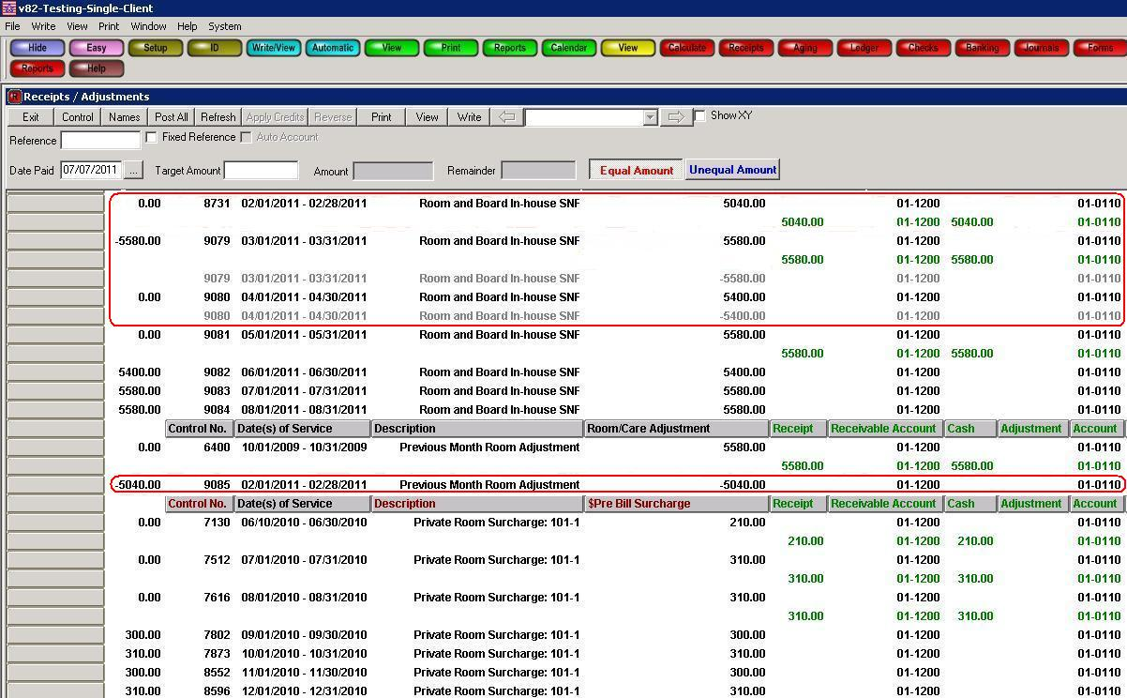

### Self Pay Bills

The adjustments to a client’s account will be reflected on the next statement that is generated. We recommend running the Self Pay Bill after verifying the cash receipts screen looks accurate and that the adjustment process was successful.

**NOTE:** If the Automatic Adjustment process didn’t give you the results you were expecting, please do not re-run the process. Contact American Data’s Financial Support Department for assistance.

# Aging

In ECS the aging is used to determine who has outstanding balances and how old they are. The aging is flexible in allowing you to run it for various periods of time. The tasks are set up to assume that you are looking for an Aging with a current outstanding balance, 30, 60, 90 day balances, and over 120 days. If you need to have an Aging with different periods of time, you can change the dates on the Aging control screen.

## Run an Aging Report

1. From the **Main Menu**, click on the **Aging** button.
2. There are buttons for each payer source and there is a button for all payer sources aging. Click the appropriate button.
3. Click the **Select All** button on the name selection screen.
   1. If you are not positive what names are currently listed, click the **Refresh** button before clicking **Select All**.
4. Click **OK**.

## Aging Detail

By default the aging will display in summary format. To see the detailed charges and/or payments that make up the outstanding balances, click the **Summary** checkbox next to the aging toolbar. This will now display the details of each charge/payment.

## Printing an Aging

You can choose whether you would like to print the aging detail or the aging summary. The detailed aging will print all the detailed information in the columns that you see on the screen. The summary aging will print exactly like the summary aging appears on the screen. No detail will be included.

1. While the aging is on your screen, click the **Print** button (Follow instructions above to get the aging on your screen).
2. Select whether you would like to print the **Detail**, **Summary**, or **Totals Only**.
   1. **Details** will print all of the detail that makes up a clients balance for each client on the screen. This print out will look just like the screen when Summary is unchecked.
   2. **Summary** will print the totals for each client. This print out will just like the screen when Summary is checked.
   3. **Totals Only** allows you to print only the totals at the bottom of the report. You will not get the individual client detail.
3. Click **OK**.
4. Click **Exit** to return to the Aging main screen.

## Exporting an Aging

You can export the Aging report to a text file which can be opened in another program like Microsoft Excel. You can choose whether you would like export the aging detail or the aging summary. The detailed aging will export all the detailed information in the columns that you see on the screen. The summary aging will export exactly like the summary aging you see on the screen. No detail will be included.

1. While the aging is on your screen, click the **Export** button (Follow instructions above to get the aging on your screen).
2. Select whether you would like to print the **Detail**, **Summary**, or **Totals Only**.
   1. **Details** will print all of the detail that makes up a clients balance for each client on the screen. This print out will look just like the screen when Summary is unchecked.
   2. **Summary** will print the totals for each client. This print out will just like the screen when Summary is checked.
   3. **Client Subtotals** will display each client and the balance due in each payer source category without displaying totals of each of the charges.
   4. **Totals Only** allows you to print only the totals at the bottom of the report. You will not get the individual client detail.
3. Click **OK**.
4. Click **Exit** to return to the Aging main screen.

## Changing the Aging Dates

Your aging will default to a specific range of dates each month; however you do have the option to run an aging with different dates. The default end date will be the last date of the prior month assuming you are often running an aging for month end purposes.

1. From the **Main Menu**, click on the **Aging** button.
2. There are buttons for each payer source and there is a button for all payer sources aging. Click the appropriate button.
3. Click the **Select All** button on the name selection screen.
   1. If you are not positive what names are currently listed, click the **Refresh** button before clicking **Select All**.
4. Click **OK**.
5. Click the **Control** button on the aging toolbar.
6. Change the **Date To** in the **Primary Period** area by clicking the … box to the right of it.

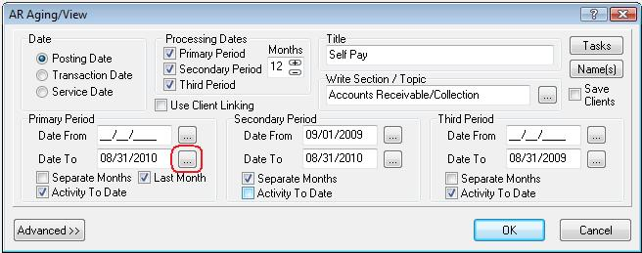

1. Select the last day of the month you would like the aging to end.
   1. **DO NOT** fill in a **Date From** in the **Primary Period**.
2. Place checkmarks ion **Secondary** and **Third Period** Checkboxes at the top. This will change the secondary and third period fields to correspond with the end date you have chosen.
   1. **DO NOT** check the **Primary Period** checkbox. This will clear out the new Date To that you just entered.
3. Click **OK** to run the aging.

### Changing the Number of Months the Aging Looks Back

By default the Aging tasks in ECS default to look back 3 months. (We may have set your defaults to something other than this.) You may change the number of months of detail. There is no limit to the number of months that you look back, however if printing a report with more than 6 months, the report may print on more than one page.

1. From the **Main Menu**, click on the **Aging** button.
2. There are buttons for each payer source and there is a button for all payer sources aging. Click the appropriate button.
3. Click the **Select All** button on the name selection screen.
   1. If you are not positive what names are currently listed, click the **Refresh** button before clicking **Select All**.
4. Click **OK**.
5. Click the **Control** button on the aging toolbar.
6. Change the **Date To** in the **Primary Period** area by clicking the … box to the right of it if you would like the aging to end on a different date than Last Month. This is optional. You may leave this as is.
7. If you choose to change the **Date To**, select the last day of the month you would like the aging to end. If you do not want to change the end date, skip this step.
   1. **DO NOT** fill in a **Date From** in the **Primary Period**.
8. Click the arrow in the **Processing Dates** section where it says 3 Months (or whatever your default may be). You may select any number of months, however more than 3 may mean your aging prints details across more than one page.
9. Click the **Secondary** and **Third Period** checkboxes to uncheck them. **DO NOT** uncheck the **Primary Period** checkbox.

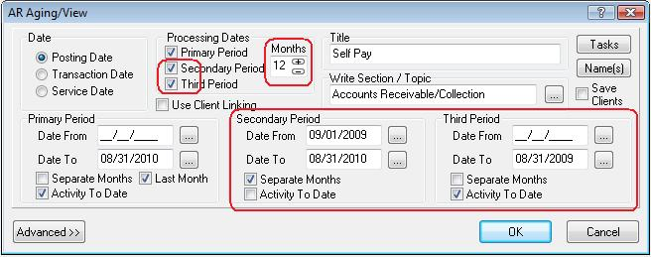

1. Click the **Secondary** and **Third Period** checkboxes to turn them back on. The **Primary Period** checkbox should still be selected. You will see the **Secondary Period** and **Third Period** dates have now adjusted to the number of months you selected. In the example above the task has been changed from 3 months to 12 months of detail.
2. Click **OK** to run the aging.

# Journals

The Journals are files that store all the data that has been posted in ECS. The Journal reports allow you to filter and sort the posted information in a variety of ways. The Journal reports can be used in addition to the Financial Reports that you print. Charges will not appear in the Journals until they have been calculated and posted. Payments will not appear until they have been posted. Journal reports are part of your month end process.

## Month End Journal Reports

There are 3 standard journal reports that we recommend running at month end:

1. Balance to Aging by Account – used to tie back to the All Payer Source Aging report.
2. Last Month Account Totals – used for your journal entry report and verifying that your credits and debits are in balance.
3. Temp Liability Account – should equal to zero.

### Balance to Aging by Account

The All Payer Source Aging must match the Receivable Account totals in your Journals at the end of each month. First you should run the **All Payer Source Aging** to get totals by Pay Source and a grand total. This will be used to compare to the **Balance to Aging by Account** journal report.

1. From the **Main Menu**, click **Month End**.
2. Click the **Journal Tasks** button.
3. Click the **Balance to Aging by Account** button.
4. Click **Close** when finished.

#### If Journal and Aging reports do not match:

If the Balance to Aging by Account Journal and the All Payer Source Aging report totals do not match you need to determine which client(s) are not matching. You will need to run the journals by client name and match up the individual totals on the aging with the individual totals on the journal report. You should have a task in the journals called **Balance to Aging by Resident**.

You should match up the grand totals for each client on the aging versus on the journals to see which ones are off. You may then be able to tell what is causing them to be off, or you can contact American Data’s Financial Department for assistance.

### Last Month Account Totals

The **Last Month Account Totals** Journal is the report that will be used to enter journal entries into your General Ledger.

* You will also want to check the following items:
* Temp Liability (999) account does not display on the report (meaning that it has no balance).
* The Cash account matches all of the cash that was received for the prior month.
* The Grand Total equals zero meaning that your debits and credits equal each other.

#### If the Grand Total does not display in the report by default.

1. Click **Control**.
2. Place a checkmark in **Grand Total**.
3. Click **OK**.

#### If the Grand Total does not equal zero:

1. Click the **Control** button.
2. Change the **Sort 1** to say **Last Name** rather than Account.
3. Change the **Sort 2** to say **First Name**.
4. Re-select the **Total** to say **Amount Posted**.
5. A box will appear in which you will look for the **Last Name** and **First Name** field. Select these fields and change the **Show Types** to the **Show** radio dial.
6. Click **OK**.
7. Click **OK**.
8. You may print or export this report if needed.
9. Click **Close** to return to the **Journals** screen.

Once you have re-sorted the report, it will display by name rather than account. Each name should equal zero. Once you determine the name(s) you can call American Data’s Financial Department and we will help you identify what is causing the problem.

### Temp Liability Account

You will want to make sure that the Temp Liability Account Journal equals to zero. If there are name(s) listed without a zero balance, contact American Data’s Financial Department and we will help identify what is causing the problem.

1. From the **Main Menu**, click **Month End**.
2. Click the **Journal Tasks** button.
3. Click the **Temp Liability Account** button.
4. Click **Close** when finished.

## Printing Journal Reports

You can print any of the journals by clicking the **Print** button at the bottom of the screen.

## Exporting Journal Reports

You may export any of the journal tasks. They will export into a format that you may then open in Microsoft Excel if you’d like.

1. From within a journal task, click **Export**.
2. Click **Yes** to the message asking if you want to **Send All Displayed Data to File?**
3. Browse for the location to save the file.
4. Click **Save**.

# Miscellaneous Cash

Miscellaneous Cash may be entered into ECS along with cash received on client accounts. The first thing that you will need to do is set up a client ID. You may want to call this client “Miscellaneous Cash.” You may choose to call it the facility name instead or some other non-client name that can be used. In the client Locate screen, it is recommended that you choose a Status of Inactive so that the clinical staff does not see this name in their default list.

## Documenting Miscellaneous Cash

1. From the **Main Menu**, click the **Post Cash** button.
2. Click the **Miscellaneous Cash** button.
3. Click the **Enter Cash** button.
4. Select the **Miscellaneous Cash** client.
5. Click **OK**.
6. Click the button that reflects the type of deposit.
7. Enter in the **amount** of the deposit.
8. Click **OK.**
9. Select the **Deposit Date**.
10. Click **OK**.
11. If you have additional cash to enter, select the appropriate type of deposit again and follow the steps listed above. If this is the only cash received, click **Save**.
12. Click **Exit**.

## Calculate and Post Miscellaneous Cash

Once you have the cash entered, you must calculate and post.

1. From the **Miscellaneous Cash** screen, select the **Calculate/Post** button.
2. Click the **Close** button on the log.
3. Click **Exit** to be brought back to the Miscellaneous Cash screen.

The Miscellaneous Cash that you post will appear on your Daily Deposit (Cash) report as long as you select that client name when running the report.

# Trust Account

Your trust account activity (withdrawals and deposits) should be documented in ECS each day. You will have an accurate current balance for each client every day. Trust calculations are done to add deposits, subtract withdrawals, disperse interest, and allow you to produce statements. These may be done monthly and/or quarterly, depending on your policies.

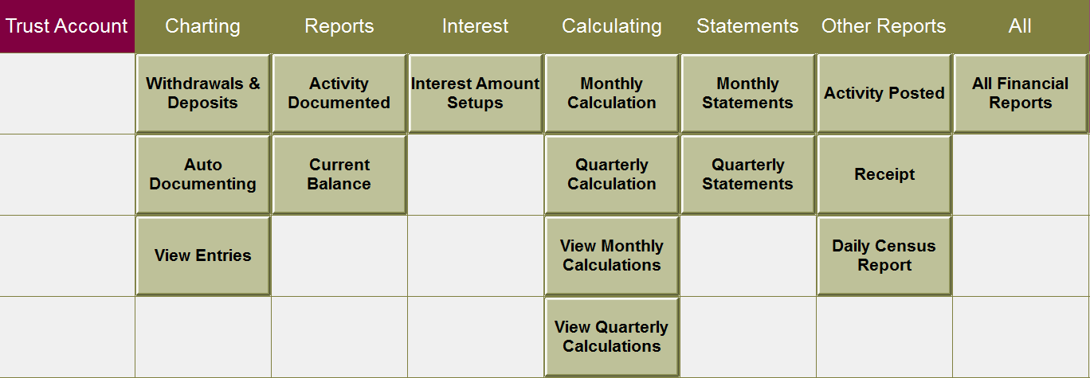

## Trust Account Beginning Balances

To create beginning balances for the Trust Account you will enter all balances as Deposits, and then calculate and post those transactions. All beginning balances will have a deposit date of the last date of the month prior to your go live. You will be walked through this process by your American Data Financial Trainer.

## Documenting Trust Account Deposits

1. From the **Main Menu**, click the **Trust Account** button.
2. Click the **Withdrawals & Deposits** button.
3. Select the name(s) of the clients who have activity.
4. Click **OK** on the name selection screen.
5. Under the **Deposit** column, click the word that describes the type of deposit.
6. Enter the **amount of the deposit**.
7. Click **OK**.
8. Select the **Deposit Date**.
9. Click **OK**.
10. If you would like to add an additional description, click the **Description** button word, enter a description, and click **OK**.
11. Click **Save** or **arrow next** to the Names button to scroll to the next client. The system will automatically save the entry when using the arrows to navigate between clients.
12. Click **Exit** when finished.

## Documenting Trust Account Withdrawals

1. From the **Main Menu**, click the **Trust Account** button.
2. Click the **Withdrawals & Deposits** button.
3. Select the name(s) of the clients who have activity.
4. Click **OK** on the name selection screen.
5. Under the **Withdrawal** column, click the word that describes the type of withdrawal.
6. Enter the **amount of the withdrawal**.
7. Click **OK**.
8. Select the **Withdrawal Date**.
9. Click **OK**.
10. If you would like to add an additional description, click the **Description** button word, enter a description, and click **OK**.
11. Click **Save** or **arrow next** to the Names button to scroll to the next client. The system will automatically save the entry when using the arrows to navigate between clients.
12. Click **Exit** when finished.

## Trust Account Reports

### Trust Account Activity Documented

Once your activity has been documented in the ECS you should run the Trust Account Activity Documented report to double-check your entries. This report should be used to make sure all activity has been entered correctly.

This report should also be run at Month End to double-check that the Total Deposits and Total Withdrawals are the correct amount. This report should tie out to the to the Trust Account Activity Posted report at month end when you are finished calculating and posting.

1. From the **Trust Account** screen, click the **Activity Documented** button under the **Reports** column.
2. Click the **Select All** button.
3. Click **OK**.
4. On the **Select Dates** dialog box, enter the first day of the month for which you will be calculating into the **Start Date** field and enter the last day of the month for which you will be calculating into the **End Date** field and click **OK**.
5. **Print** or **Save** the report if needed.
6. Click **Exit** to return to the **Trust Account** screen.

### Trust Account Current Balance

When documenting trust account activity, the client’s individual balance will be displayed on the documenting screen.

A report called Trust Account Current Balance may also be run to see every client’s current balance. This report will show you as of today what the client’s balance is. This report can be run at any time and may be run on individual or all clients.

1. From the **Trust Account** access screen, click the **Current Balance** button under the **Reports** heading.
2. Click the **Select All** button.
3. Click **OK**.
4. On the **Select Dates** dialog box, enter the last day of the month for which you will be calculating into the **End Date** field and click **OK**.
   1. For example, if it is currently September and you are calculating for August you would enter an end date of August 31.
5. **Print** or **Save** the report if needed.
6. Click **Exit** to return to the **Trust Account** screen.

## Trust Account Interest

For ECS to distribute interest, you must first determine the amount of money that is within the Trust Account and the amount of interest to be distributed. These figures are entered into ECS and are changed each month to reflect the new balance and interest amount.

* You should take the **Trust Account Interest** from the statement that you receive from the bank.
* To determine how much should be entered as the Trust Account balance, you should run the report called **Trust Account Current Balance** with an end date of the month that you will be calculating. For example, if it is currently September and you are calculating for August you would enter an end date of August 31. (See instructions above for running Current Balance report if needed).
  1. Take the grand total from this report and add back any negative balances that are shown. This will give you the total amount to enter in the Trust Account Balance row in the charge master task.

### Entering Account Balance and Interest

1. From the **Trust Account** screen, click the **Interest Amount Setups** button.
2. In the **Trust Account Balance** row enter the total from the **Trust Account Current Balance** report.
3. In the **Trust Account Interest** row enter the amount of interest earned which is found on the bank statement.
4. Click in the white space below these rows to deactivate the rows.
5. Click **Save**.
6. Click **Exit**.

Once you have these figures entered, you are ready to calculate and post your transactions for the month. The calculations this time will include any transactions that have taken place in the last month, as well as distributing the interest. Every month you will have to enter the correct Trust Account Balance and the Trust Account Interest for the current month.

## Calculating and Posting Trust Account Activity

Once you have documented the trust account activity for the month, you are ready to calculate and post. This is typically done monthly. (In order to do Quarterly Statements and Quarterly Interest you must calculate and post quarterly).

1. From the **Trust Account** access screen click the **Monthly Calculation** button.
2. Click **Select All**.
3. Click **OK**.
4. A common task will run, click **Select All** and **OK**.
5. Click **Yes** to process and place results on hold.
6. The system will calculate and hold all selected name(s).
7. The report called **Trust Account Activity (Held)** will display automatically when the calculating is completed. This report should show all deposits, withdrawals, and show the correct amount of interest to be distributed. The totals on this report must match the totals on the **Trust Account Activity Documented** report (plus interest) before you go on. If the two reports do not match, you must print this report and compare it to the **Trust Account Activity Documented** report to determine who is off.
8. If it looks correct, close the report, and click the **Post All** button.
9. If the report does not look correct:
   1. If there are accounts that have changes, you can go to the Control button, click the **View Calculations** button, highlight the held invoice, and delete it. You must then make necessary changes and re-calculate the client’s account.
   2. If the interest did not calculate correctly, you may select a client to adjust by clicking the drop-down arrow next to the client names.
   3. Enter the amount to allocate in the **Enter Amount** field on the **Allocating Leftover Pennies** line.
   4. Click **Screen**.
   5. Click **Post**.
   6. Switch to a different client name and click **Post All**.
10. Click **Close** on the log.
11. Click **Exit** to exit out of the screen.

## Trust Account Activity Posted Report

This report will preview automatically for you. This report is used to verify that all deposits and withdrawals and have been calculated and posted. It also displays the amount of interest that has been posted for the month. This report should balance back to your Trust Activity Documented Report plus include Interest. You should keep this report with your month end reports.

### To print the Trust Account Activity Posted after this process

1. From the **Trust Account** screen, select the **Activity Posted** underneath the **Other Reports** column.
2. Click **Select All**.
3. Click **OK**.
4. Click the **Print** or **Save** button.
5. Click **Exit** to return to the **Trust Account** screen.

## Printing Monthly Trust Account Statements

When you are finished calculating and posting your transactions, you may want to send monthly statements to the clients.

1. From the T**rust Account** screen, click the **Monthly Statements** button.
2. Click **Select All**.
3. Click **OK**.
4. Click the **Print** button to print this report.
5. Click **Close** to return to the **Trust Account** screen.

## Quarterly Trust Account

If you print statements quarterly instead of monthly, you will need to follow the steps above on a monthly basis and then do this **additional** calculation quarterly.

1. From the **Main Menu**, click the **Trust Account** button.
2. Click the **Quarterly Calculation** button.
3. Click **Select All**.
4. Click **OK**.
5. On the Calculate Control box, change the Past Period dates to represent your quarter. For example if you are calculating January 1 through March 31, your **Date From** field will be 01/01/2020 and the **Date To** field will be 03/31/2020.
6. Click **OK**.
7. A common task will run. Click **Select All** and **OK** on the Name Selection screen.
8. Click **Yes** to process and place results on hold.
9. The system will calculate and hold all selected name(s).
10. Click the **Post All** button (there is nothing that needs to be tied out on this screen).
11. Click **Close** on the log.
12. Click **Exit** to exit out of the screen.

## Printing Quarterly Trust Account Statements

When you are finished calculating and posting your quarterly task, you can print the financial report called Trust Account Statement.

1. From the **Trust Account** screen, click the **Quarterly Statements** button.
2. Click **Select All**.
3. Click **OK**.
4. Click the **Print** button to print this report.
5. Click **Close** to return to the **Trust Account** screen.

# Security Deposit

Your Security Deposit activity (withdrawals and deposits) should be documented in ECS when received. You will have an accurate current balance for each client every day.

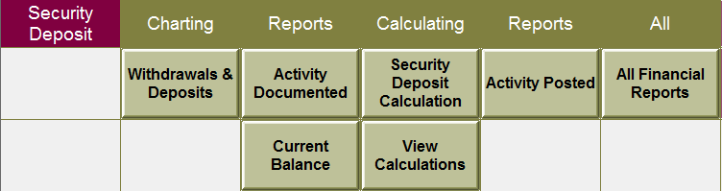

## Security Deposit Beginning Balances

To create beginning balances for the Security Deposits, you will enter all balances as Deposits, and then calculate and post those transactions. The balances will be as of the end of a month, for example balances as of June 30, 2016. You will be walked through this process by your financial trainer. Follow the steps below for documenting a deposit.

## Documenting Security Deposit Deposits

1. From the **Main Menu**, click the **Security Deposit** button.
2. Click the **Withdrawals & Deposits** button.
3. Select the name(s) of the clients who have activity.
4. Click **OK** on the name selection screen.
5. Under the **Deposit** column, click the word that describes the type of deposit.
6. Enter the **amount of the deposit**.
7. Click **OK**.
8. Select the **Deposit Date**.
9. Click **OK**.
10. If you would like to add an additional description, click the **Description** button word, enter a description, and click OK.
11. Click **Save** or **arrow next** to the Names button to scroll to the next client. The system will automatically save the entry when using the arrows to navigate between clients.
12. Click **Exit** when finished.

## Security Deposit Reports

### Security Deposit Activity Documented

Once all of your activity has been documented in the ECS you should run the Security Deposit Activity Documented report to double-check your entries. This report should be used to make sure all activity has been entered correctly.

This report should also be run at Month End to double-check that the Total Deposits and Total Withdrawals are the correct amount. This report should tie out to the to the Security Deposit Activity Posted report at month end when you are finished calculating and posting.

1. From the **Security Deposit** screen, click the **Activity Documented** button under the **Reports** column.
2. Click the **Select All** button.
3. Click **OK**.
4. **Print** or **Save** the report if needed.
5. Click **Exit** to return to the **Security Deposit** screen.

### Security Deposit Current Balance

When documenting security deposit activity the client’s individual balance will be displayed on the documenting screen.

A report called Security Deposit Current Balance may also be run to see every client’s current balance. This report will show you as of today what the client’s balance is. This report can be run at any time and may be run on individual or all clients.

1. From the **Security Deposit** screen, click the **Current Balance** button under the **Reports** column.
2. Click the **Select All** button.
3. Click **OK**.
4. On the **Select Dates** dialog box, enter the last day of the month for which you will be calculating into the **End Date** field and click OK.
5. For example, if it is currently September and you are calculating for August you would enter an end date of August 31.
6. **Print** or **Save** the report if needed.
7. Click **Exit** to return to the **Security Deposit** screen.

## Calculating and Posting Security Deposit Activity

Once you have documented the security deposit activity for the month, you are ready to calculate and post. This is typically done on a monthly basis.

* In addition to the Security Deposit activity documentation, clients must have an Occupancy Status documented in order for the calculations to work.

1. From the **Main Menu**, click the **Security Deposit** button.
2. From the **Security Deposit** screen click the **Monthly Calculation** button.
3. Click **Select All**.
4. Click **OK**.
5. Click **Yes** to process and place results on hold.
6. The system will calculate and hold all selected name(s).
7. The report called **Security Deposit** **Activity (Held)** will display automatically when the calculating is completed. This report should show all deposits and withdrawals for the month. The totals on this report must match the totals on the **Security Deposit** **Activity Documented** report before you go on. If the two reports do not match, you must print this report and compare it to the **Security Deposit** **Activity Documented** report to determine who is off.
8. If it looks correct, close the report, and click the **Post All** button.
9. If the report does not look correct:
   1. If there are accounts that have changes, you can go to the Control button, click the **View Calculations** button, highlight the held invoice and delete it. You must then make necessary changes and re-calculate the client’s account.
10. Click **Close** on the log.
11. Click **Exit** to exit out of the screen.

## Security Deposit Activity Posted Report

This report will preview automatically for you. This report is used to verify that all deposits and withdrawals and have been calculated and posted. This report should balance back to your Security Deposit Documented Report. You should keep this report with your month end reports.

### To print the Security Deposit Activity Posted after this process

1. From the **Security Deposit** screen, select the **Activity Posted** underneath the **Other Reports** column.
2. Click **Select All**.
3. Click **OK**.
4. Click the **Print** or **Save** button.
5. Click **Exit** to return to the **Security Deposit** screen.

# Lock Periods

ECS gives you the ability to Lock Periods for billing purposes. Locking a period means that you can no longer post any charges or payments into the Locked Period. Once you have finished your billing, and ran your reports for the month, you should lock that period. Your Trust Account and Miscellaneous Cash must be calculated and posted as well prior to locking the period.

Periods must be locked separately for each Site/Service combination you have in your database.

## Locking Periods

1. From the **Main Menu**, click the **Month End** button.
2. Click the **Lock Periods** button.

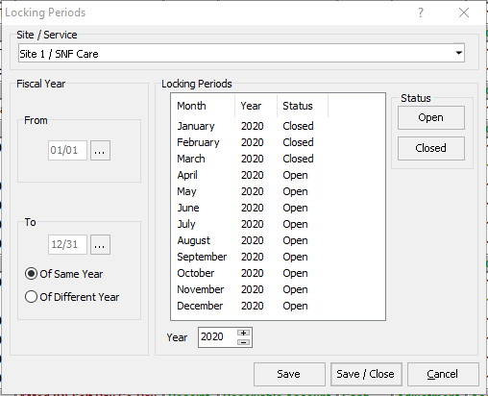

1. Select the appropriate **Site/Service** from the dropdown.
2. Select the **month** that you would like to change the status of.
3. Click **Closed**.
   1. Click onto a month again and click **Open** if you need to open a month that is closed.
4. Click **Save** if needing to make adjustments to other Site/Services or **Save/Close** to save and exit the screen.

## Adjustments to Locked Periods

### Billing Screen

If you need to create charges with dates of service that fall within a locked period, you can calculate the charges like you normally would. The system will not allow you to post to that period; it will give you the error that says the period is locked.

1. The message will ask you to choose the date to post to.

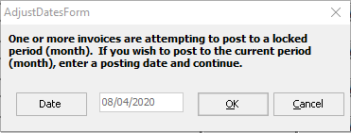

1. This message will default to today’s date. If you would like to select a different date, click the **Date** button on the left side of the screen. It will allow you to choose any date that is not within a locked period.
2. Once the date is selected, click **OK**.
3. It will prompt a question box asking if you want to use this date for all posting dates. Click **Yes**.

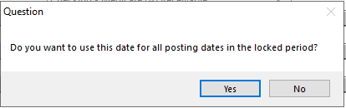

You will also receive messages if you try to reverse an invoice that has posting dates within a locked period. You may still reverse (as long as no payments/adjustments are applied). You will just have to select a date in an open period to post the reversal to.

1. 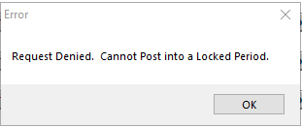Click **OK** to this error message.
2. 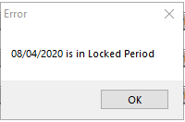Click **OK** to this next error message.
3. 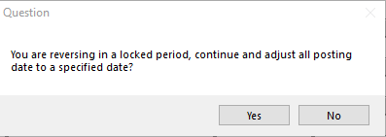A Question box will appear. Click **Yes** to continue and reverse the invoice using a specified date or click **No** to cancel.
4. The message will ask you to choose the date to post to.
5. This message will default to today’s date. If you would like to select a different date, click the **Date** button on the left side of the screen. It will allow you to choose any date that is not within a locked period.
6. Once the date is selected, click **OK**.

### Receipts/Adjustments Screen

Payments and/or Adjustments may not be posted using a date paid that is within a locked period.

You are not allowed to reverse a payment or adjustment on the Receipts/Adjustments screen, from a locked period. If you try to use a Date Paid that falls within the locked periods date range you will get the same error messages as above.

# Month End Procedures

Once you have calculated and posted for the month there are some steps that you should take to make sure all charges and payments have been posted correctly and that everything is in balance. Once the following reports have been generated you should lock the prior period. Locking the prior period will close the month and not allow any changes to account numbers for that period.

Based on customization at each facility there may be different procedures to be able to close a month. This is a suggested list of items that you must complete to be able to lock the month.

## Billing Summary Reports

You should have a copy of the Billing Summary reports that were generated for each Primary Payer Source. The number of billable days on your Daily Census calendar report should match the total number of billable days on all Billing Summary reports.

## Ancillary Charges Documented vs Posted

There may be multiple different Documented vs Posted reports in your system for the various types of ancillaries in which your facility provides. You will want to run each of these individual reports to verify that all the ancillaries that were documented were also billed out. When running these reports you should be verifying that the documented column ties to the posted column.

## Miscellaneous Cash

All prior month Miscellaneous Cash must be entered and calculated and posted. You should have a copy of the Miscellaneous Cash Entered report and the Miscellaneous Cash Posted report for the entire month. The totals on these two reports must balance.

## Trust Account

All prior month Trust Account activity must be entered and calculated and posted. You should have a copy of the Trust Account Activity Documented report and the Trust Account Activity Posted report. The totals on the Withdrawal and Deposit columns should equal. The Trust Account Activity Posted report will include any interest that was dispersed as well.

## Aging Reports

You should run the All Payer Source Aging report. The Primary Period End Date should be the last day of the prior month. This will give you your outstanding balances as of the last day of the prior month. This aging will not include the latest pre-bill. This is the report that will be used to match to the Journal task called Balance to Aging by Account. You may leave this aging up on your screen and then run the Journal task. To view both reports at the same time go to the American Data – ECS menu dropdown and choose Window then Tile Side by Side.

## Journal Tasks

### Balance to Aging by Account Journal

The All Payer Source Aging must match your Receivable Account Numbers in your Journals at the end of each month. The Balance to Aging by Account Journal task should be run using the Posting Date field and selecting the same End Date that you chose when running the All Payer Source Aging. You should not select a Start Date in the Posting Date field.

If the Balance to Aging by Account Journal task does not match back to your aging, click the Control button. Select the task called Balance to Aging by Resident. Use the same Posting Date and click OK. Compare the client totals. Once you have identified the client(s) who are not balanced you may call American Data’s Financial Support to help identify why they are off and fix the problem.

### Last Month Account Totals Journal

The Last Month Account Totals task is what should be used to export to or key data into your General Ledger. It will display the account totals for the selected month for every account.

This task should be run for the prior month to make sure that Revenue, Receivable, and Contractual Adjustment amounts are in balance. The Grand Total at the bottom of this report should be zero.

### Temp Liability Account Journal

The Temp Liability Account task should display zero at the bottom of the report. If it is not zero, contact American Data’s financial support to assist you in correcting those resident(s) without a zero balance.

## Lock Periods

ECS gives you the ability to Lock Periods for billing purposes. Locking a period means that you can no longer post any charges or payments to the Locked Period. Once you have finished your billing, and ran the billing summary, aging and journal reports for the month, you should lock that period.

Adjustments may be done to charges in locked periods; however, the adjustments must be posted into a current (open) month.